**List of Activities**

1. Resource group (Assignment, EastusRG)
2. Virtual Network (Host-vnet, eastus-vnet)
3. Network Security Group
4. Network Security Group Rule
5. Availability Set
6. Virtual Machine (webserver1, webser1, jumpserver, server11)
7. Enable Backup
8. Alert Rule (CPU usage)
9. Installing Webserver (IIS)
10. Load Balancer
11. Vnet-Peering
12. Storage Account for EastUS (ZRS (Zone-redundant storage))
13. Sales Manager user to access resource from window explorer
14. Storage Account for Southeast-Asia (GRS (Geo-redundant storage))
15. User (VMadmin, Backup admin)
16. Vmadmin at subscription level
17. Backupadmin at EastusRG (resource group) level

___________________________________________________________________________

**Diagrams**

Host-Vnet-------------------

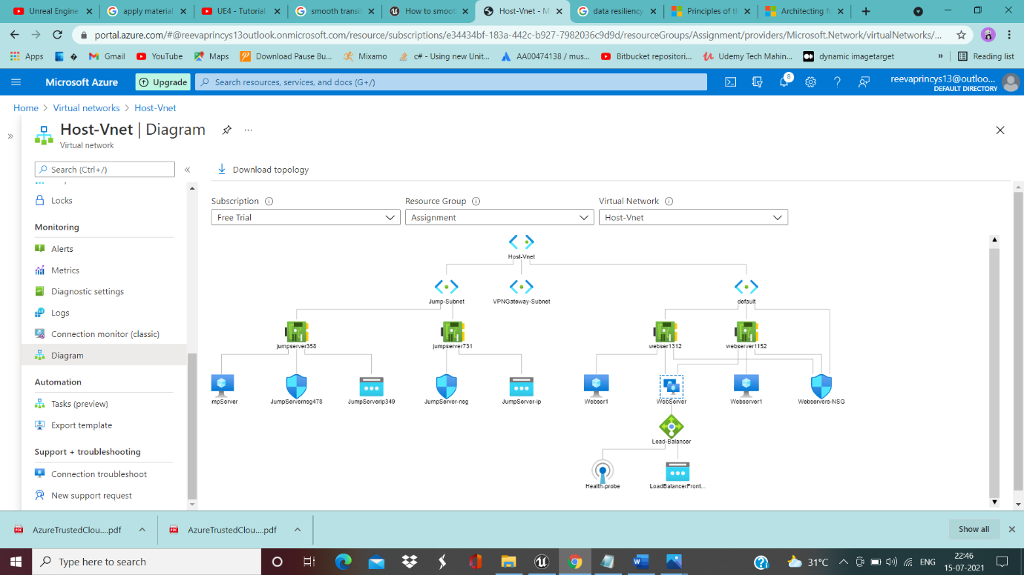

Eastus-vnet----------------------

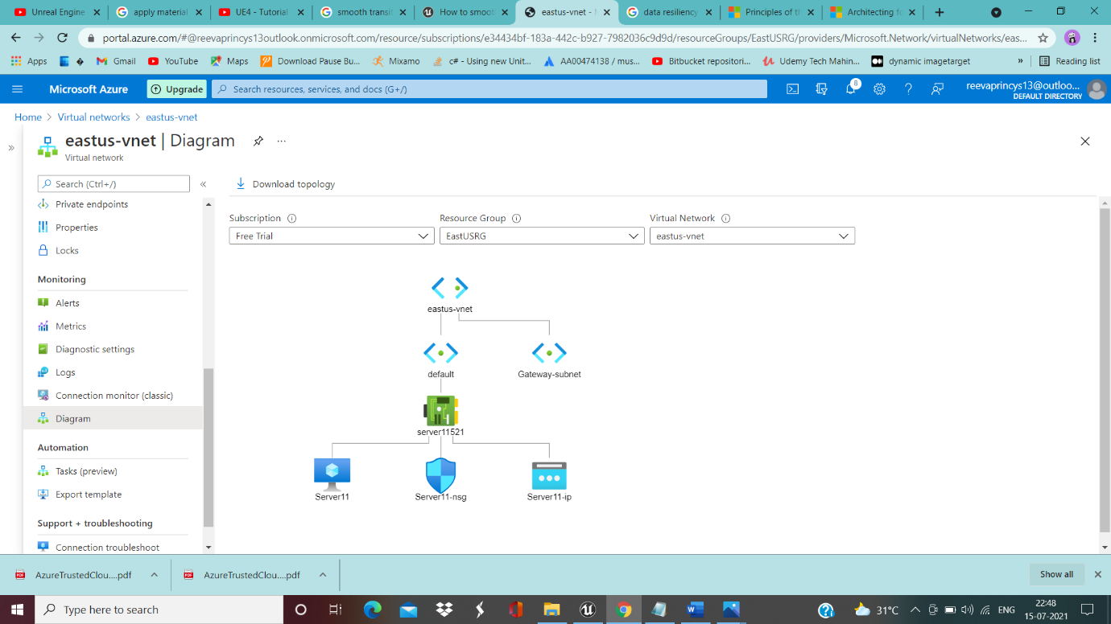

Load Balancer------------------------

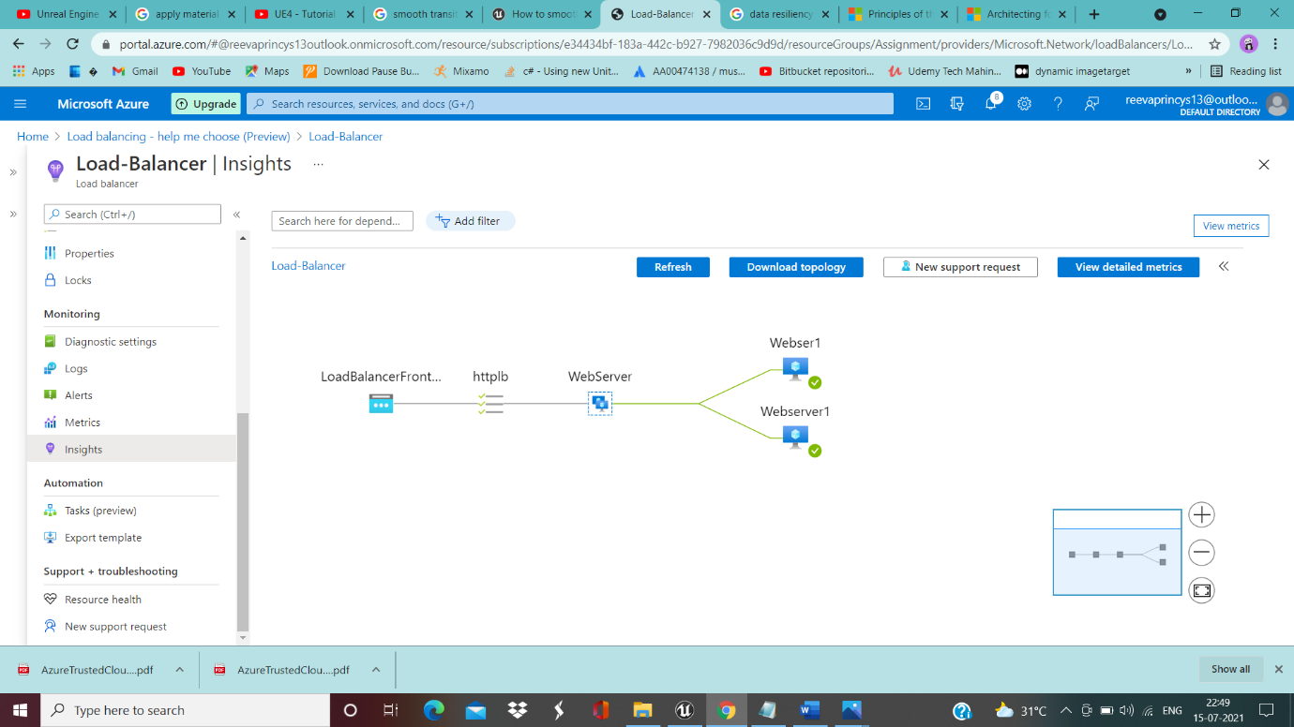

___________________________________________________________________________

**SEA region**

Creating Vnet, Subnet and NSG…………………………………..

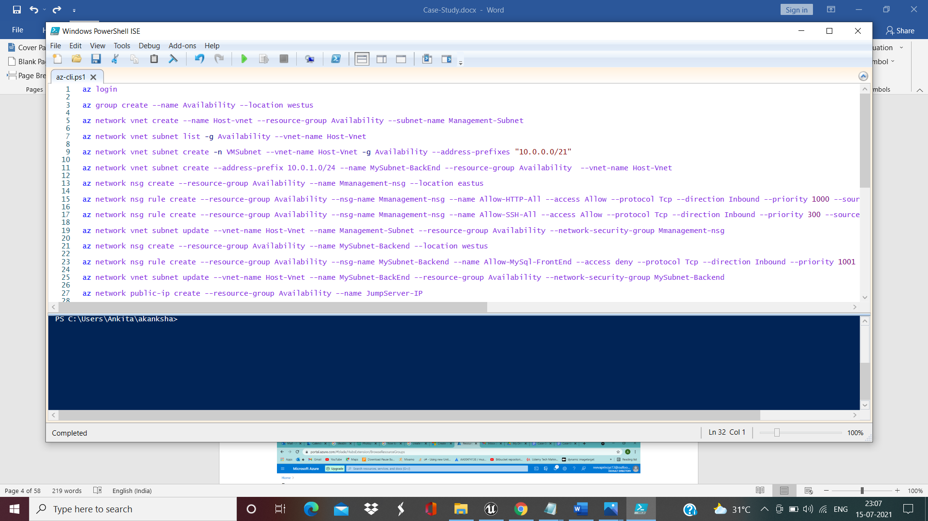

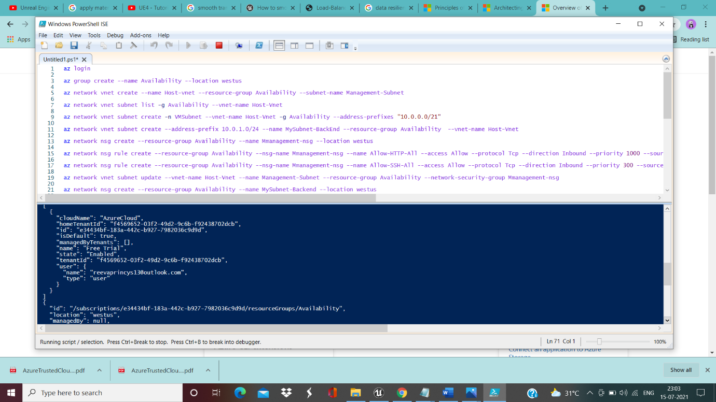

Output Resource group --------------------------------------------------

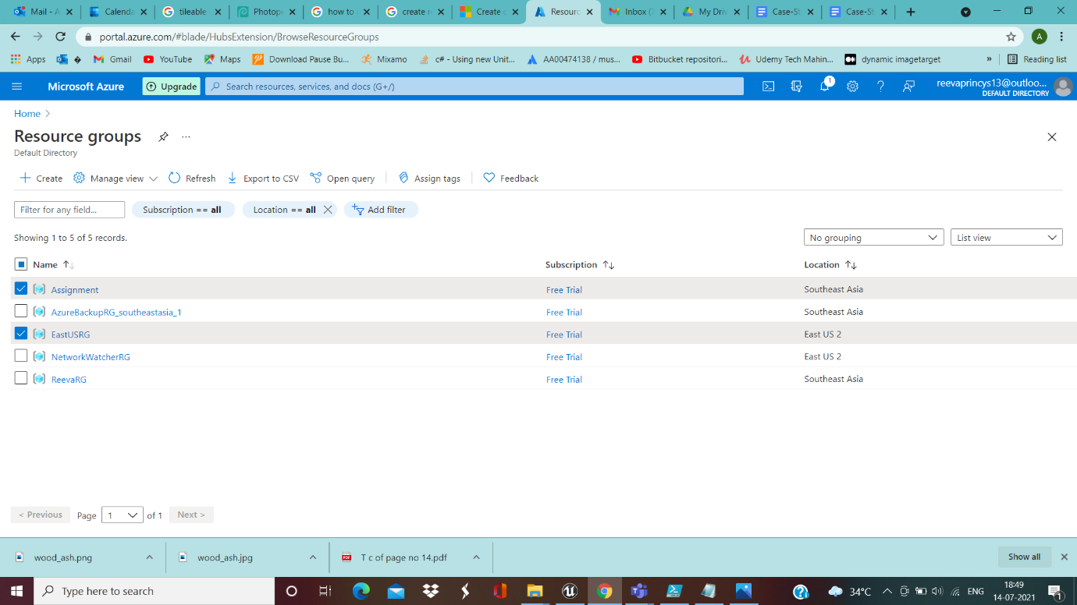

Output – Vnet,Subnet and nsg ---------------------------------------

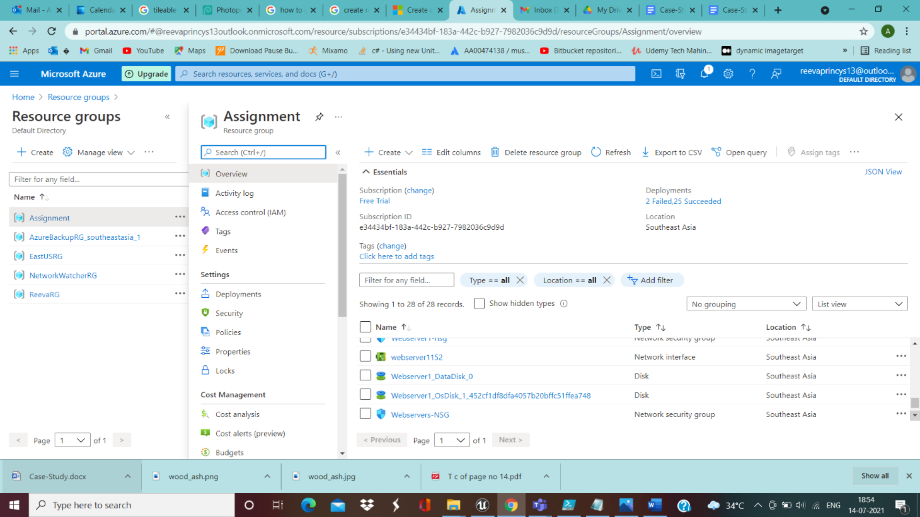

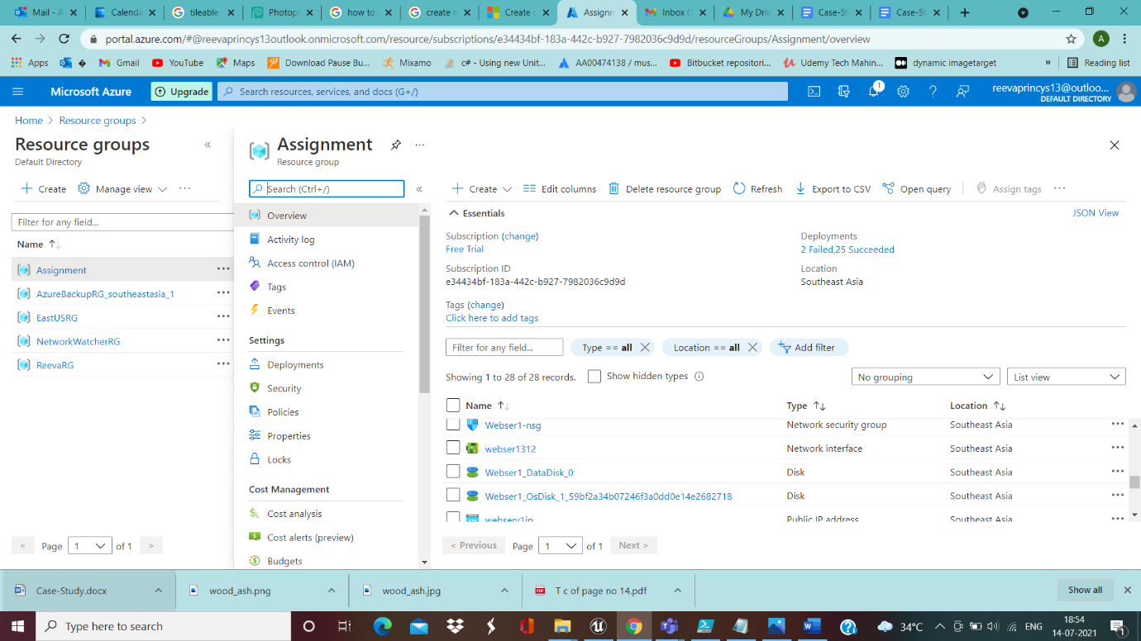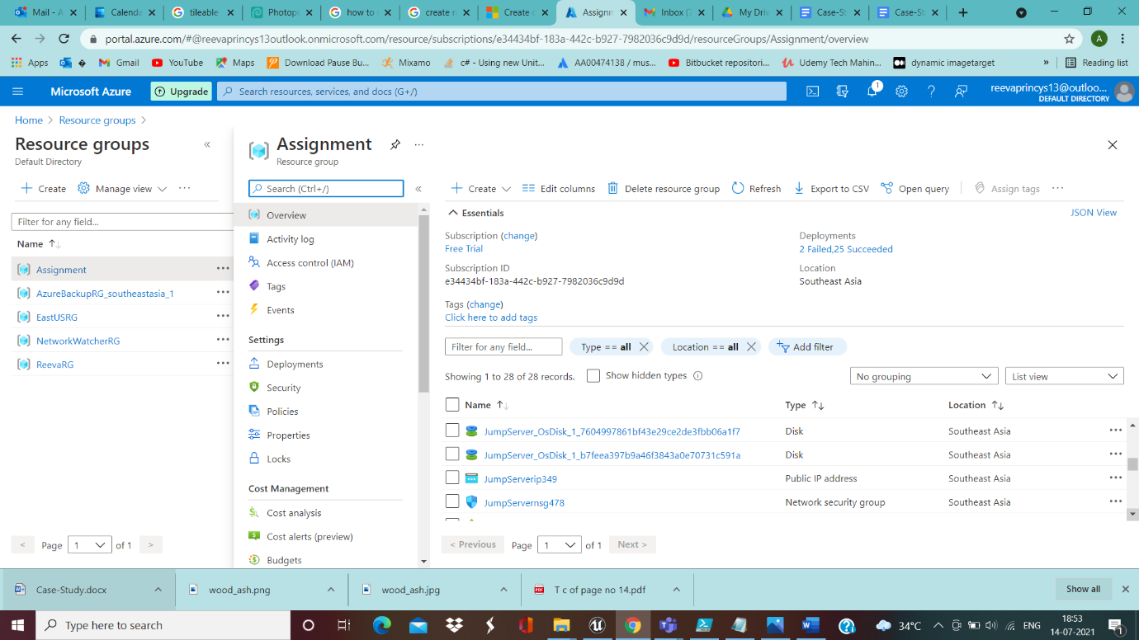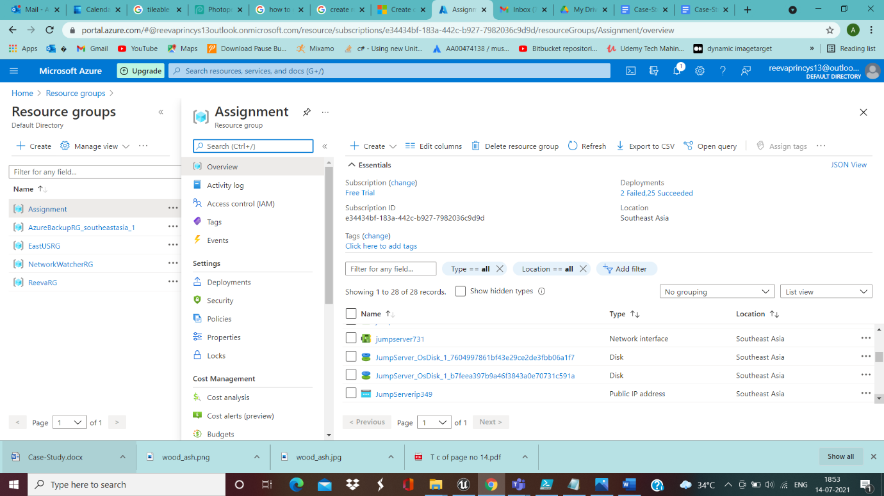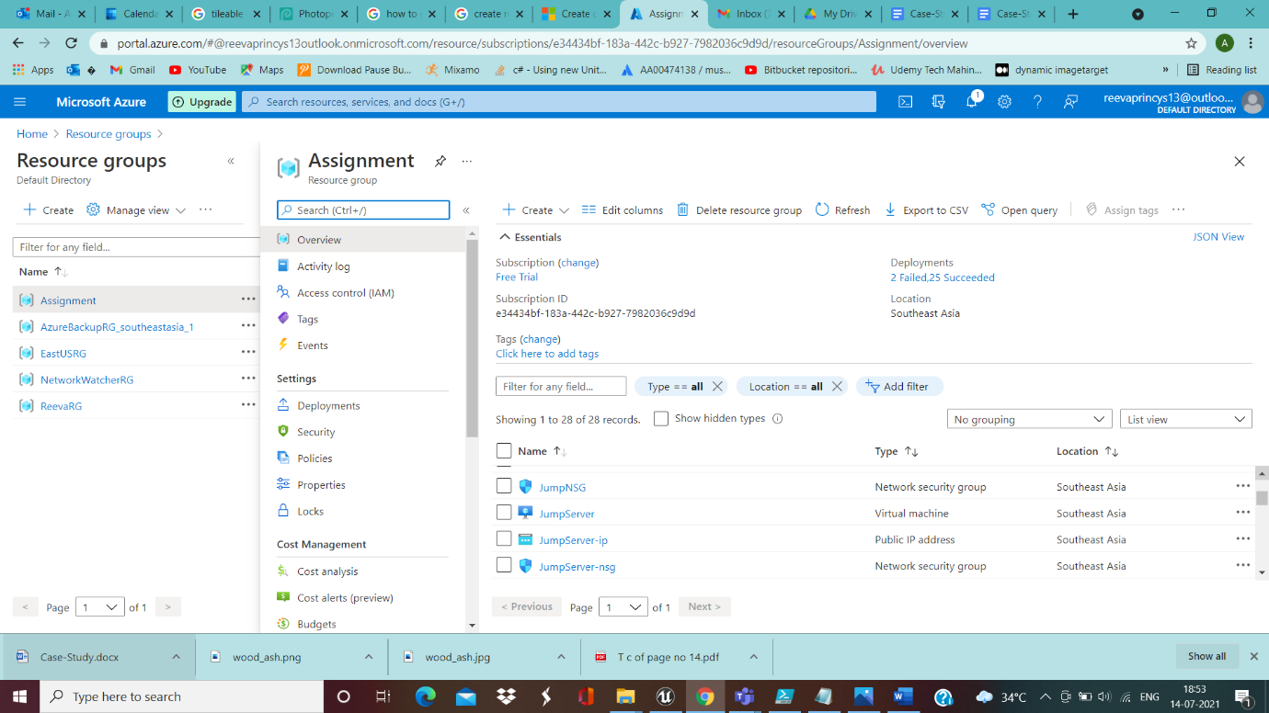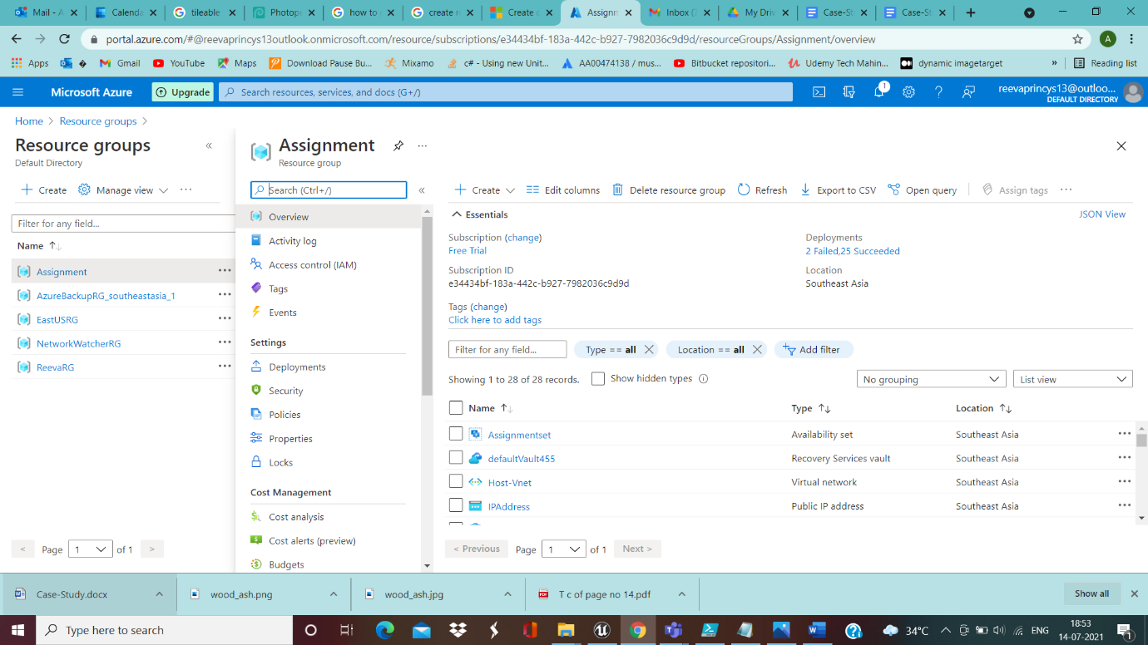

__________________________________________________________________________________

Creating Jumpserver………………………………..

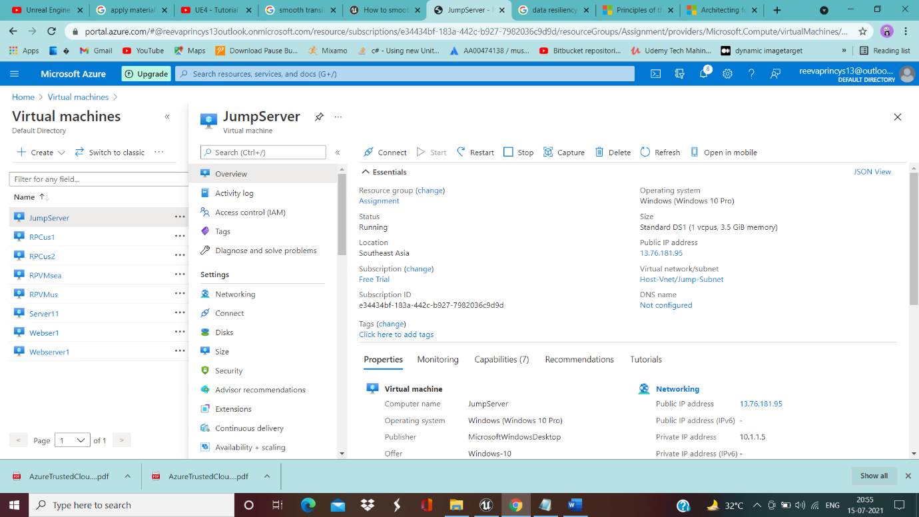

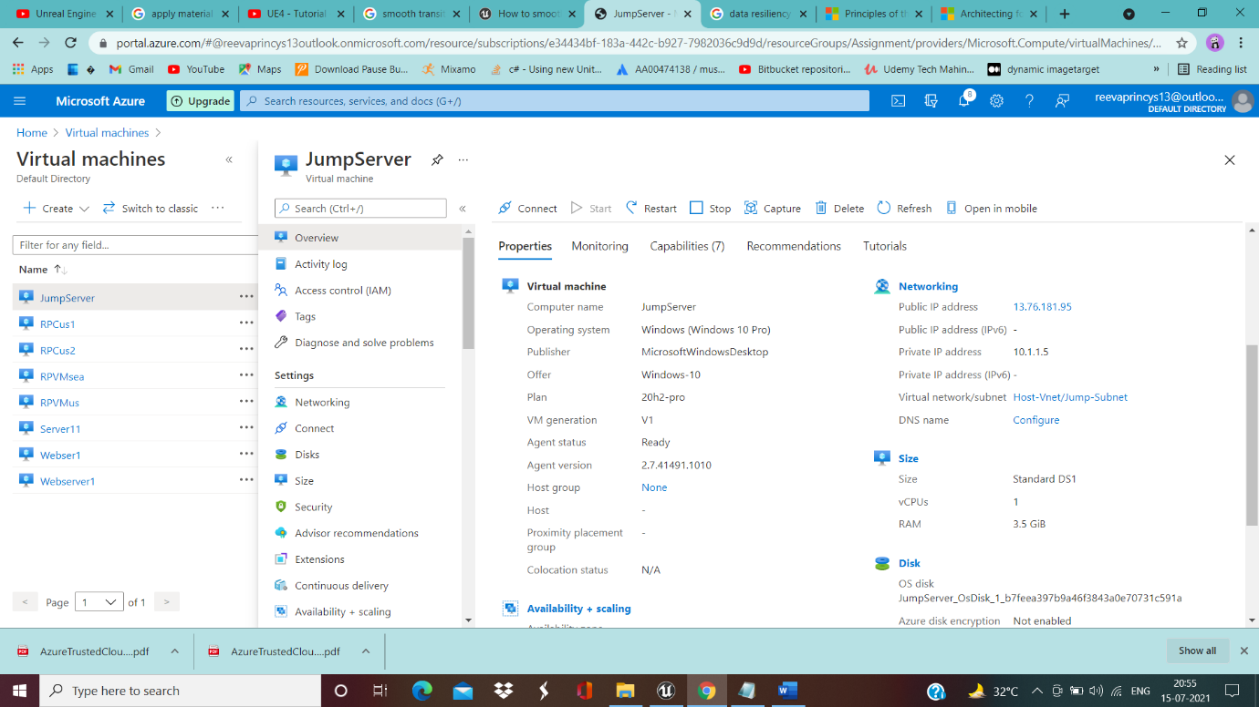

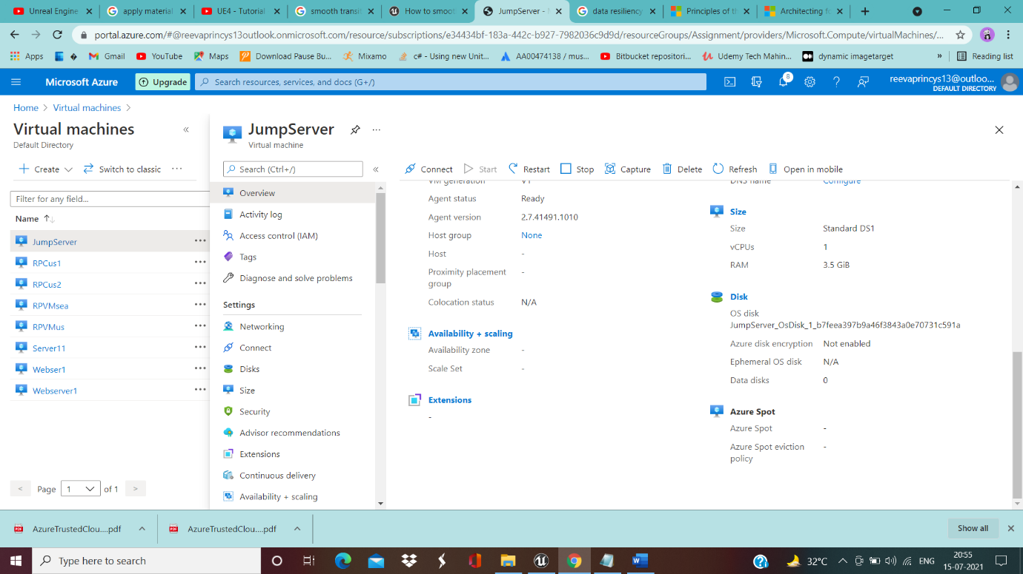

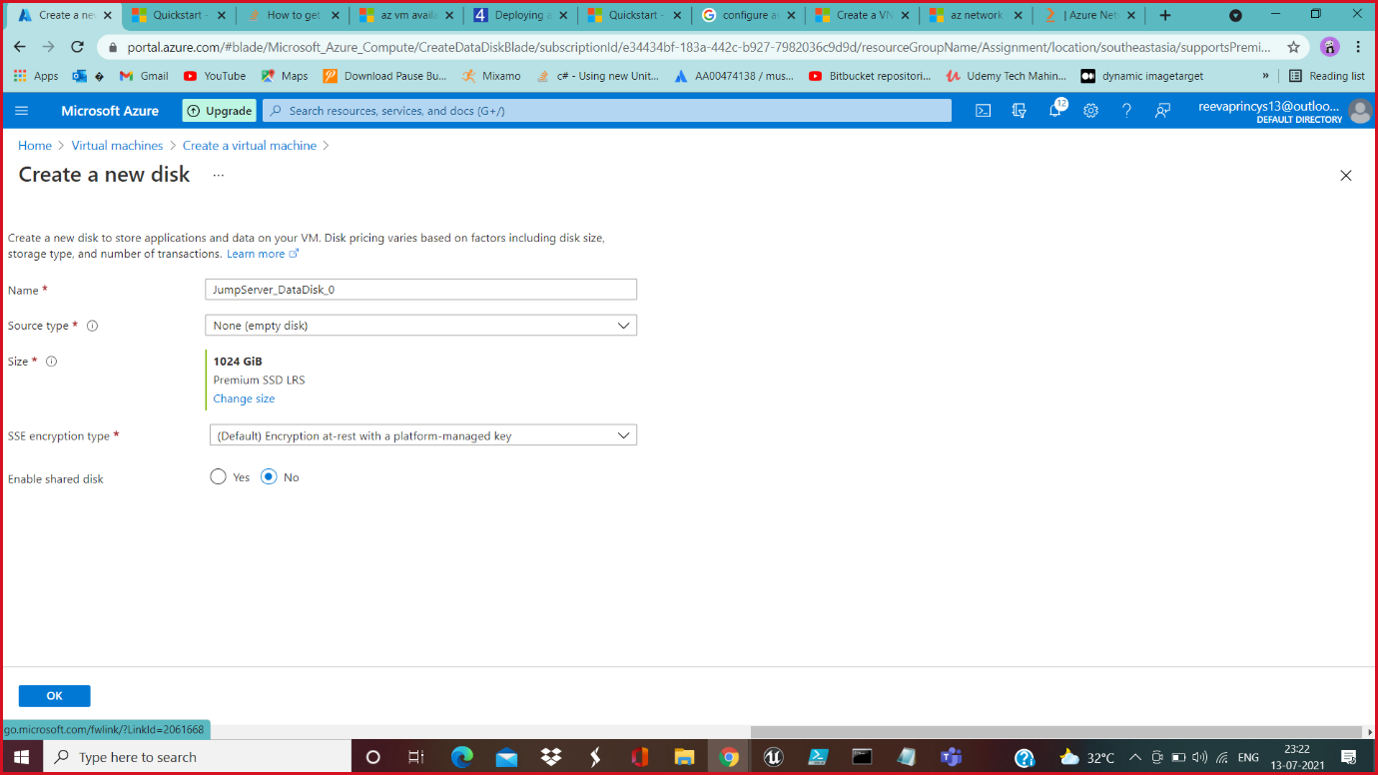

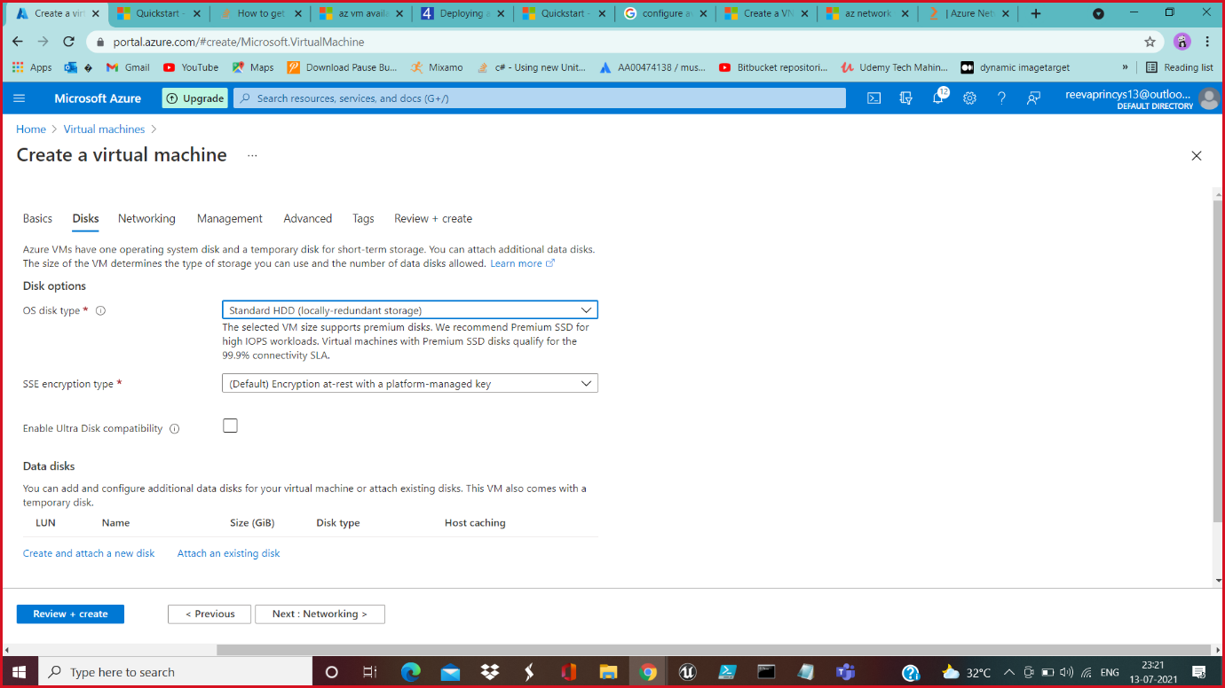

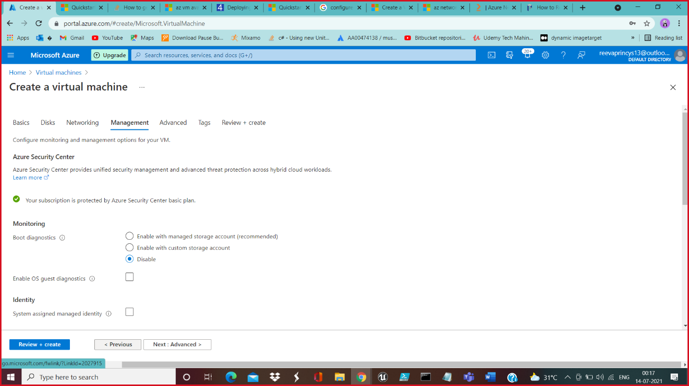

__________________________________________________________________________________

Creating Webservers in SEA region-----------------------------------

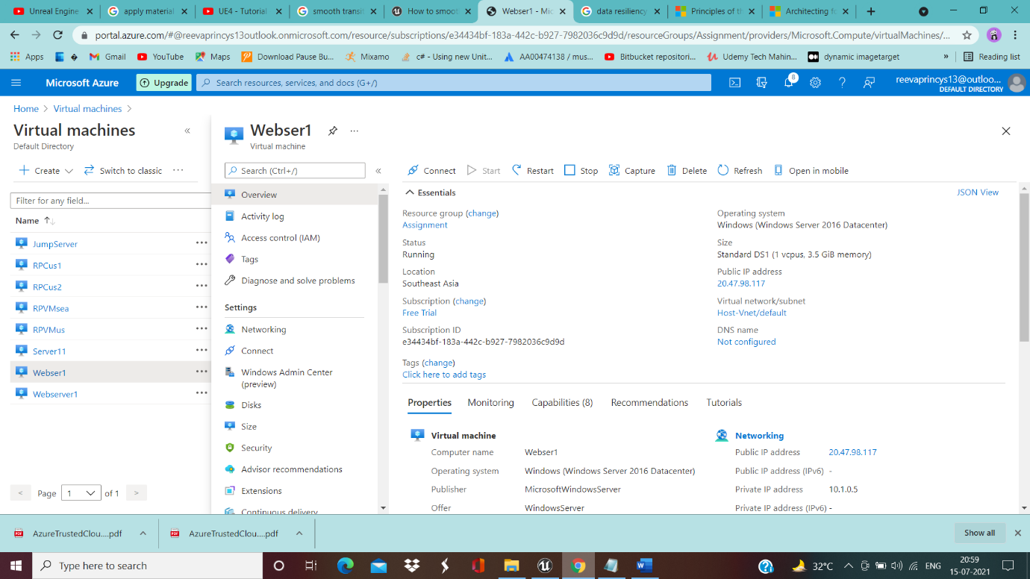

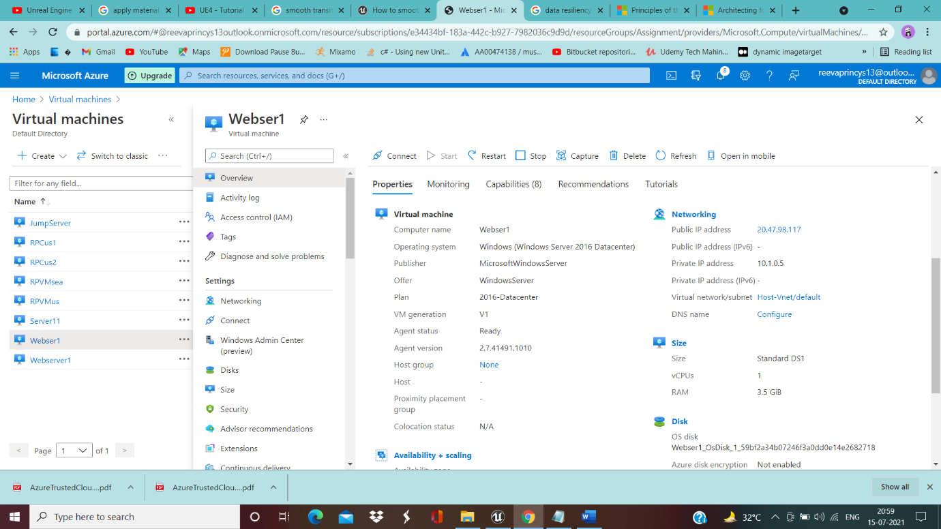

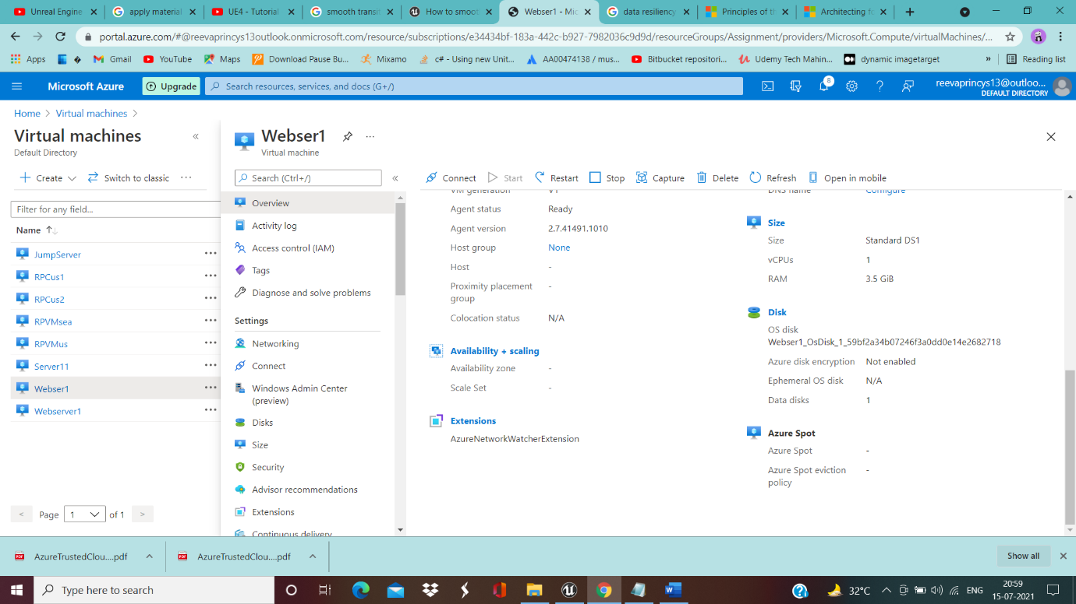

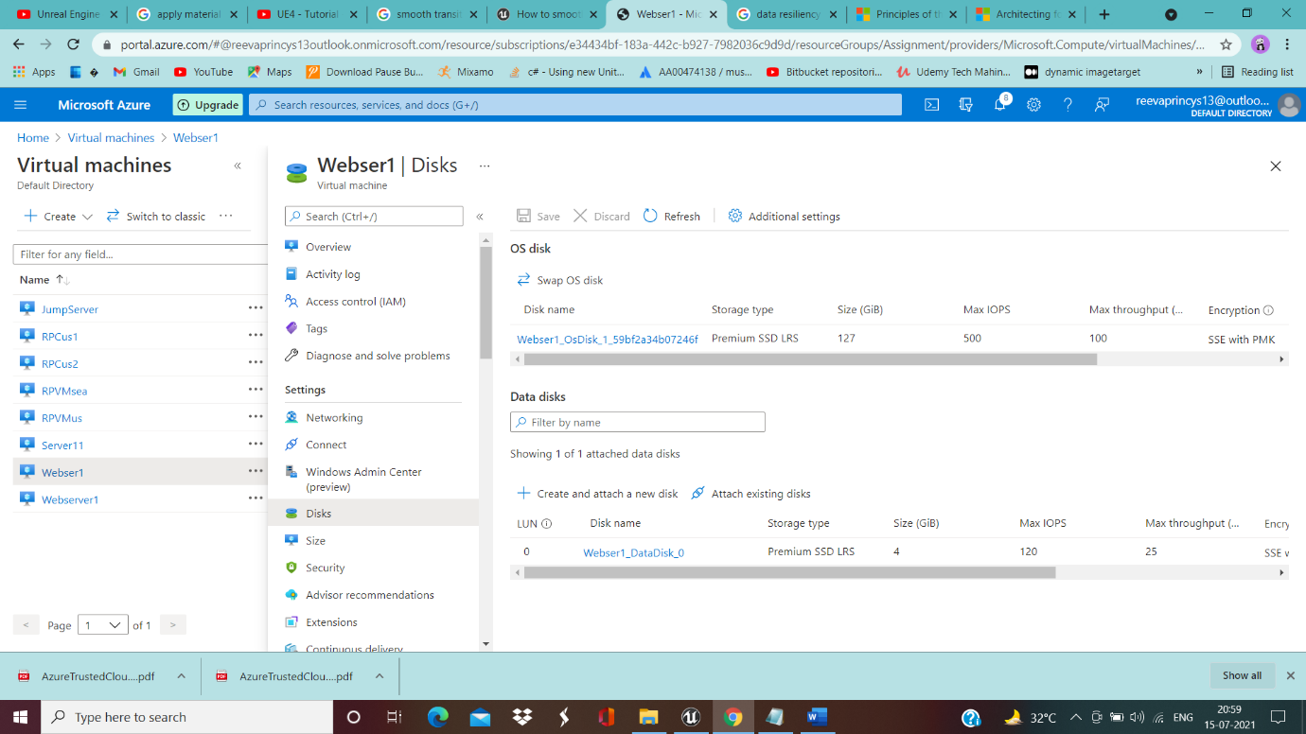

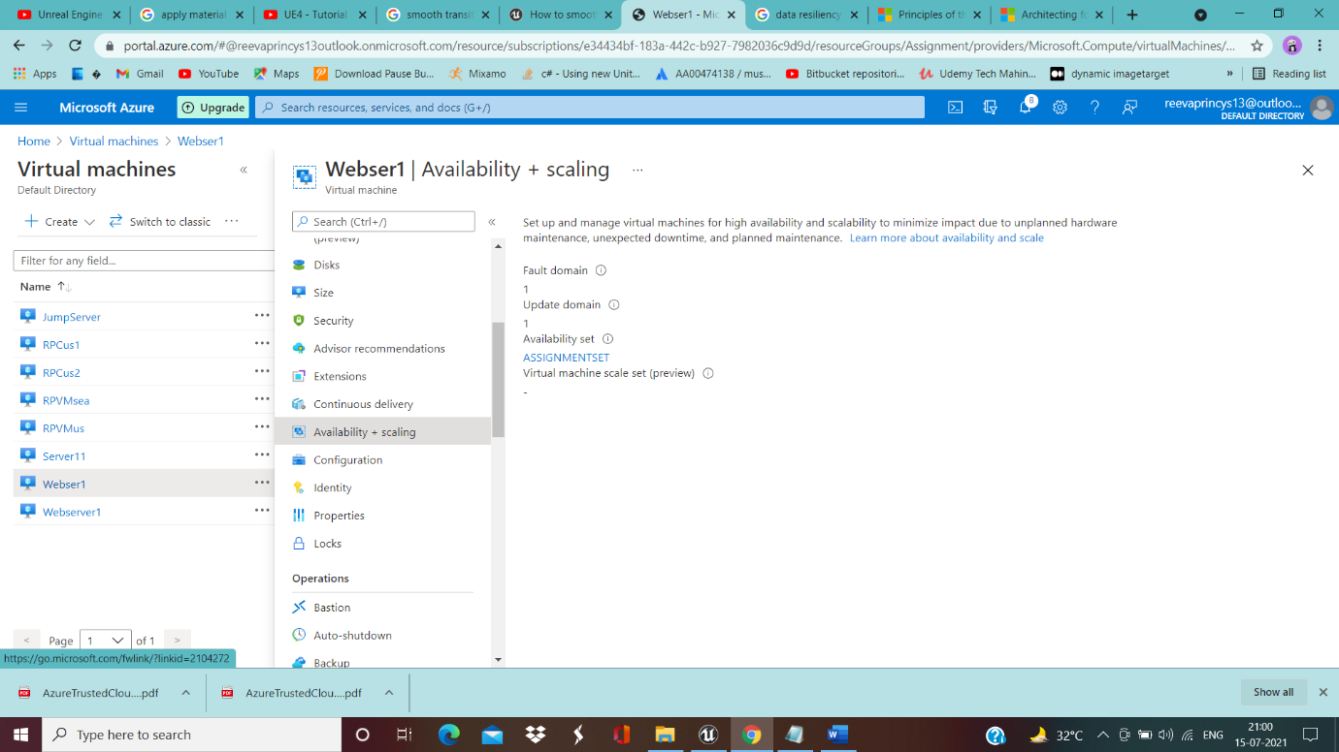

__________________________________________________________________________________

Two Webservers with Storage account………………..

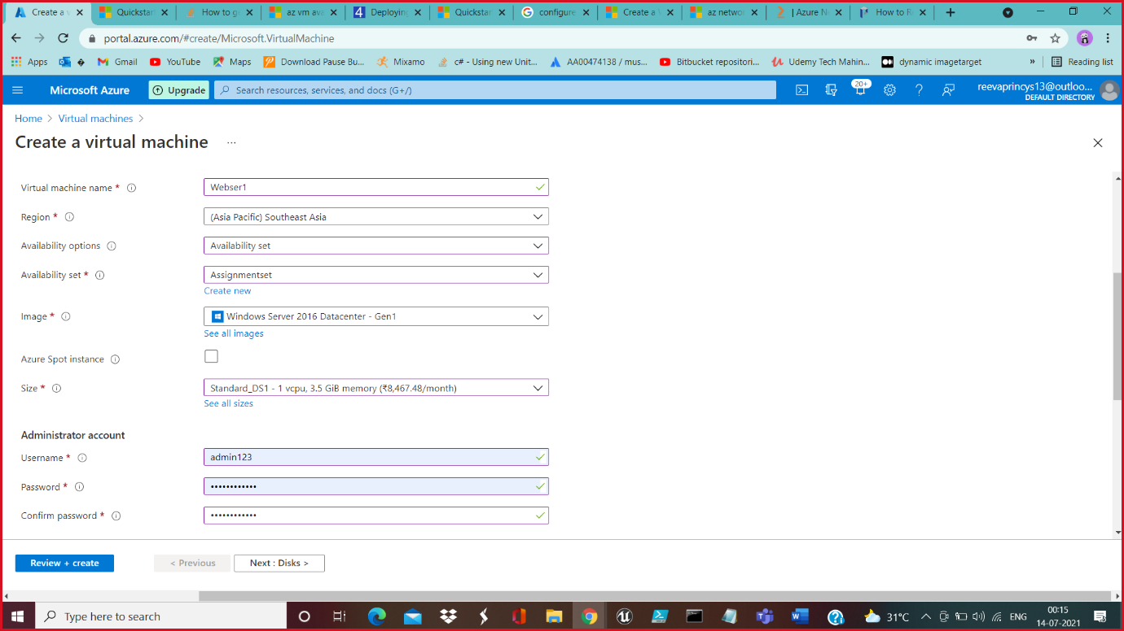

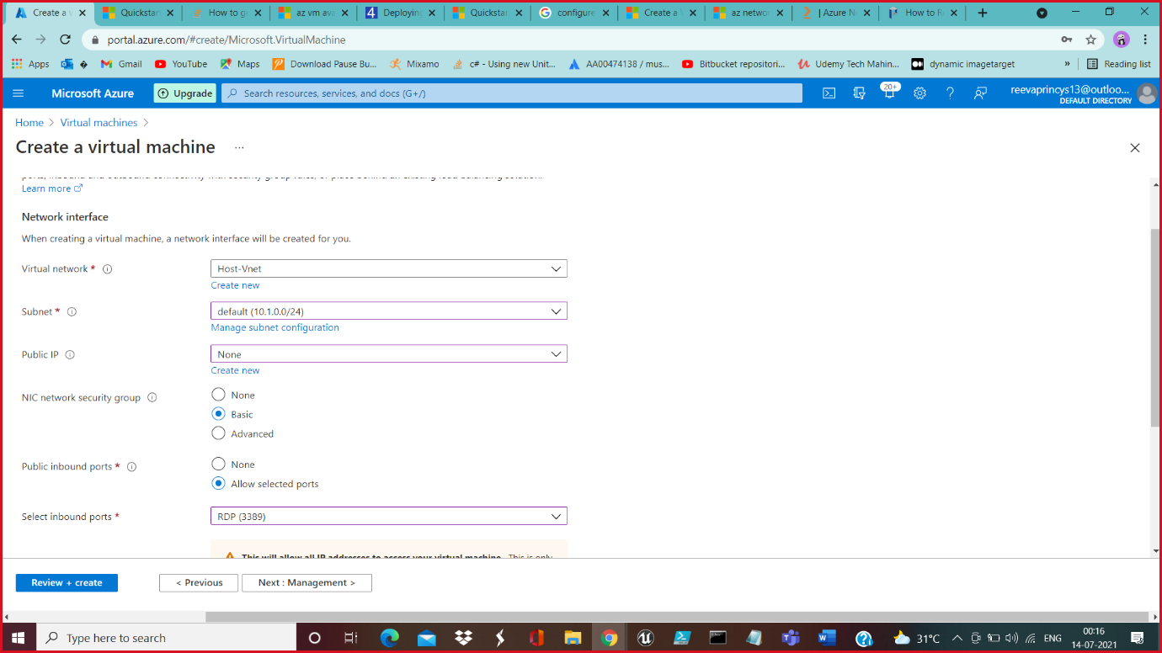

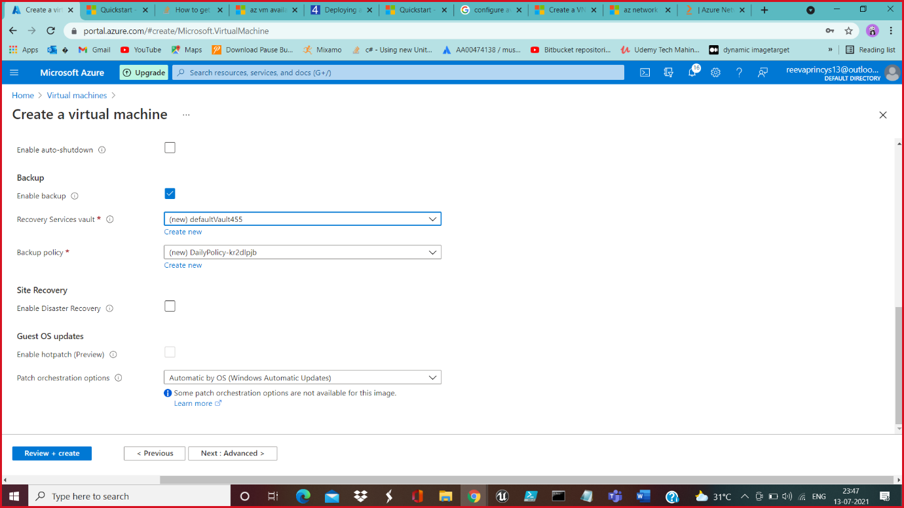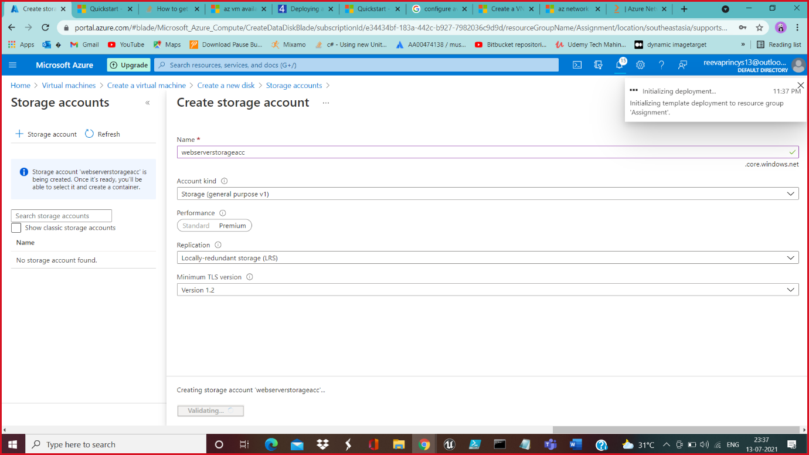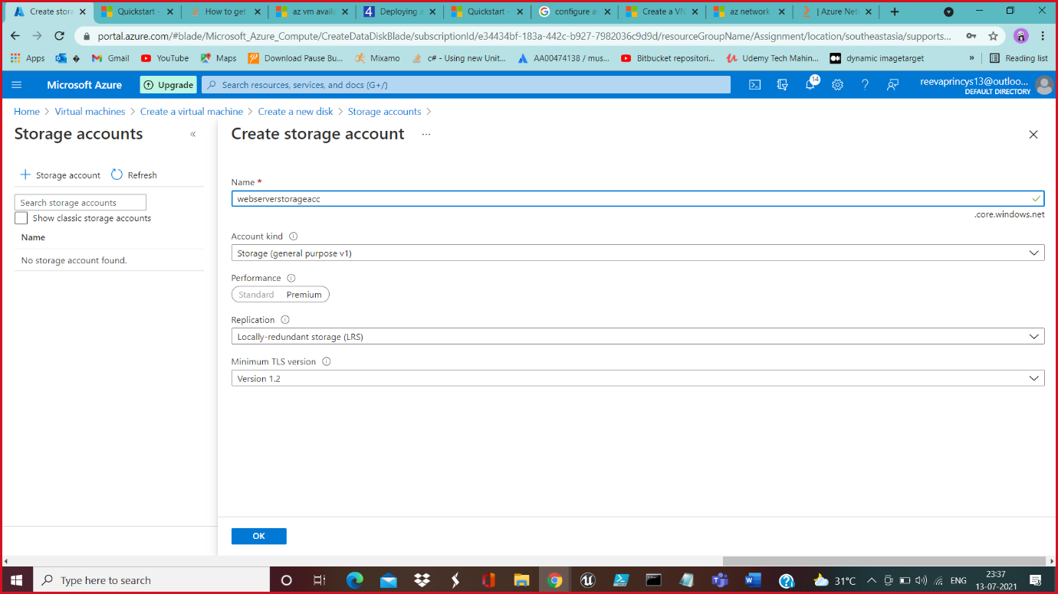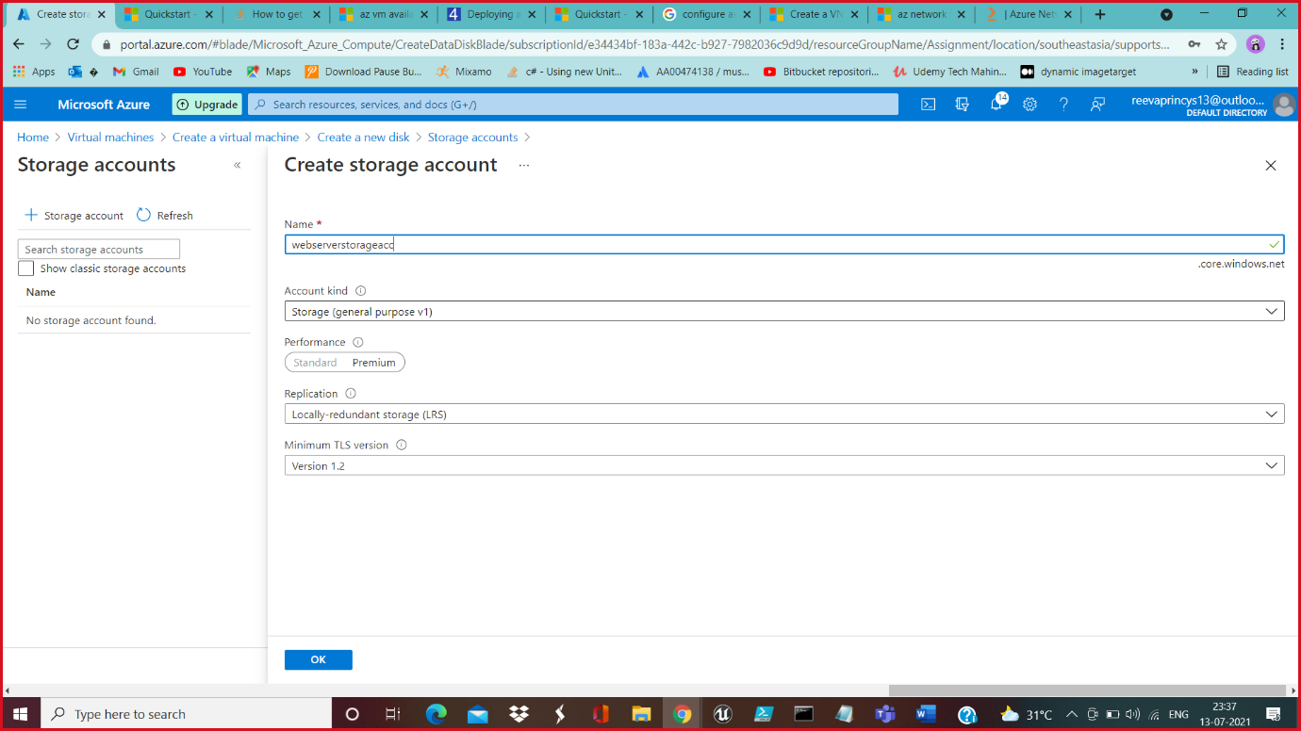

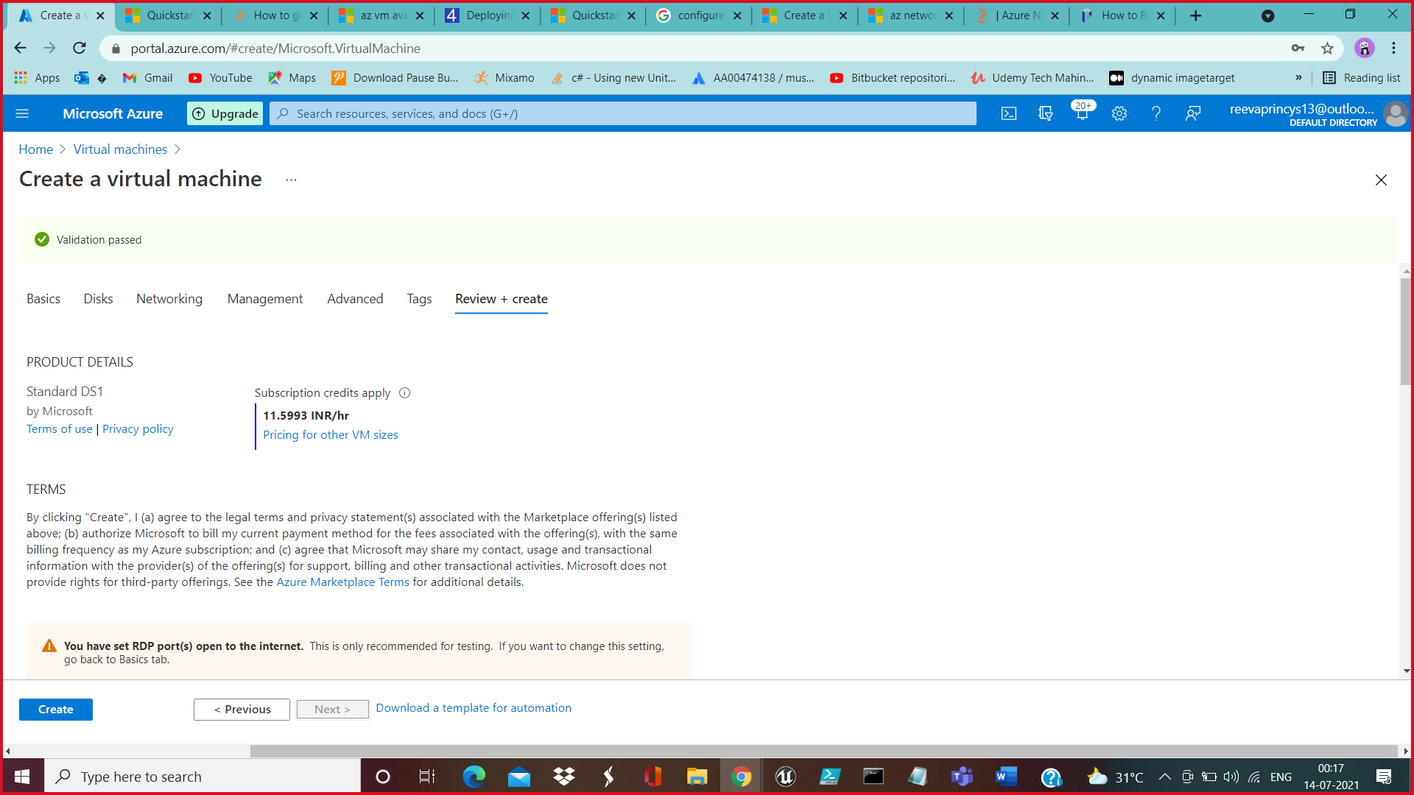

__________________________________________________________________________________

Installed VMs

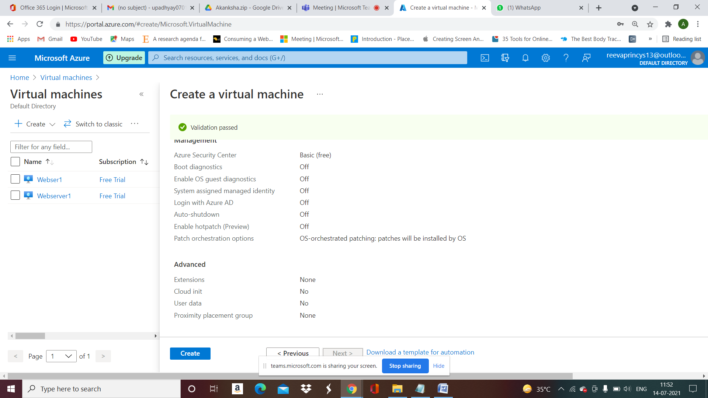

__________________________________________________________________________________

Jump Server and Webservers----------------------------------

__________________________________________________________________________________

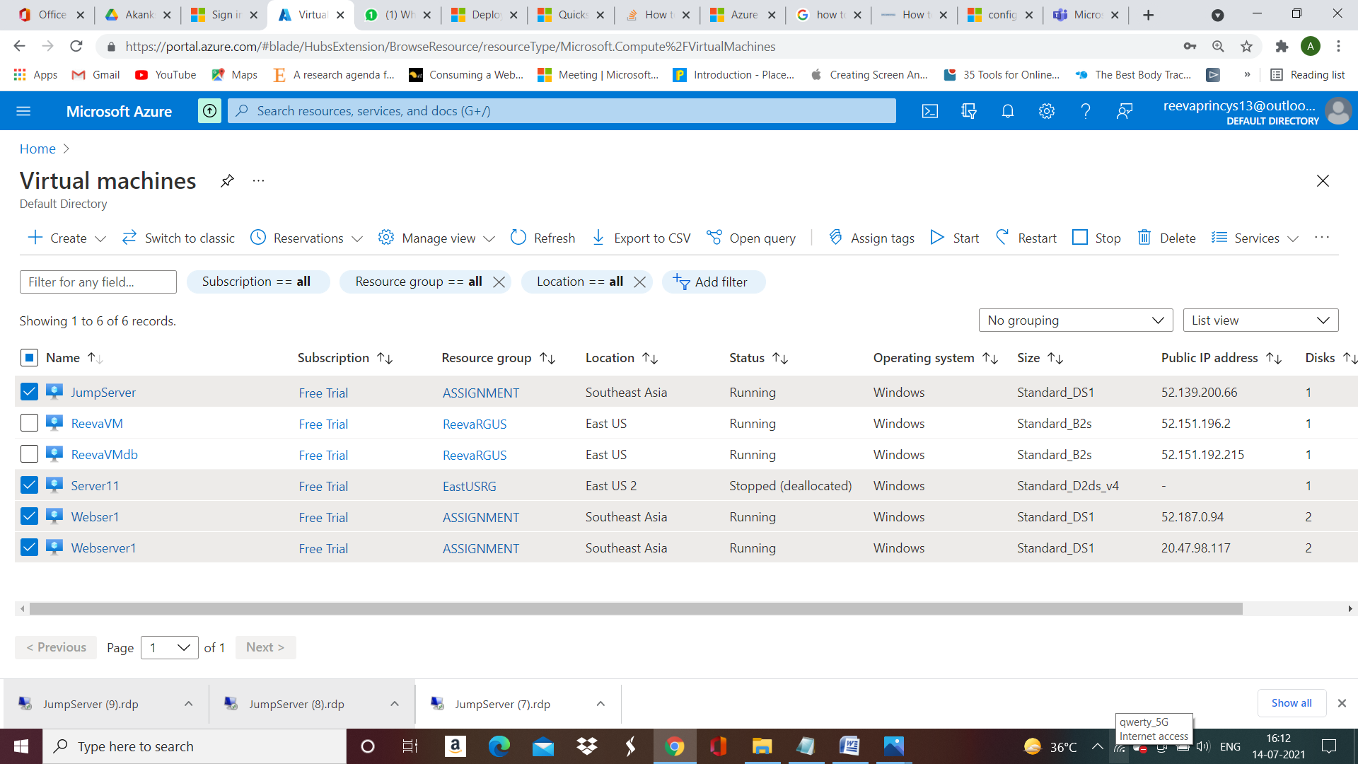

__________________________________________________________________________________

Webserver installing in both Webservers …………………..

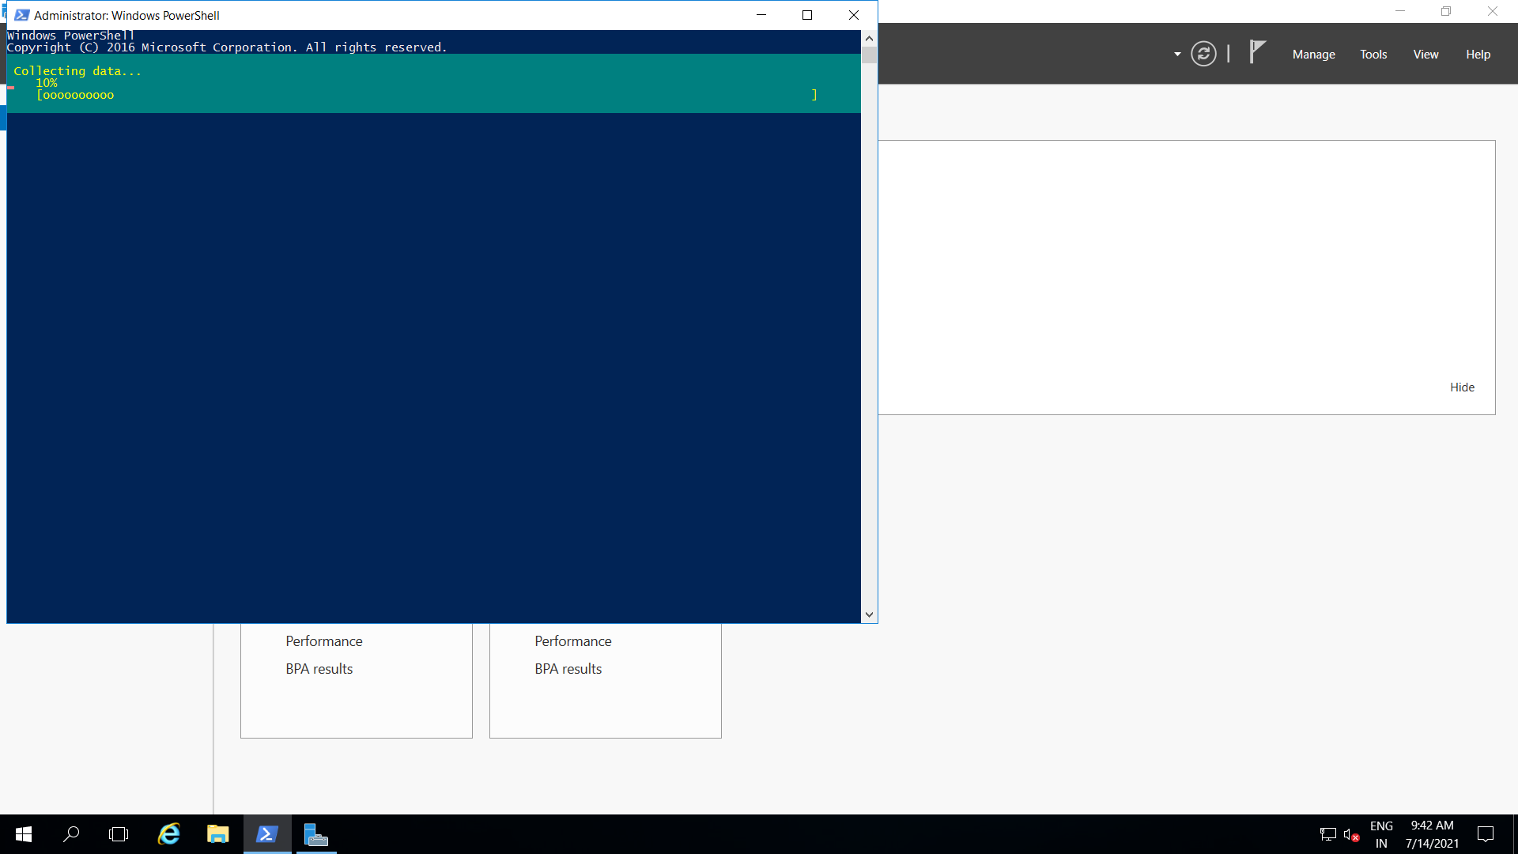

__________________________________________________________________________________

__________________________________________________________________________________

Load Balancer ,Load Balancing Rule ,health-probe -------------------------

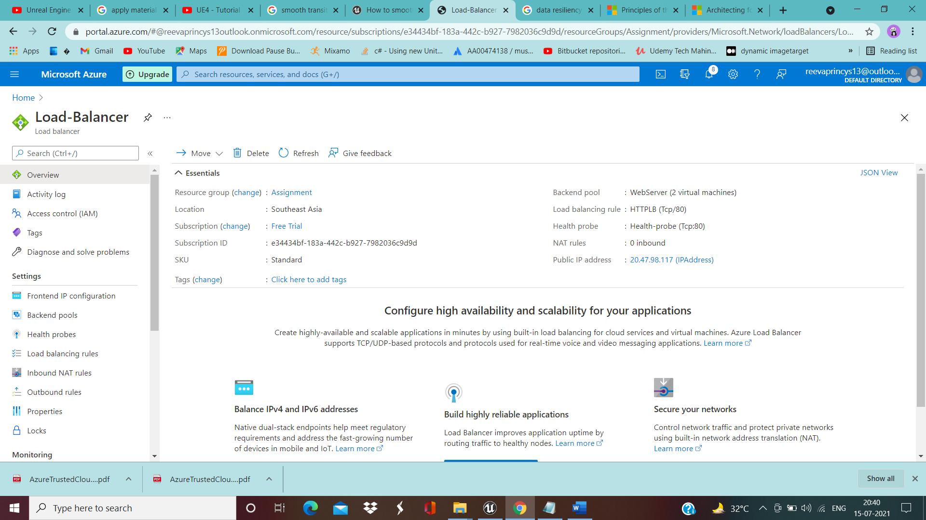

Adding IP Configuration ----------------------

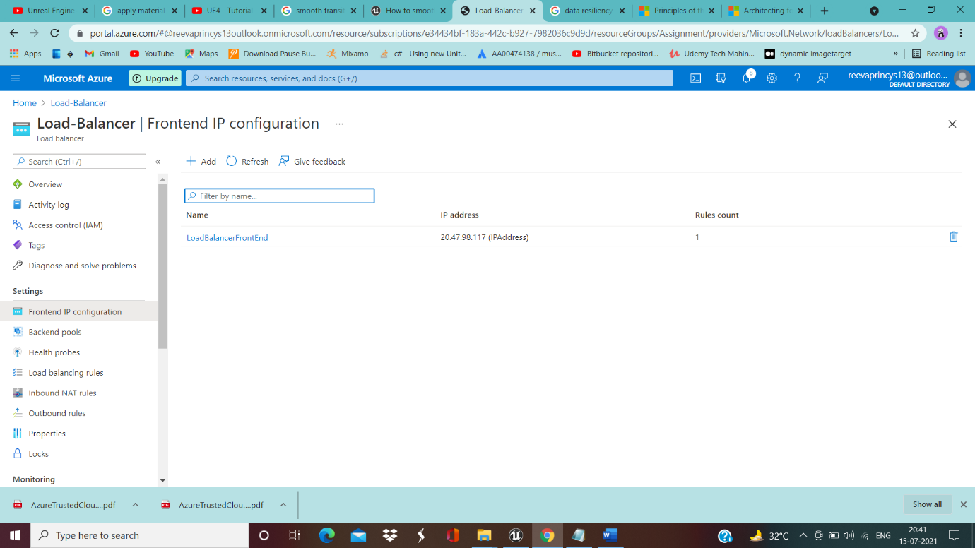

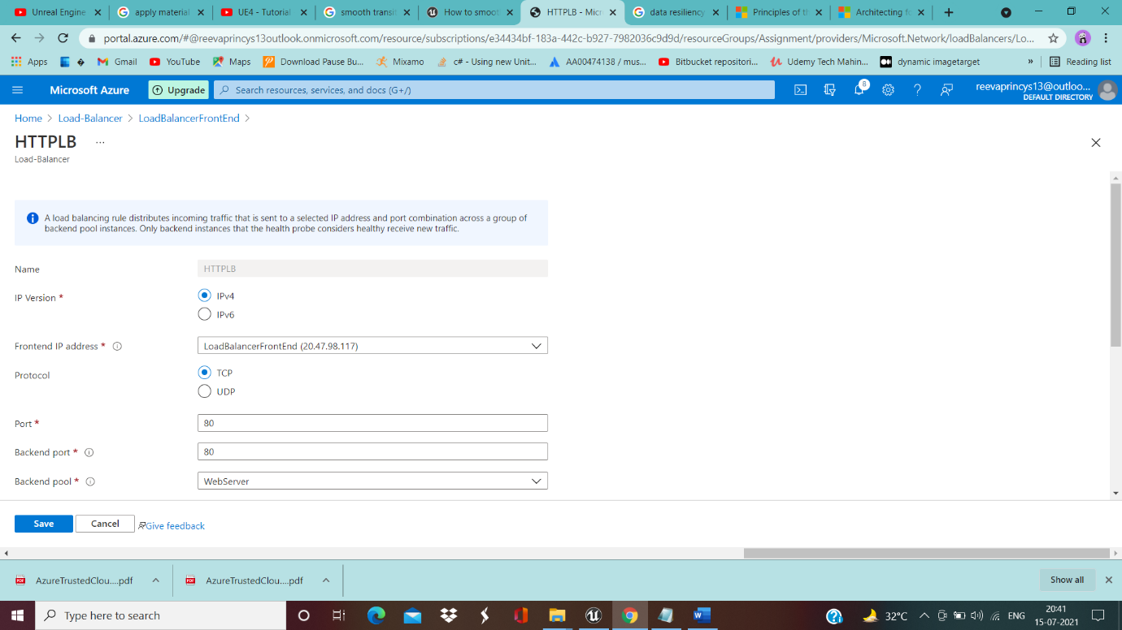

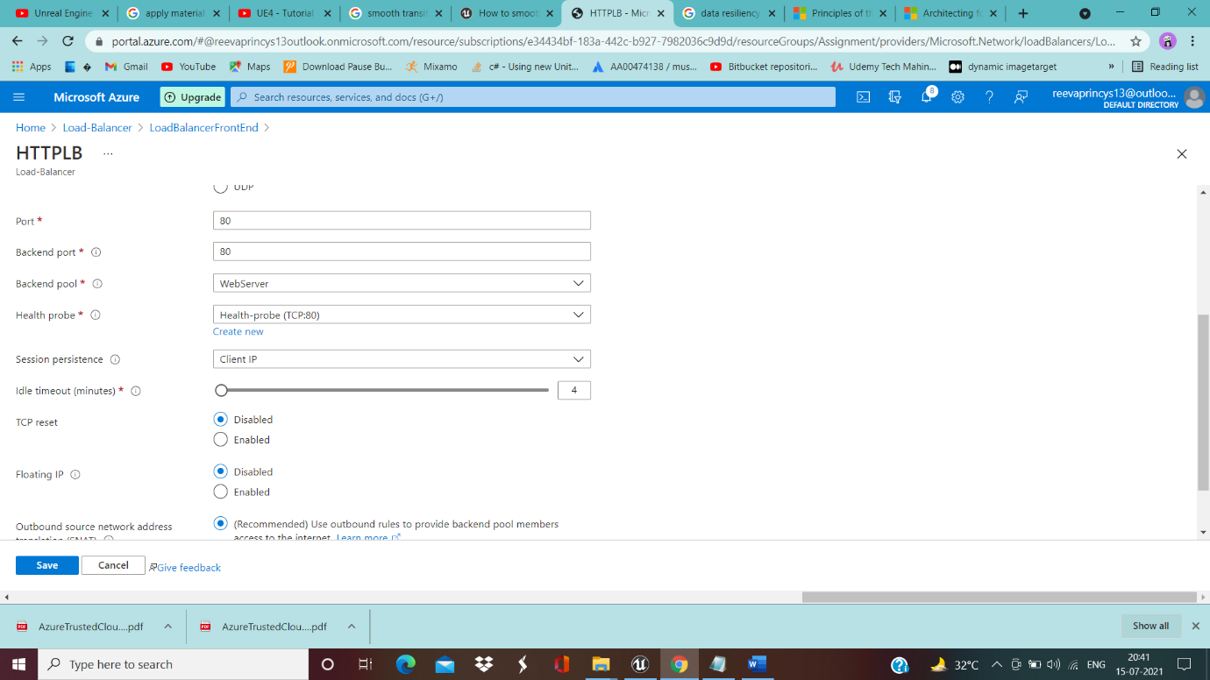

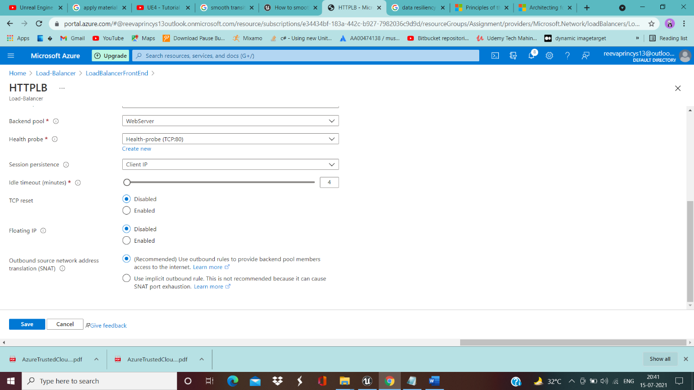

Backend Pool-------------------

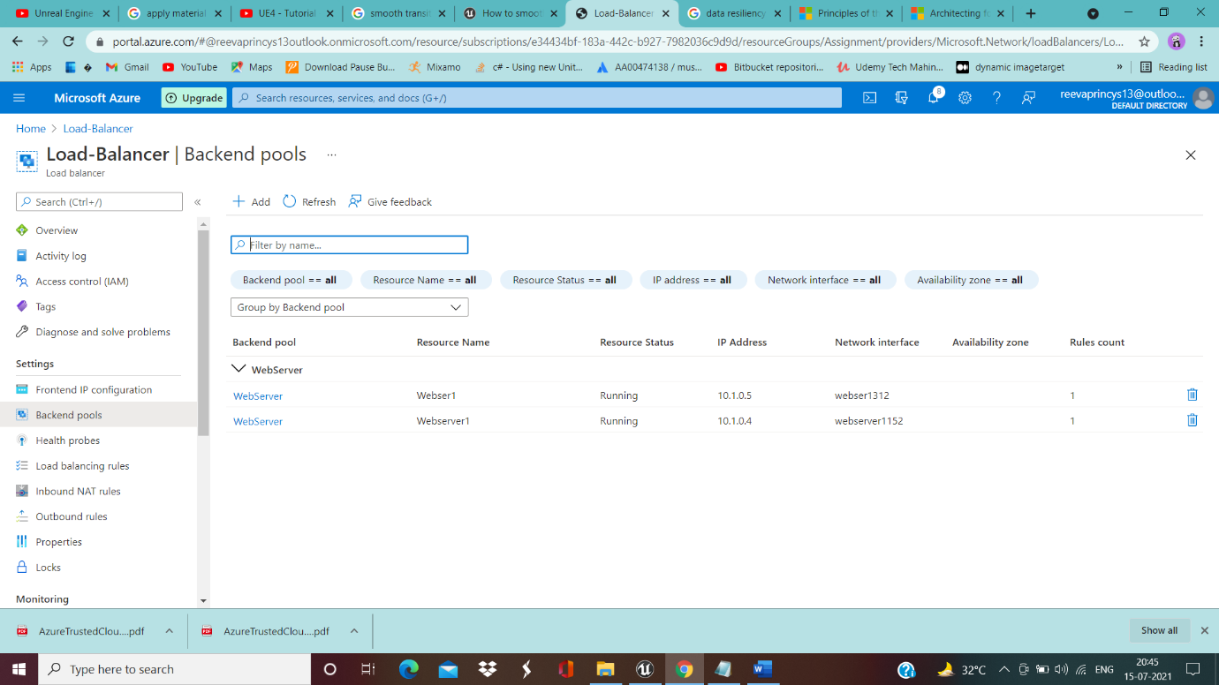

Health-Probe----------------

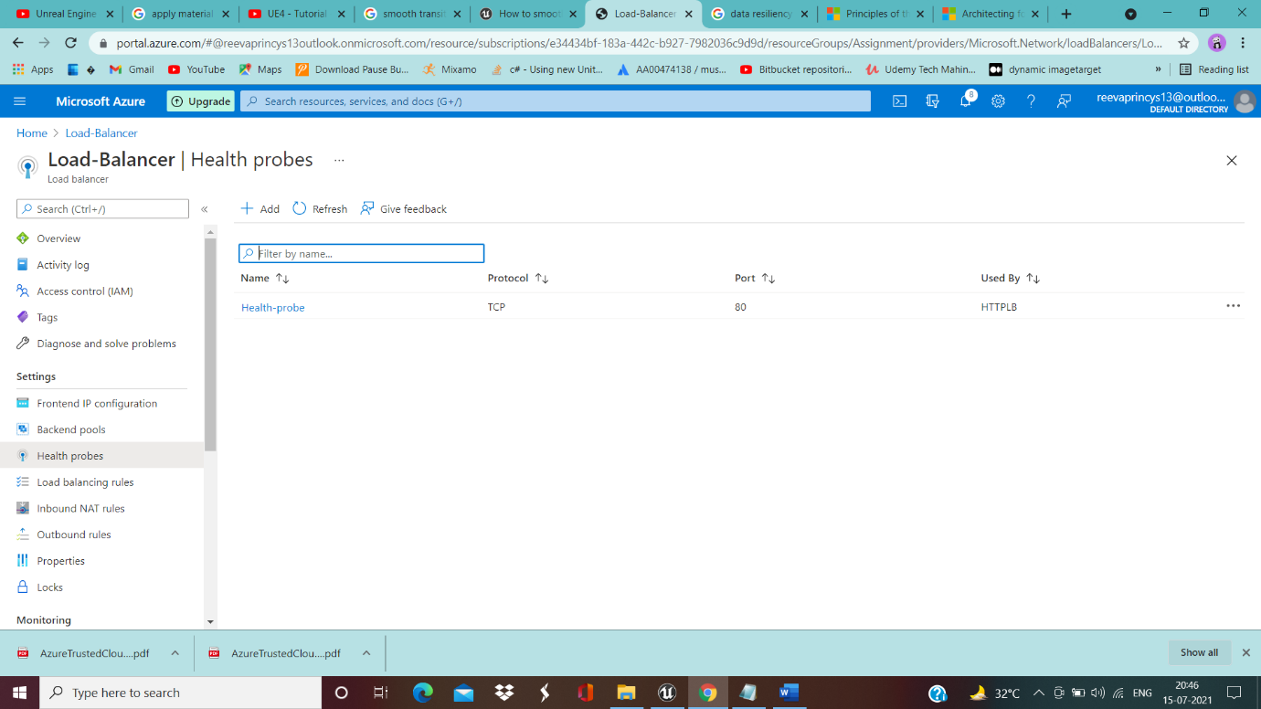

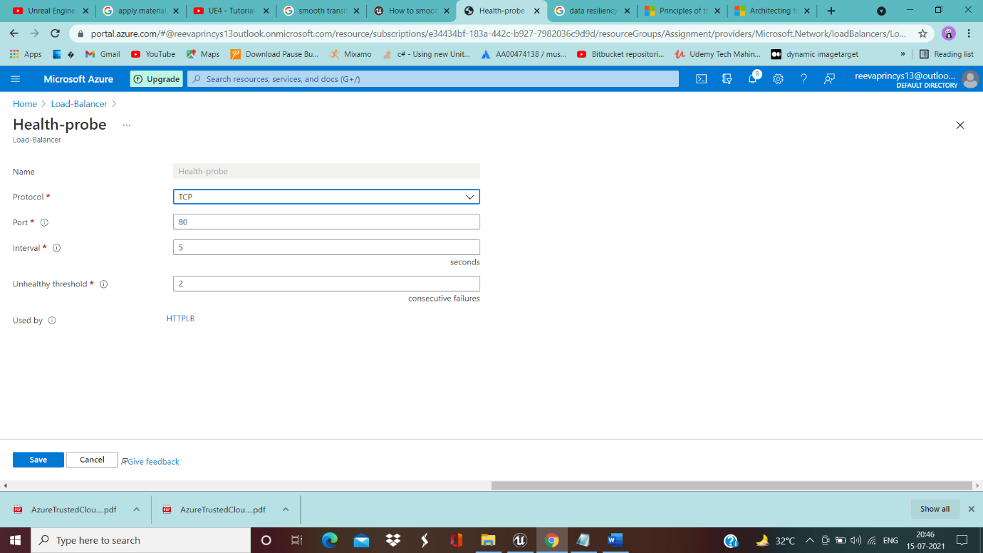

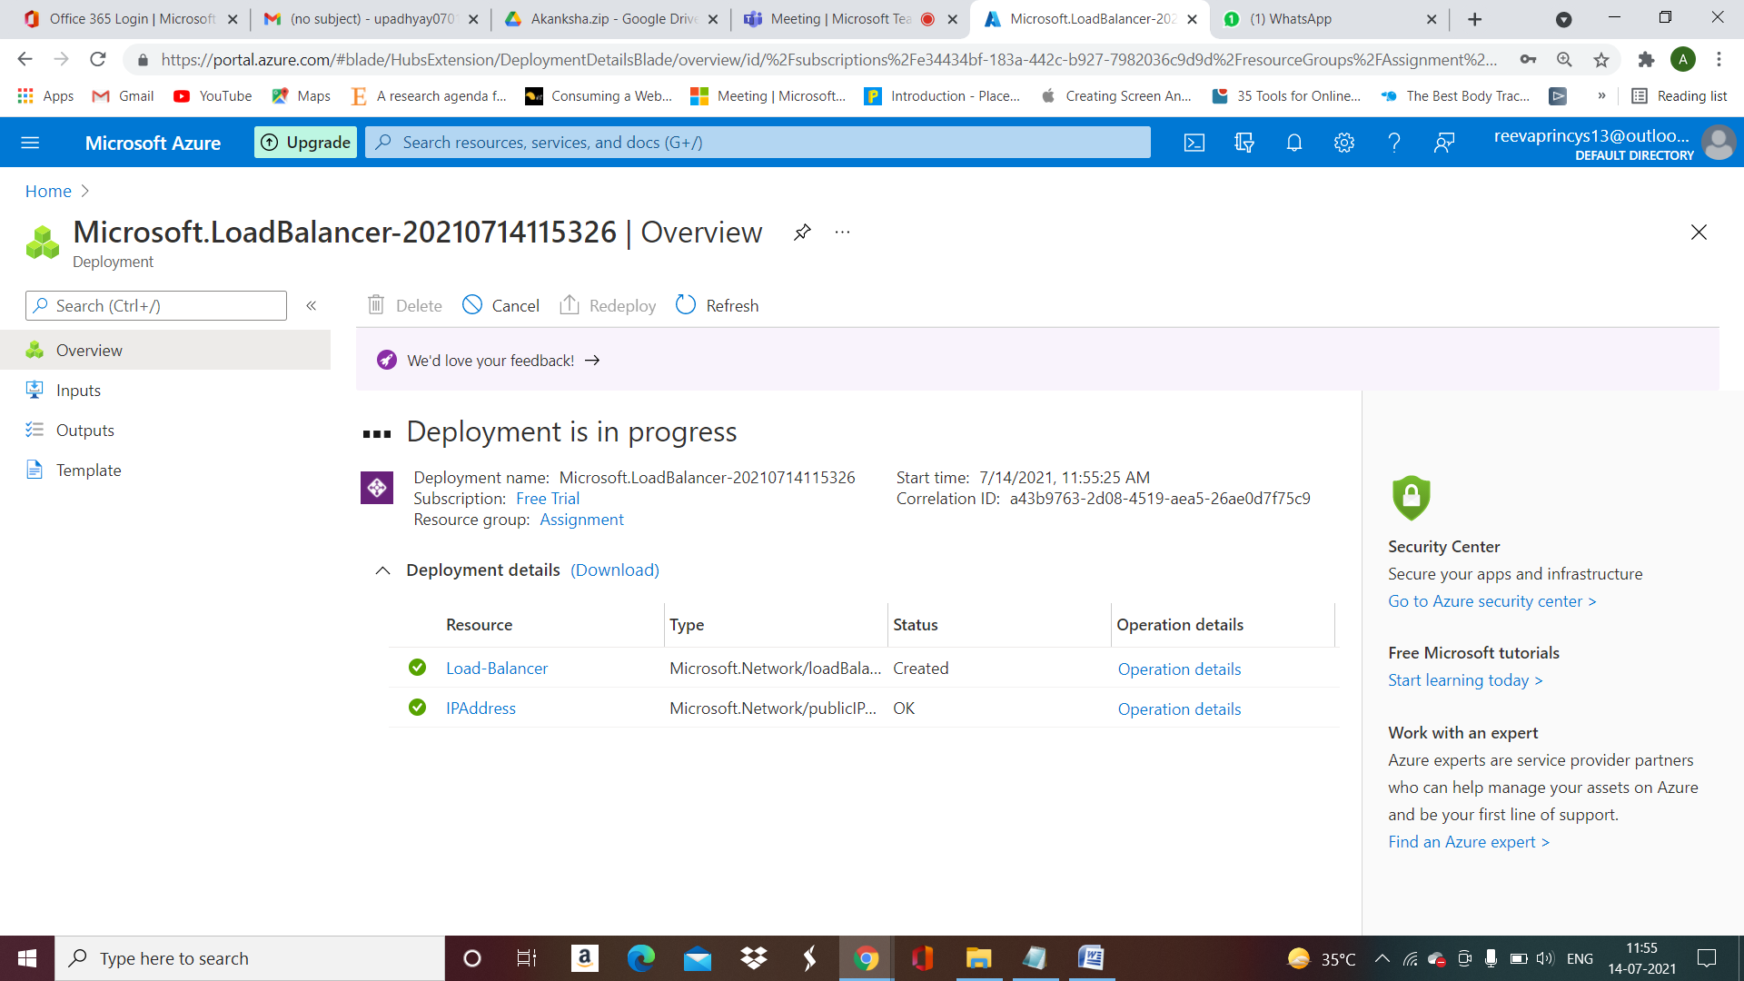

__________________________________________________________________________________

Alerts for 80% CPU utilization………………….

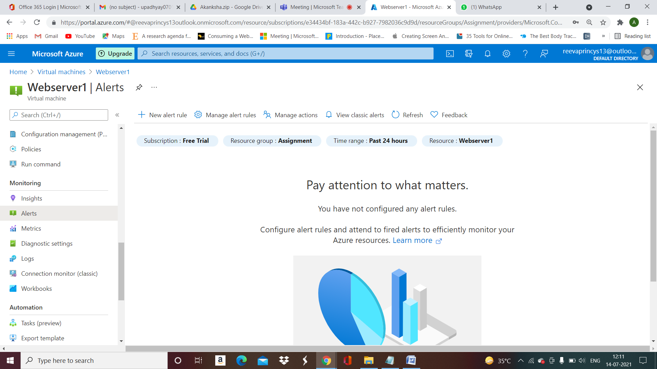

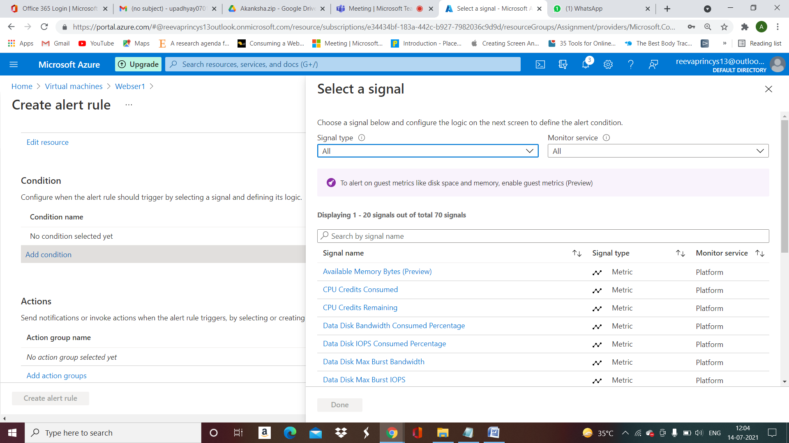

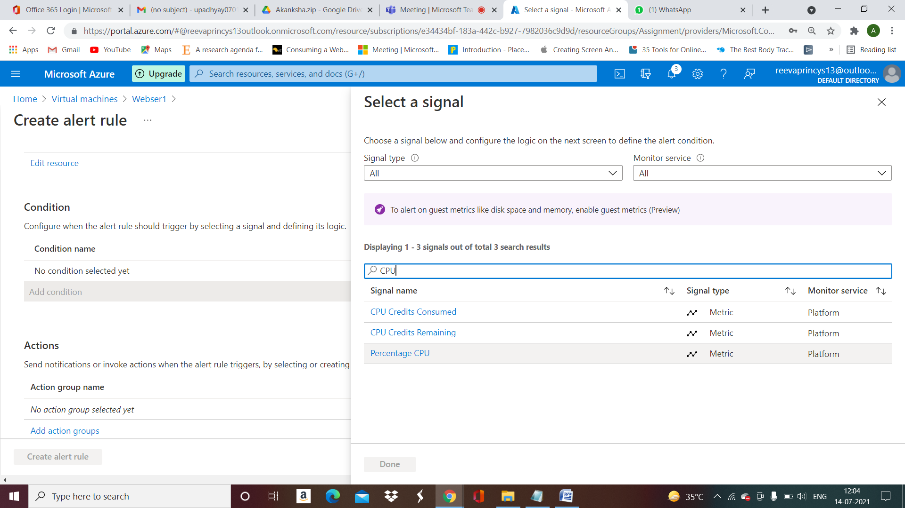

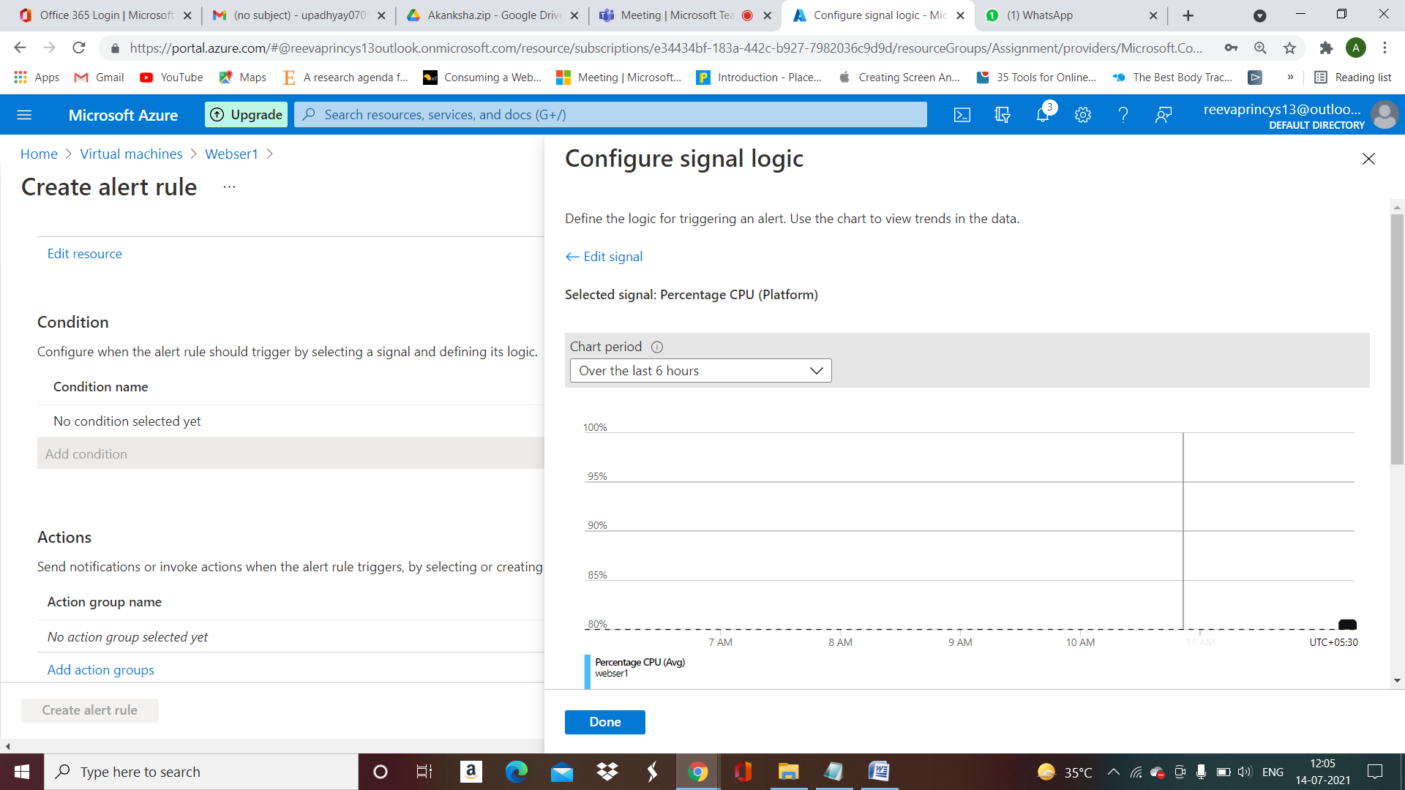

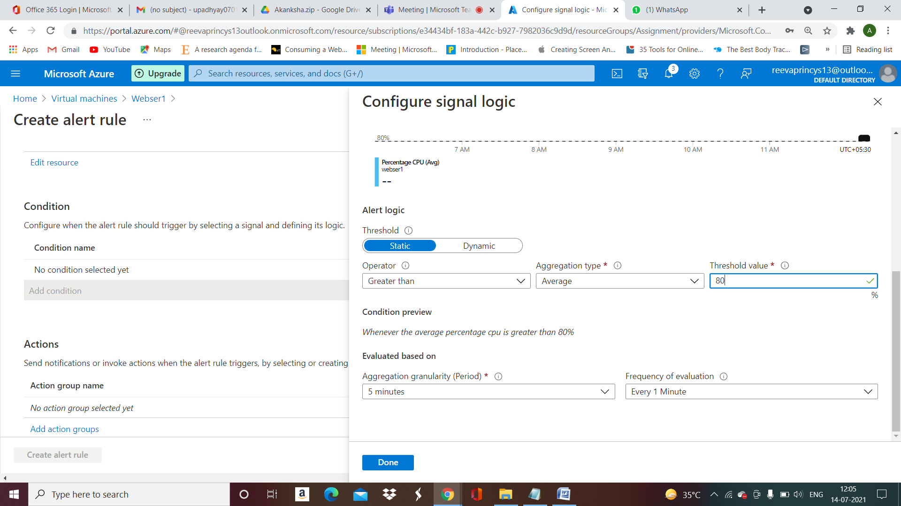

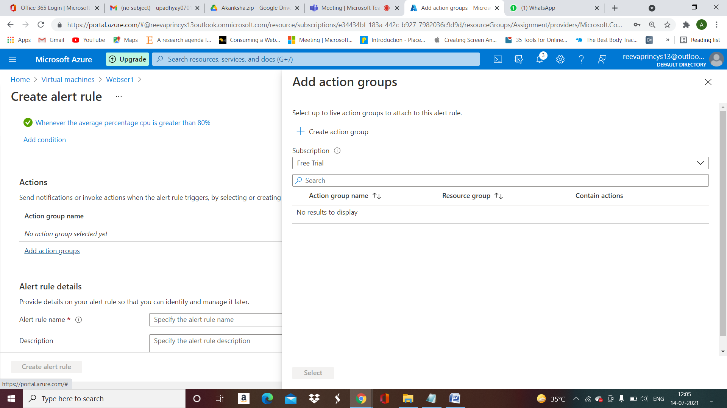

Create Action group ---------------------------

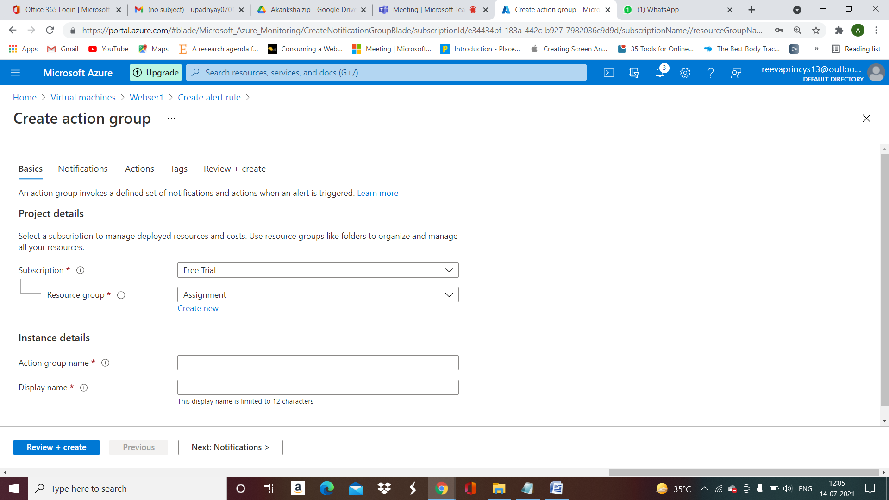

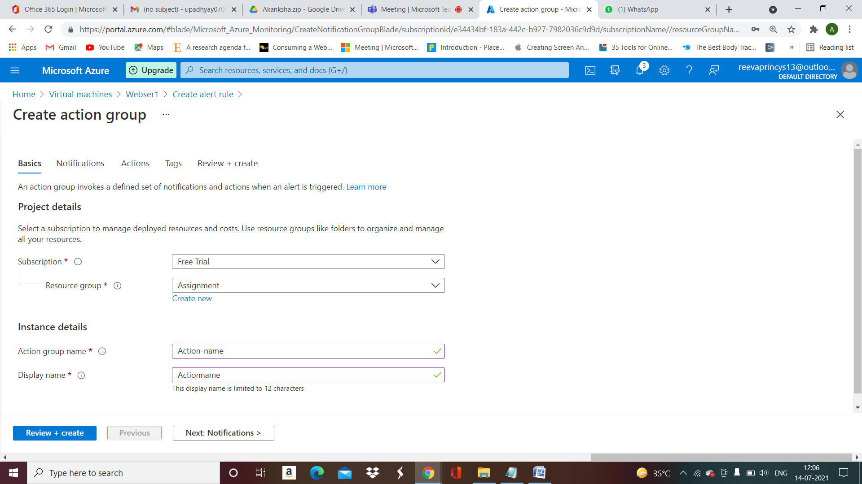

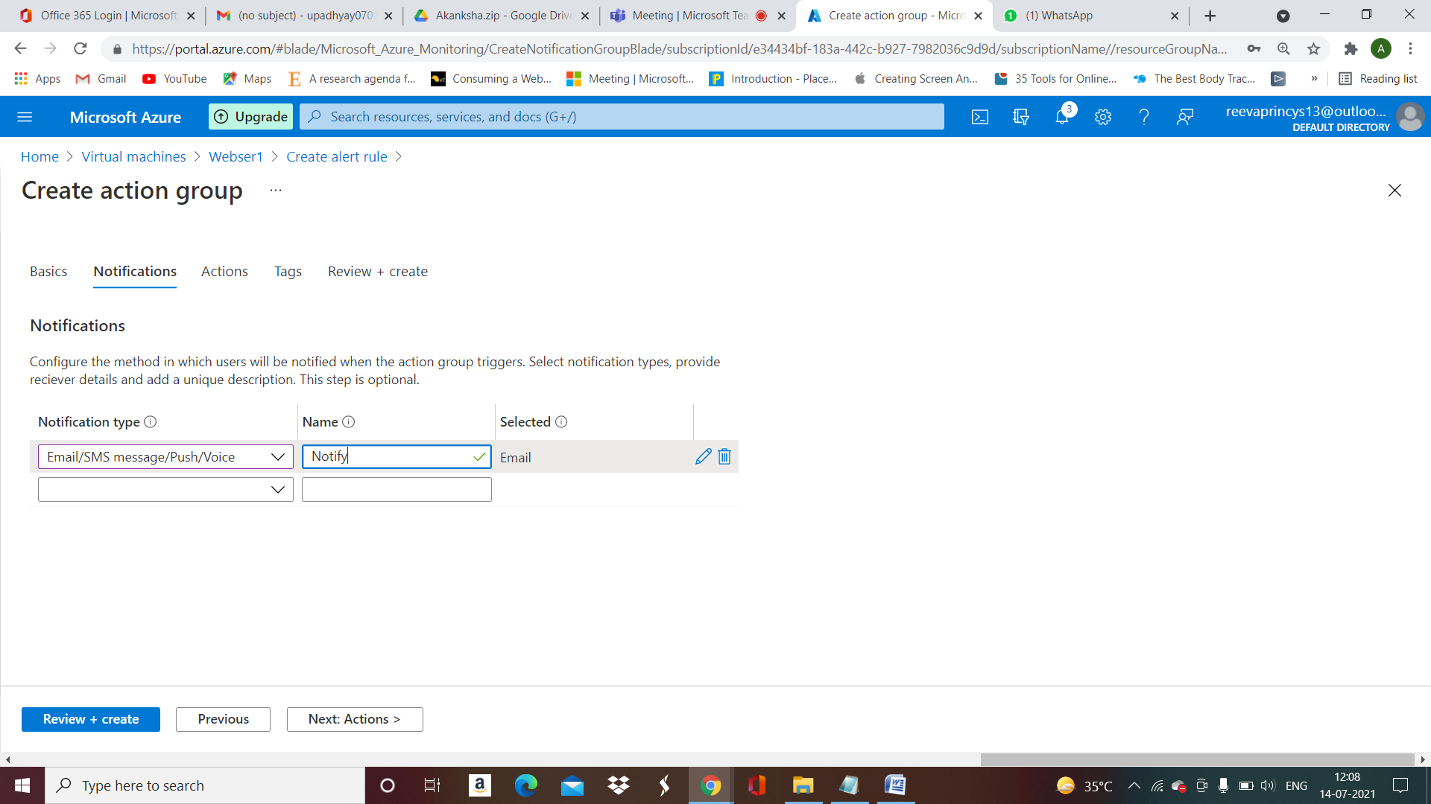

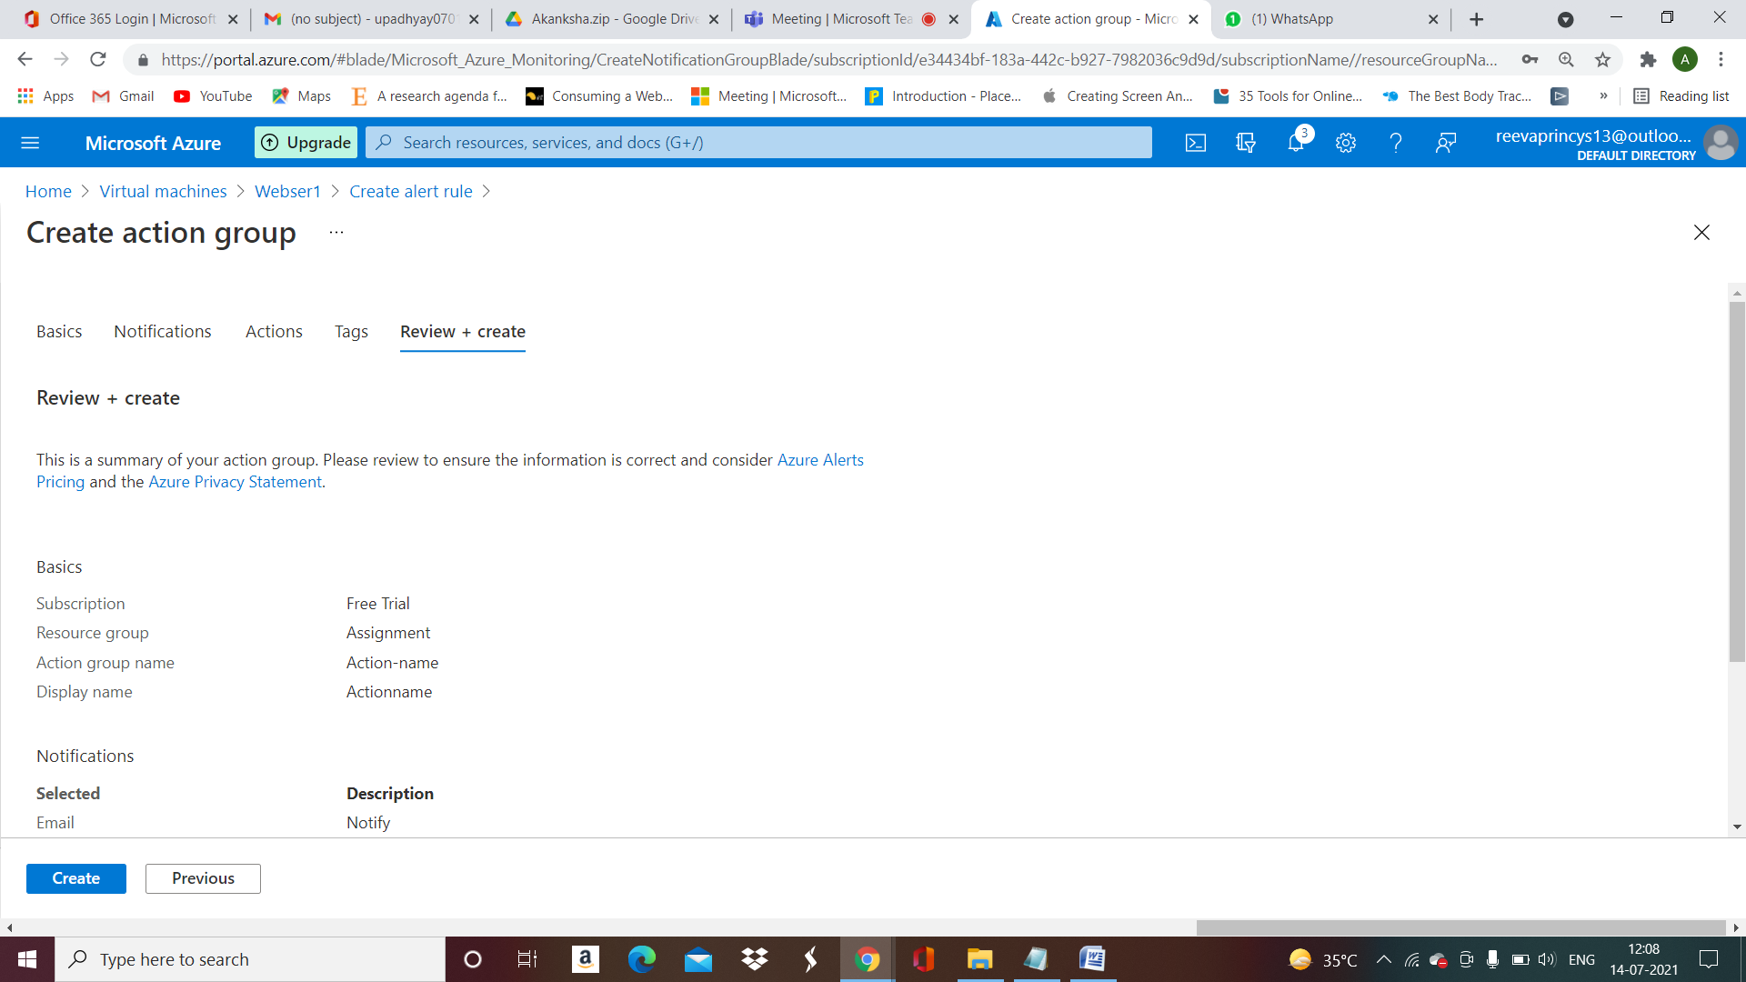

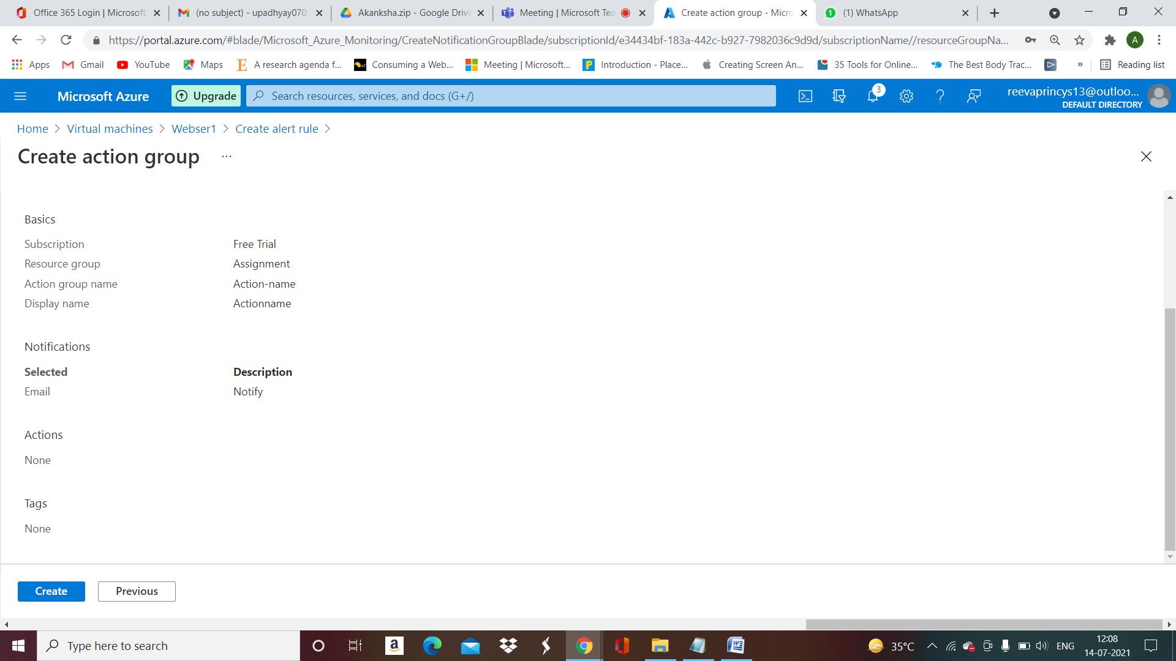

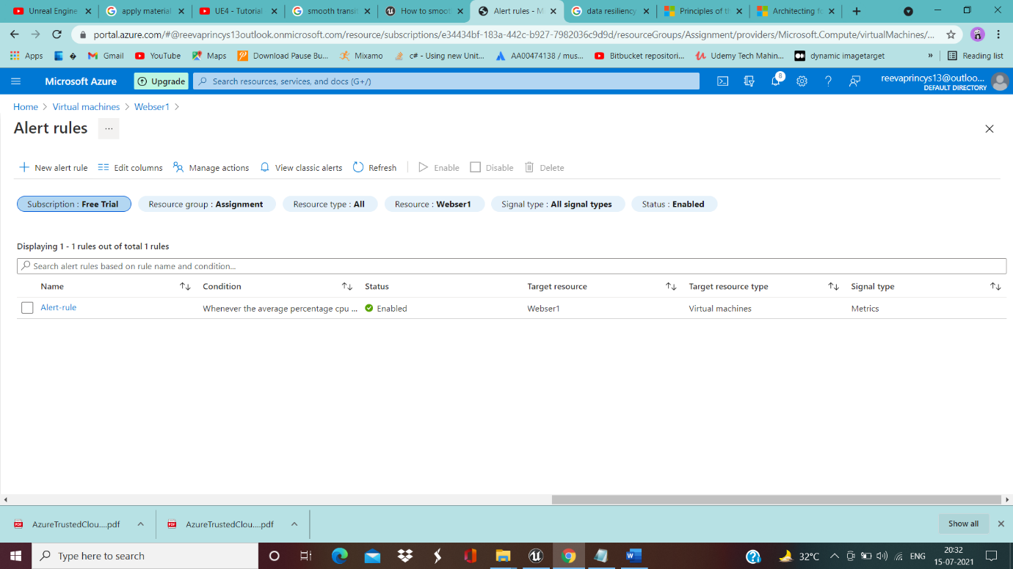

__________________________________________________________________________________

Backup for VMs…………………

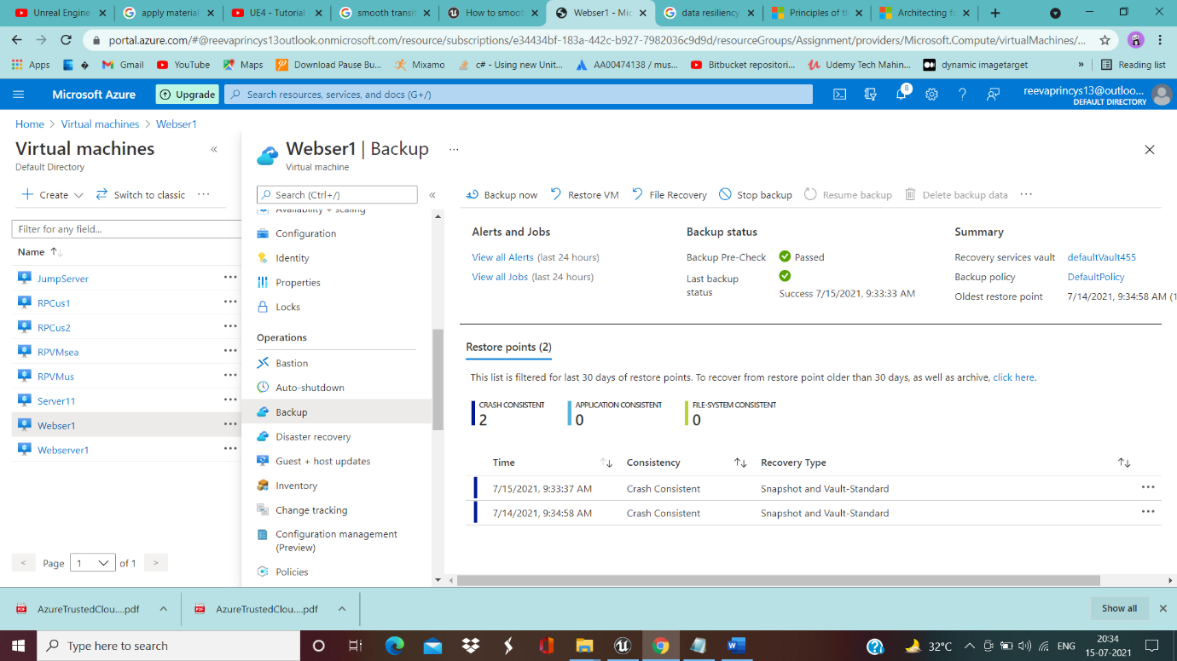

__________________________________________________________________________________

Working of WebServers through public IP Addresses of Webservers……….…….

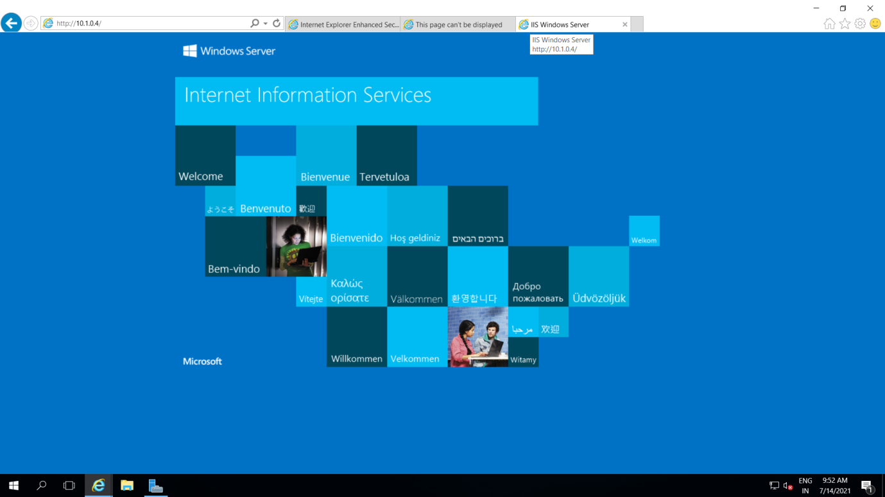

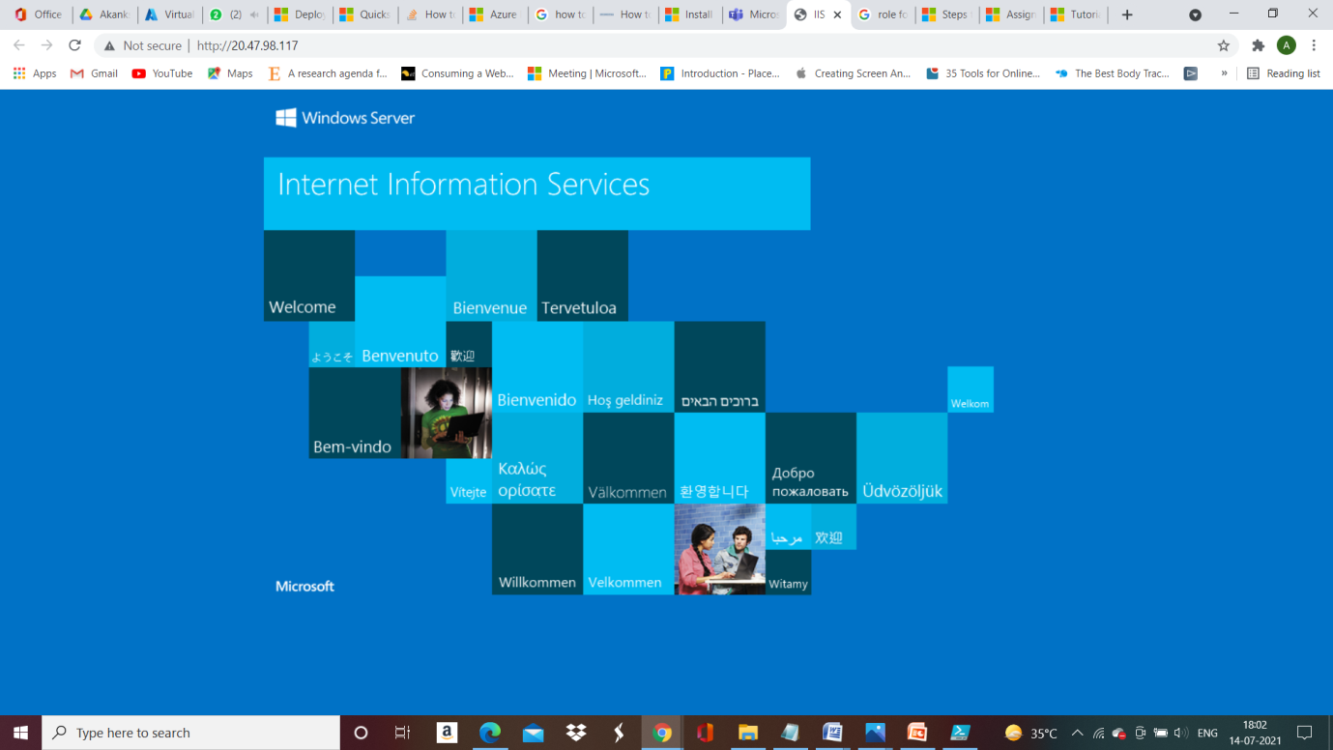

__________________________________________________________________________________

**EastUS**

Eastus-vnet(East US Vnet)------------------------------------------

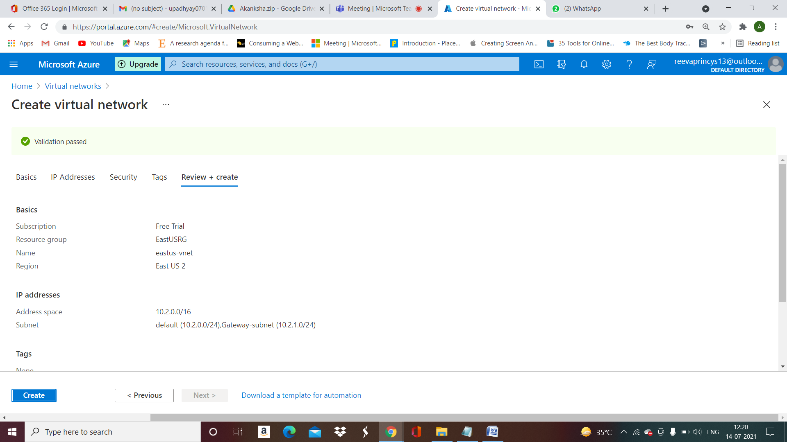

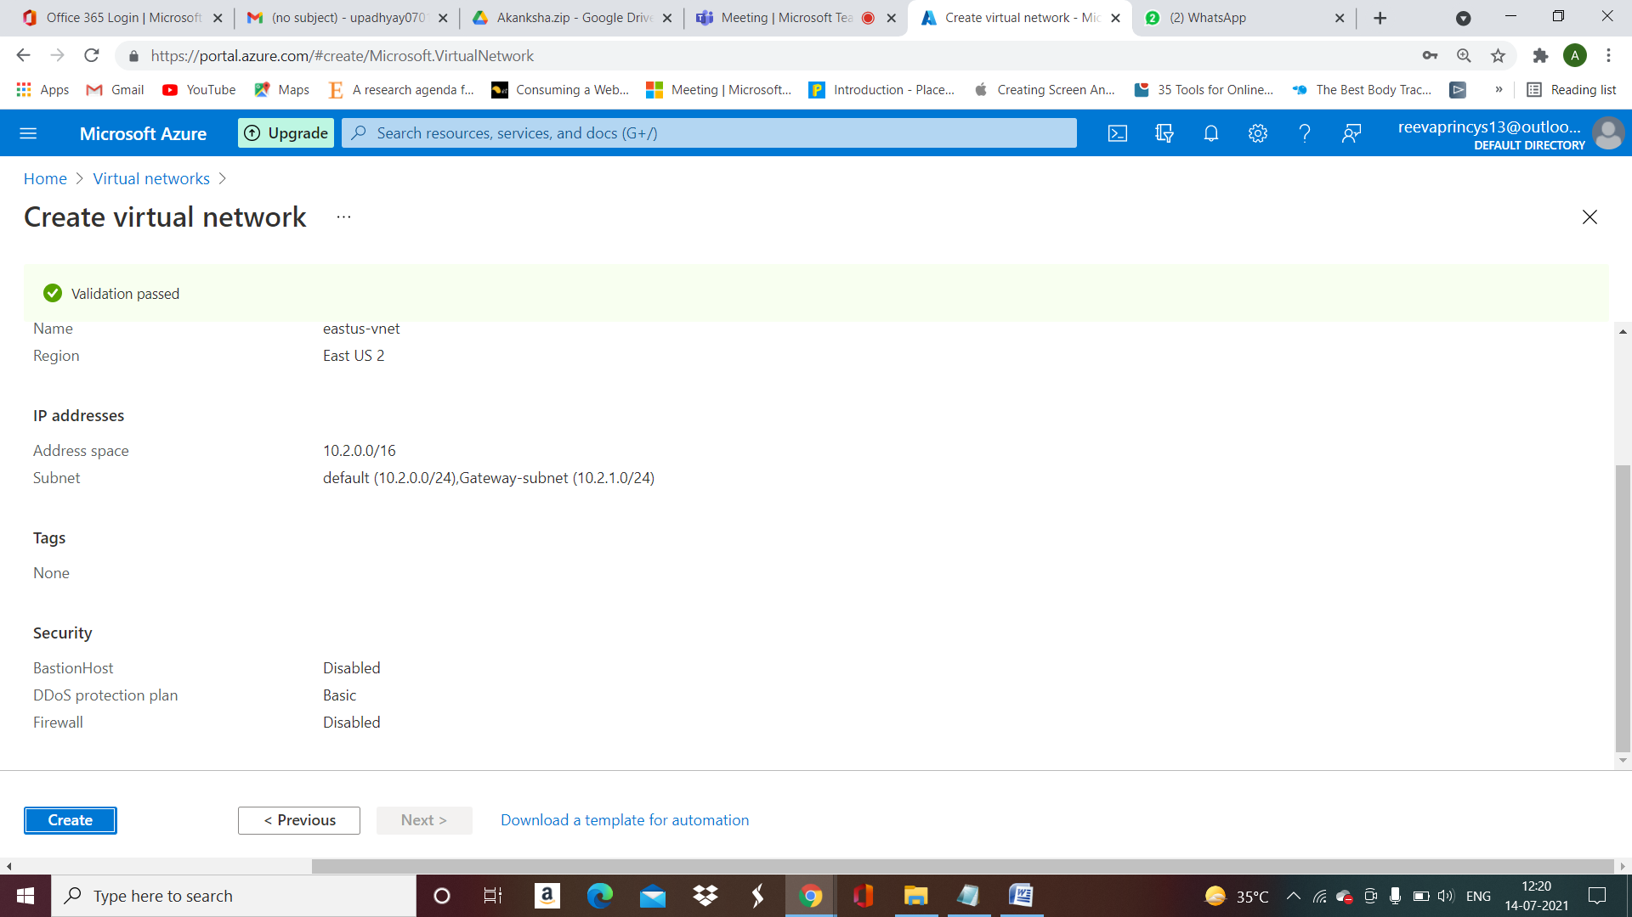

__________________________________________________________________________________

Server11 -----------------------------------

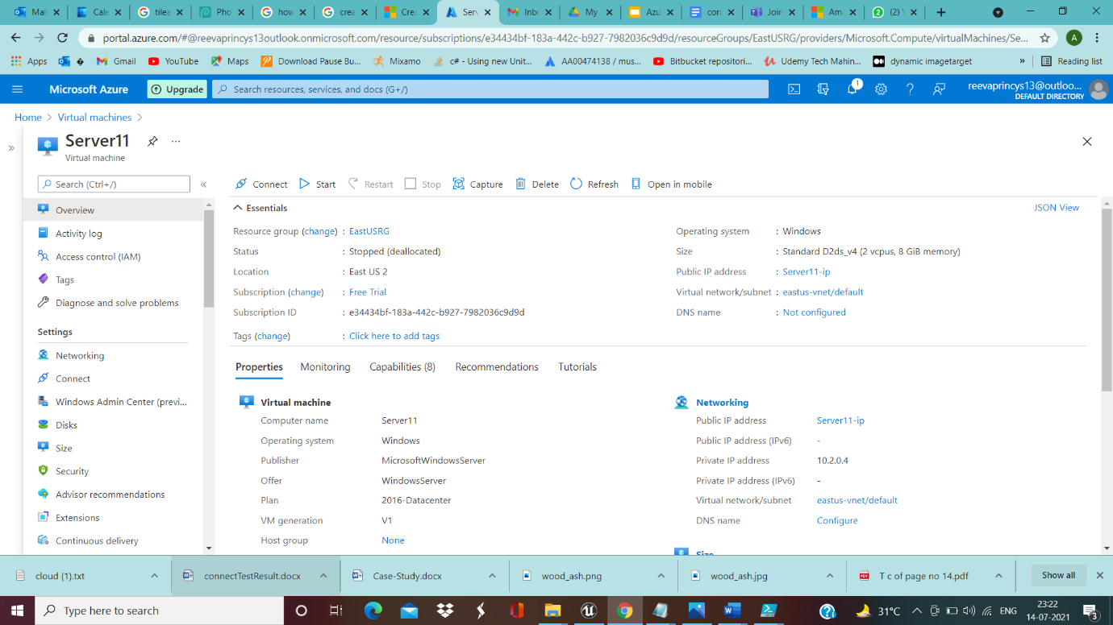

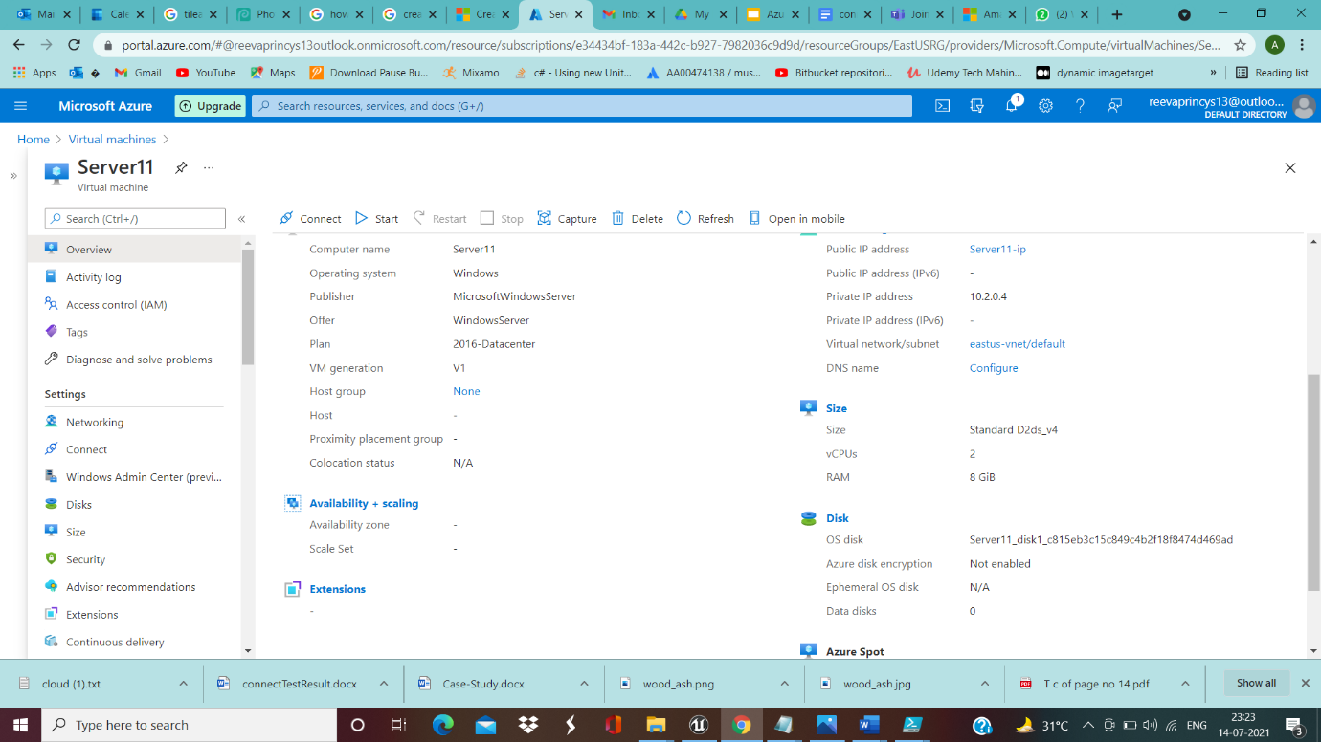

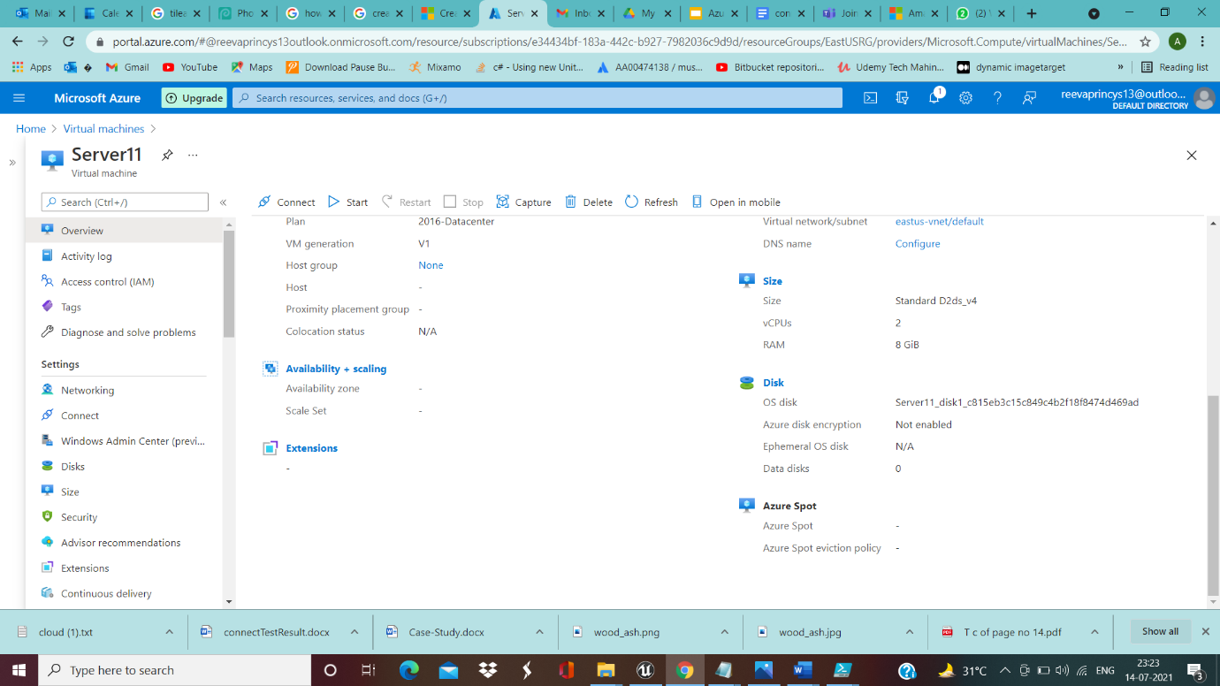

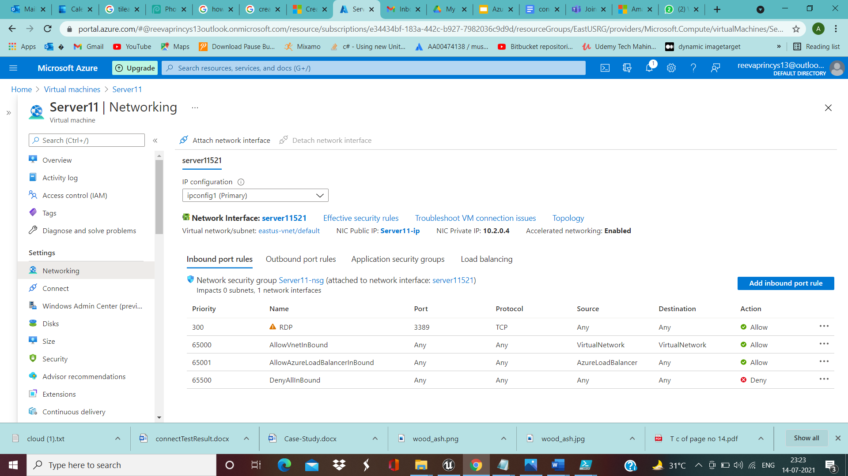

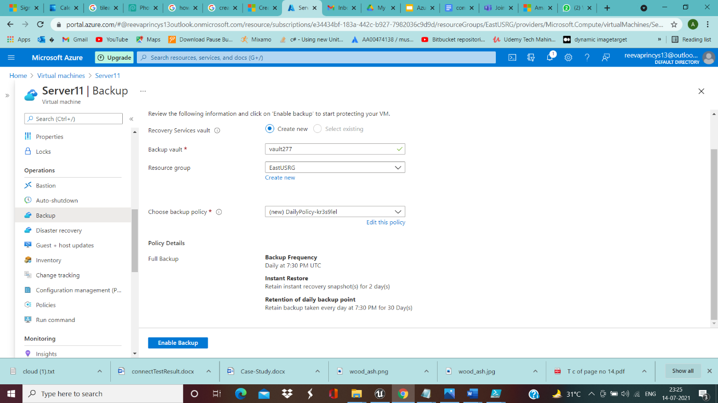

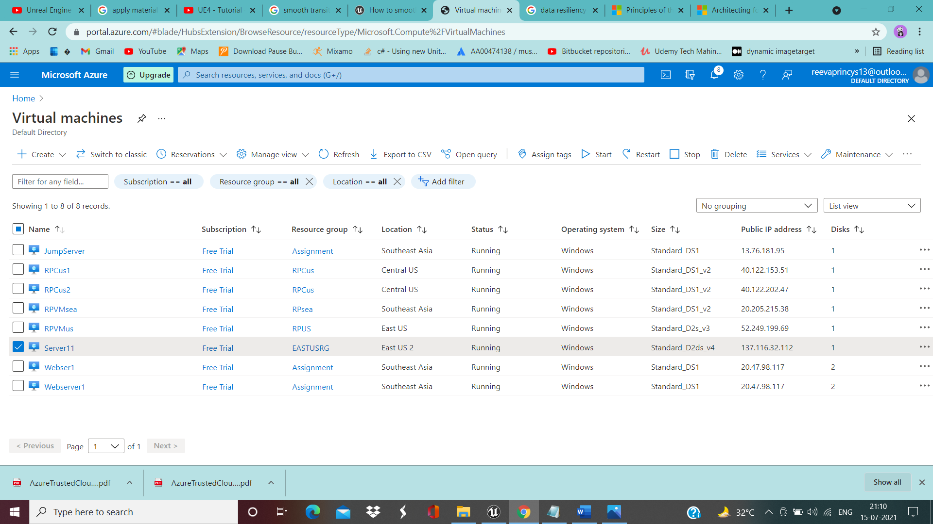

__________________________________________________________________________________

Vnet-Peering--------------------------------------

Eastus-vnet(eastus-region)----------------------

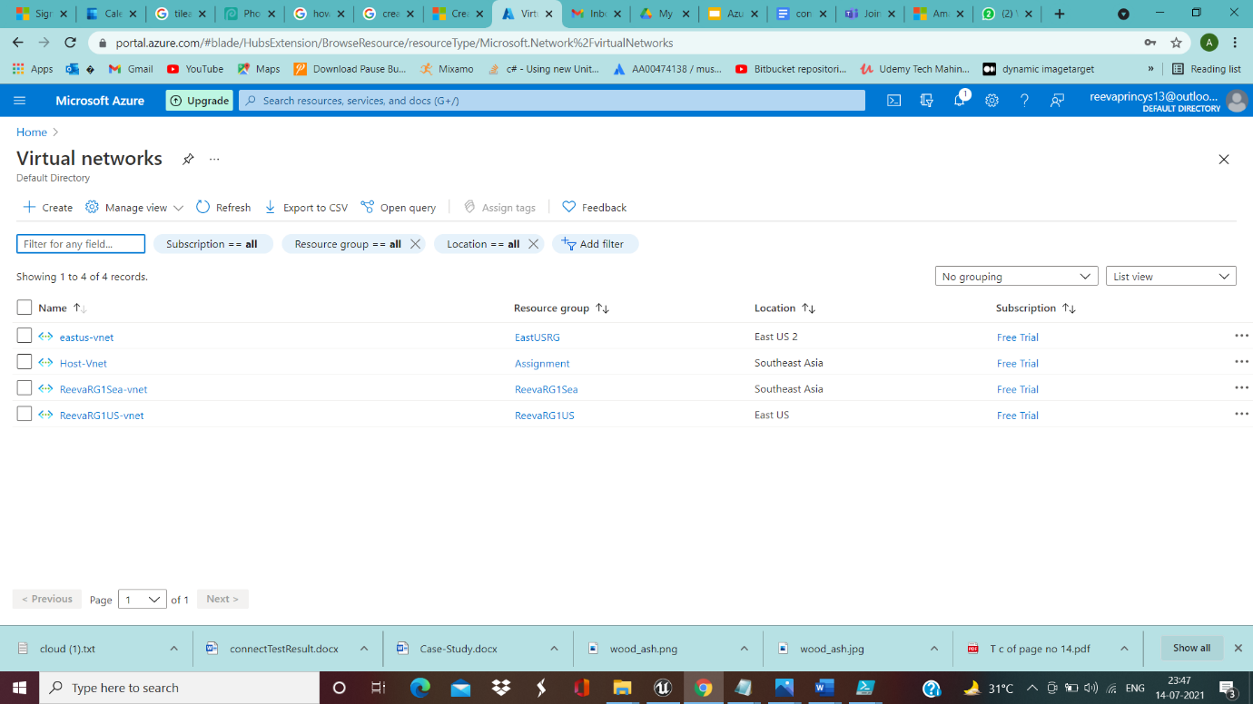

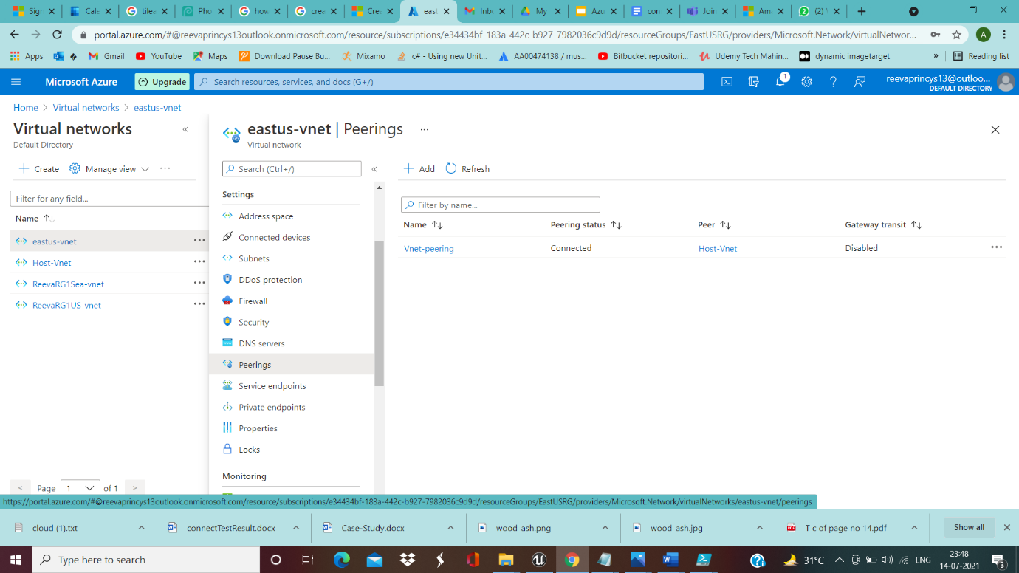

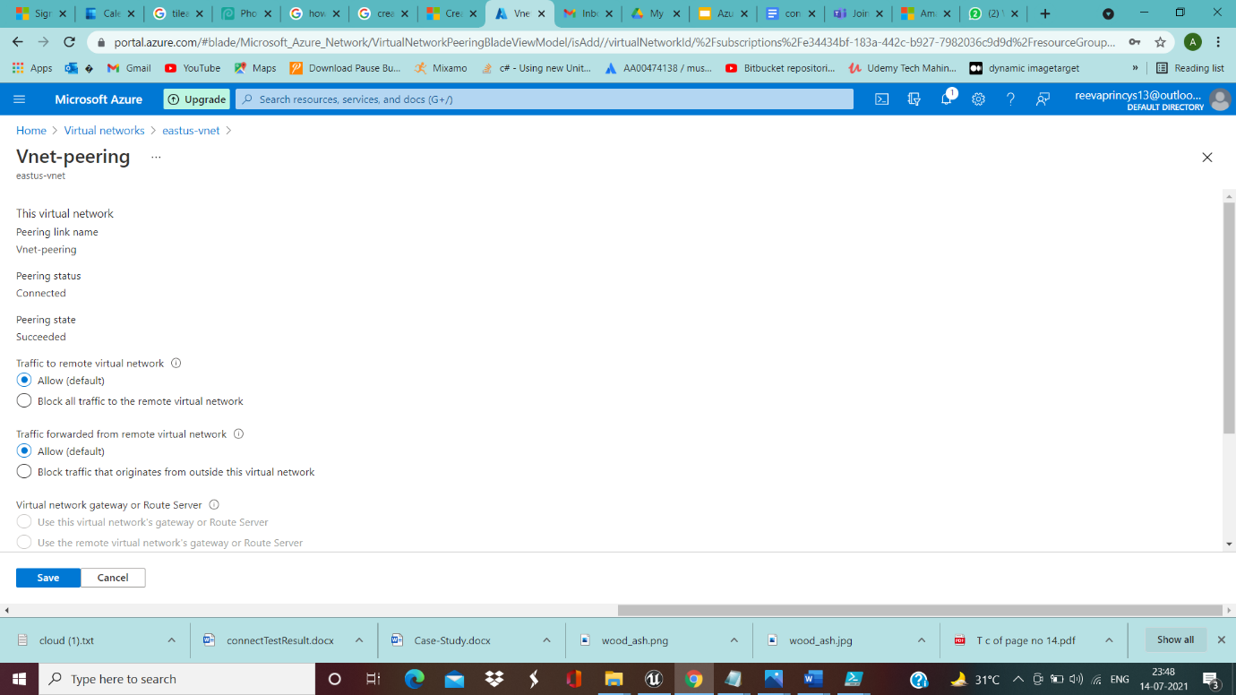

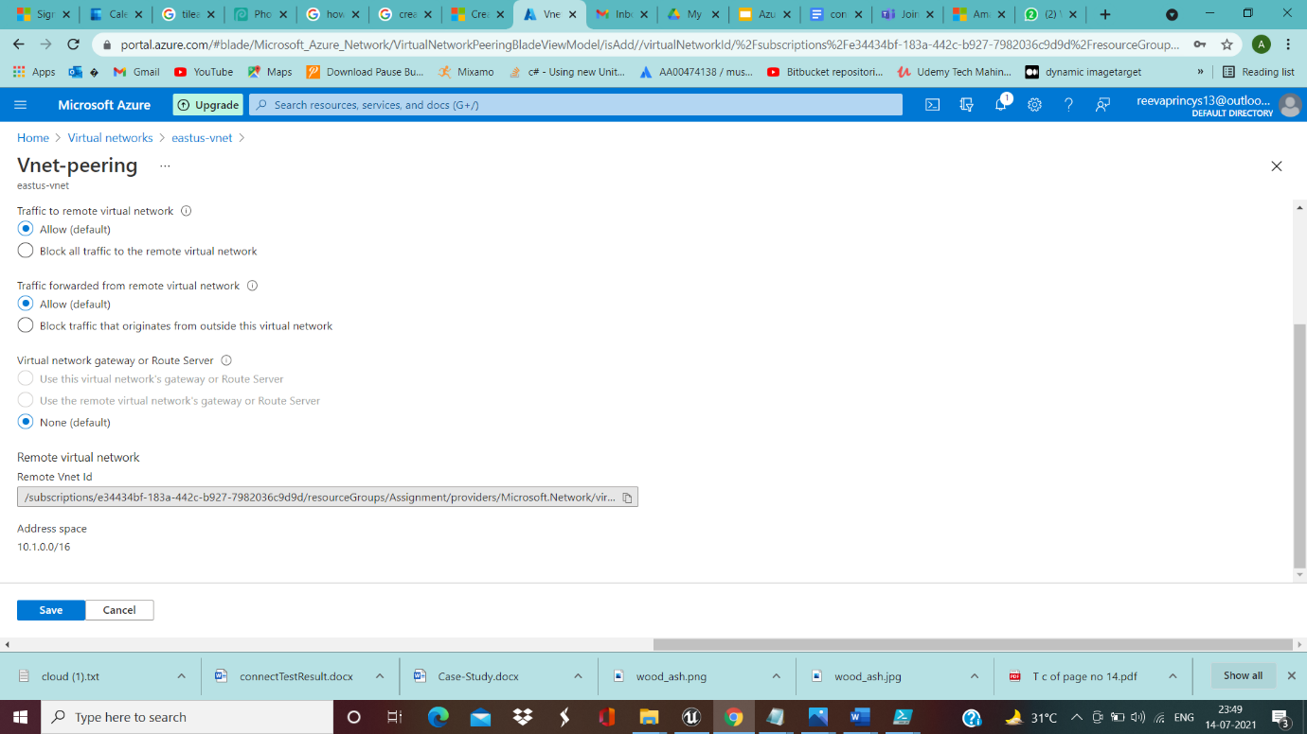

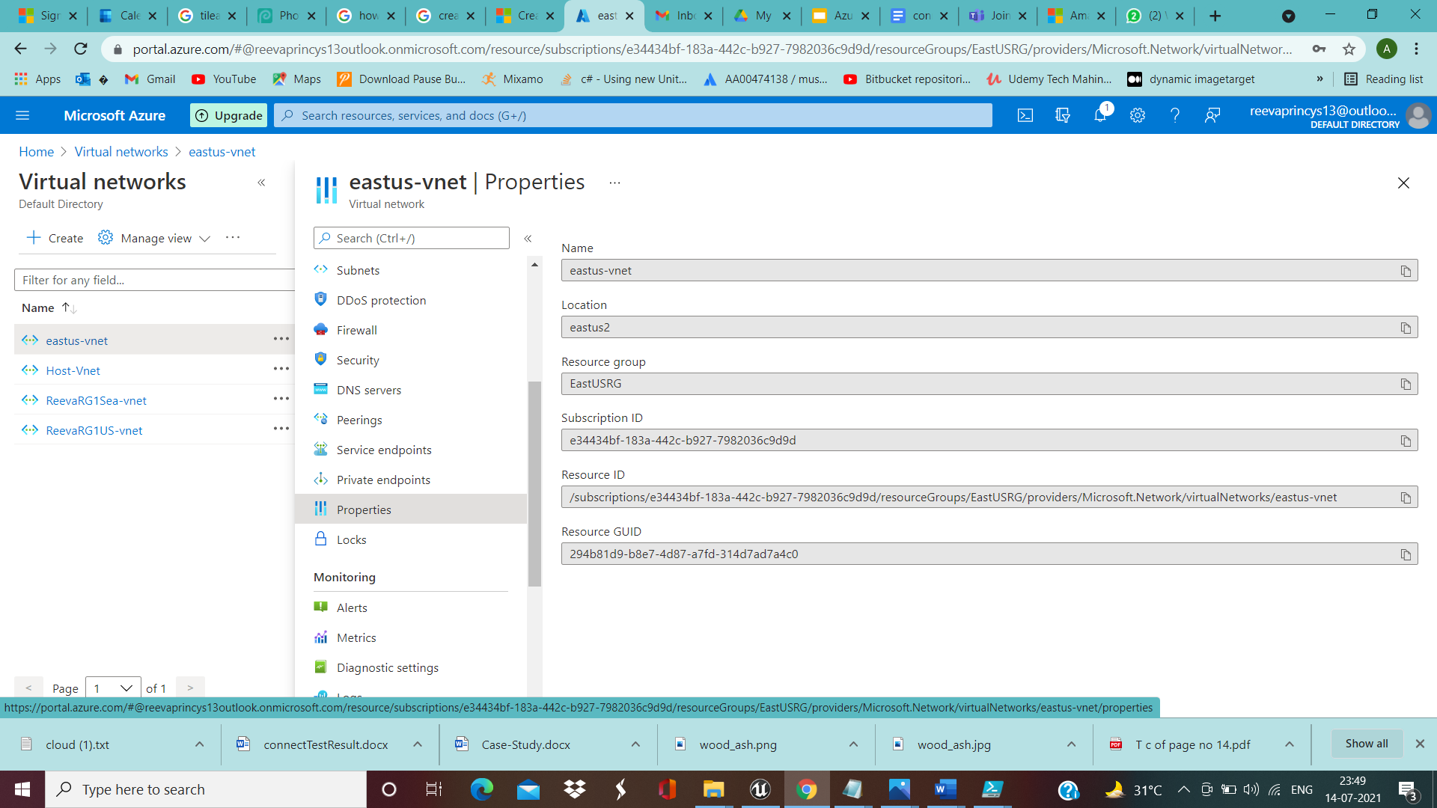

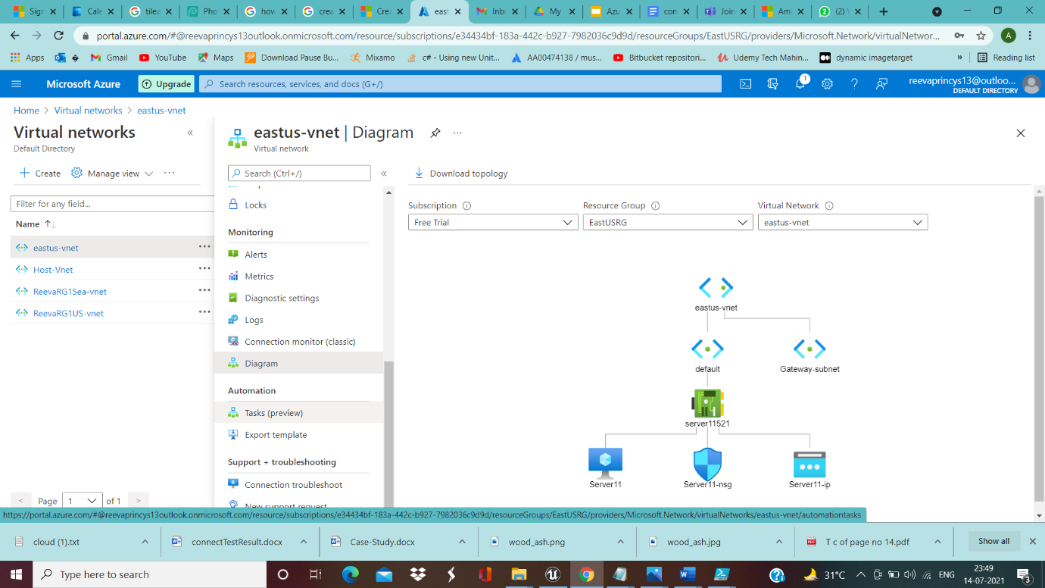

Host-vnet(SEA-Region)----------------------------------------------------

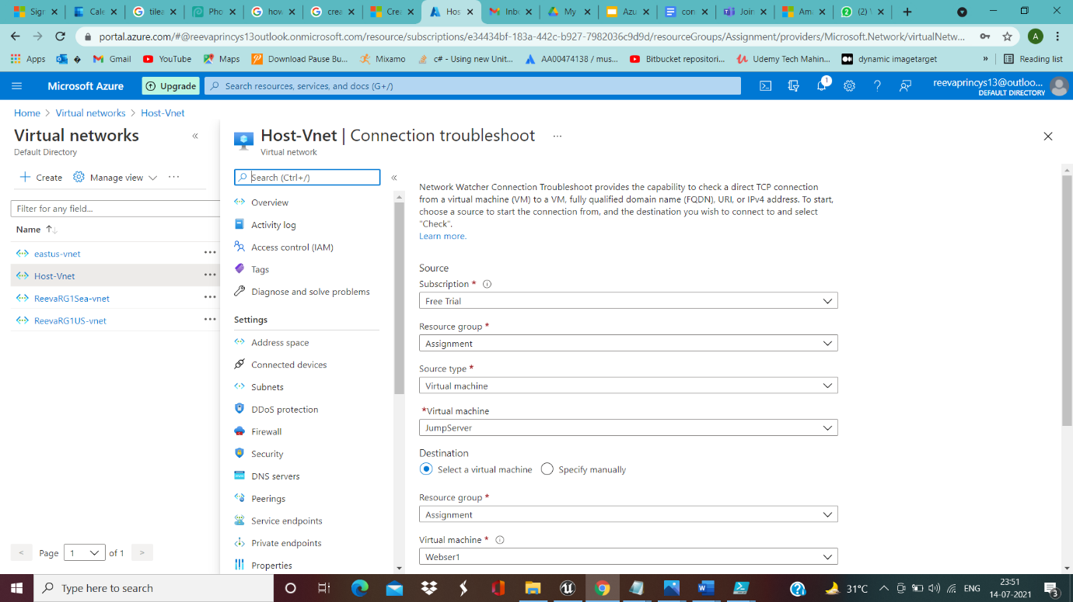

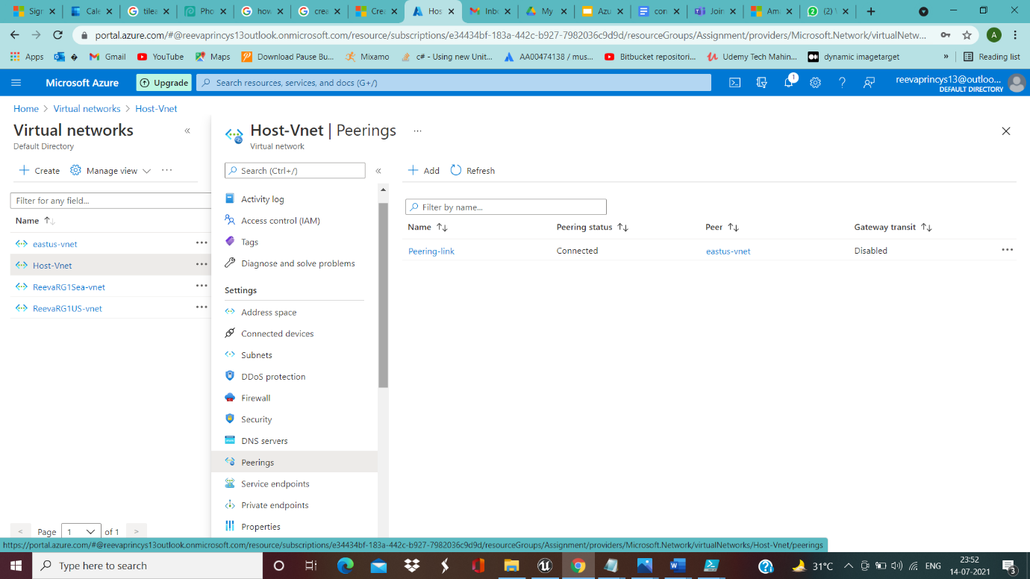

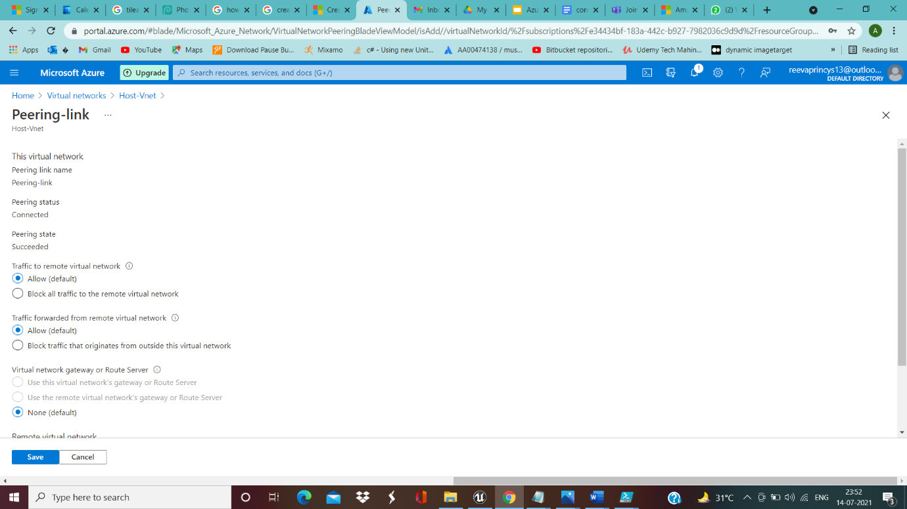

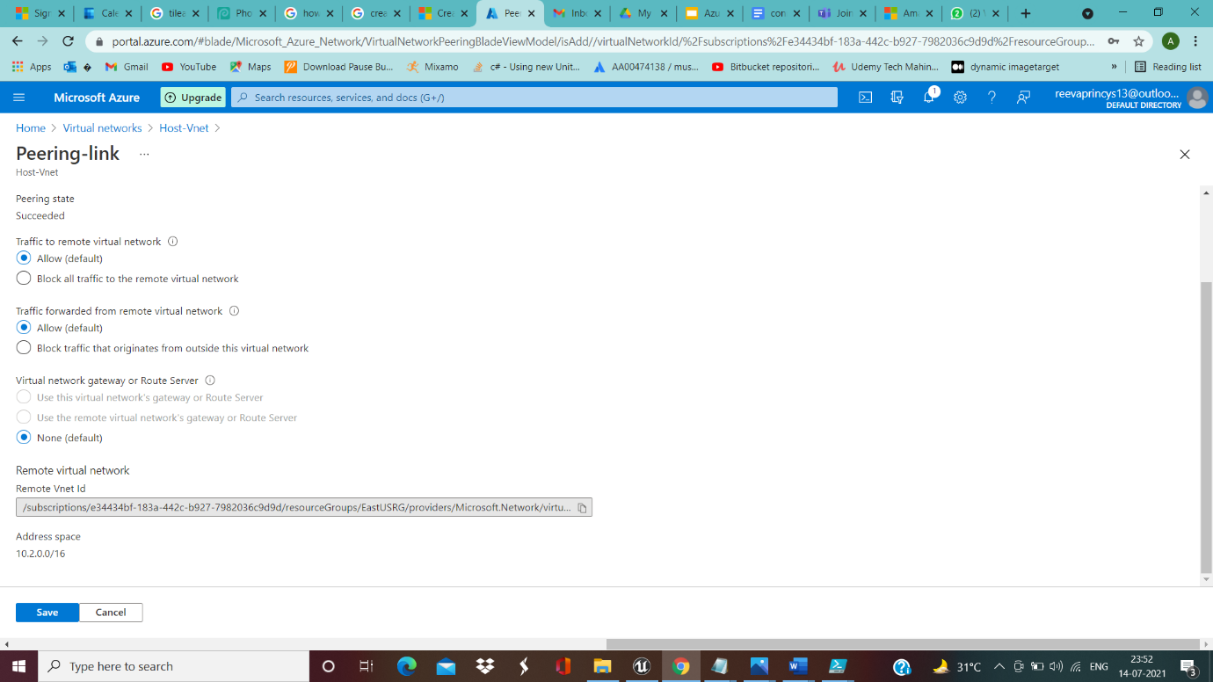

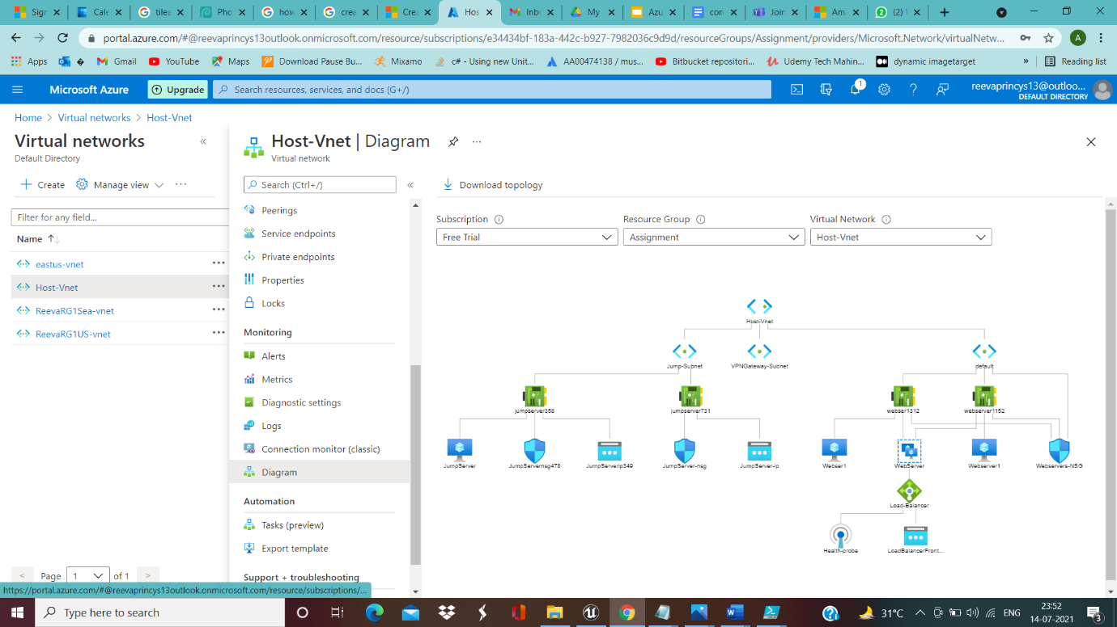

__________________________________________________________________________________

**Storage Requirements**

Eastusstoracc(storage for EastUS-Region)-------------------------------------------------

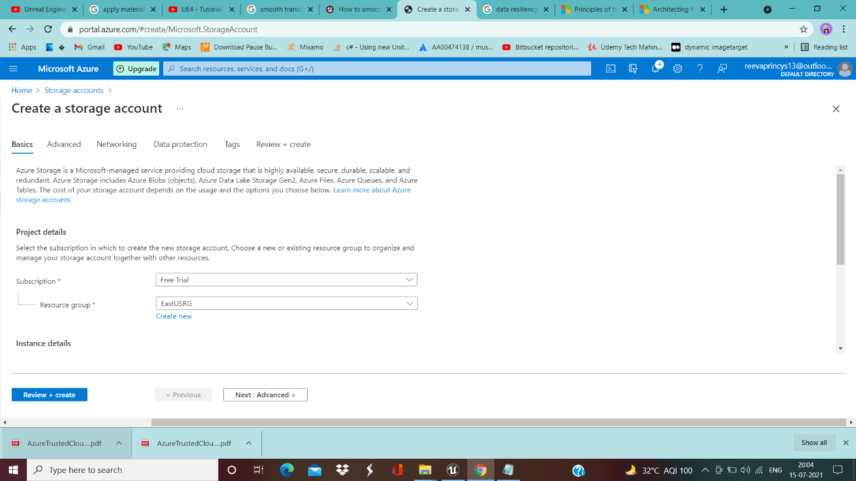

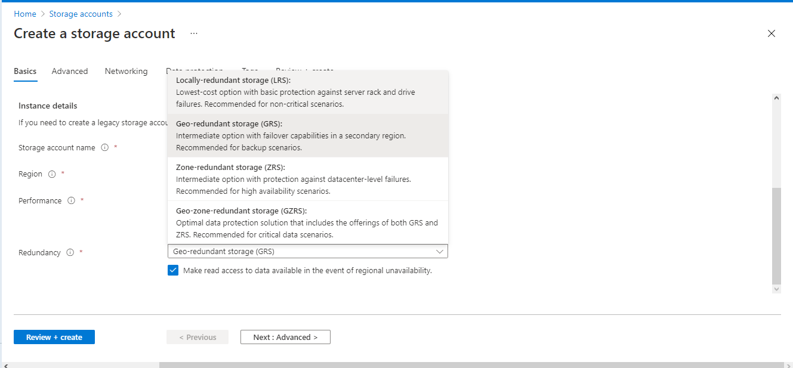

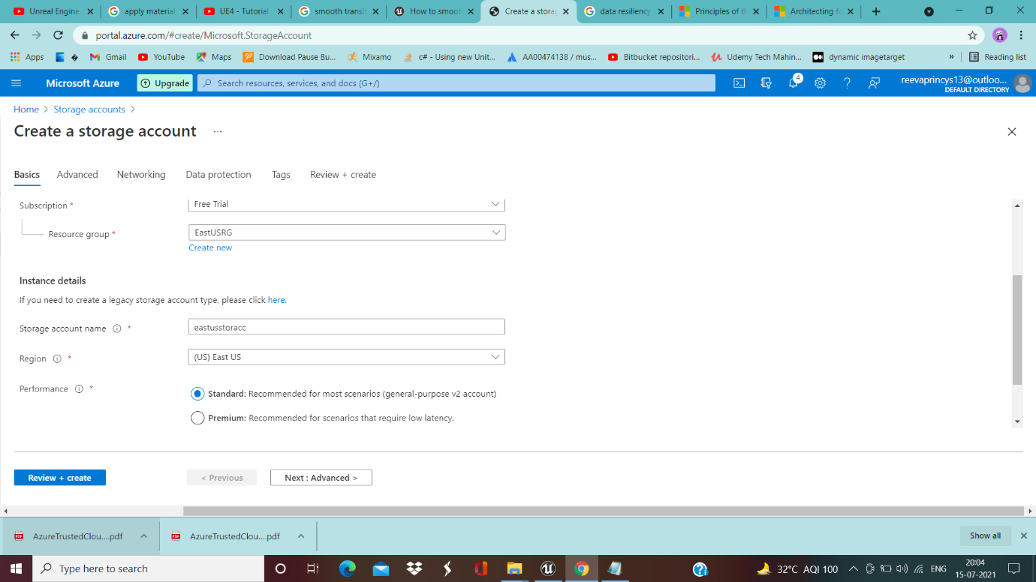

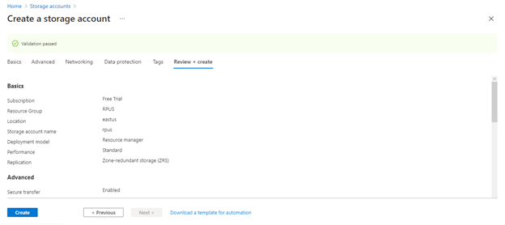

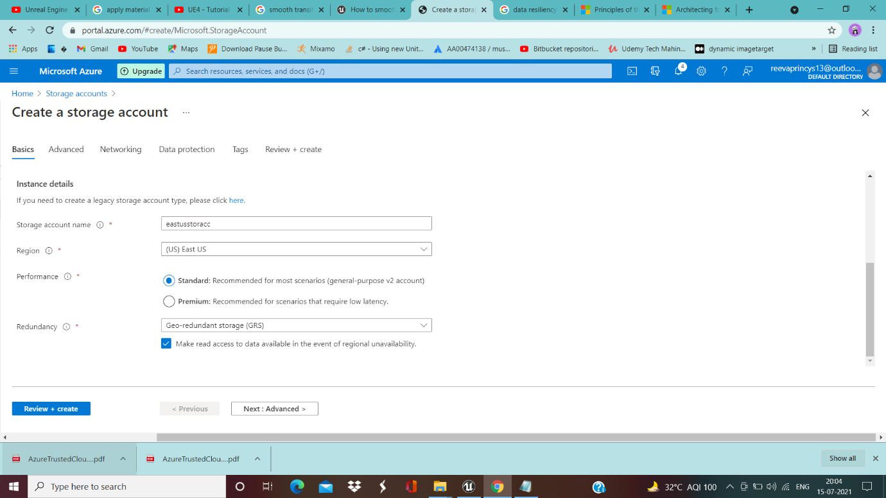

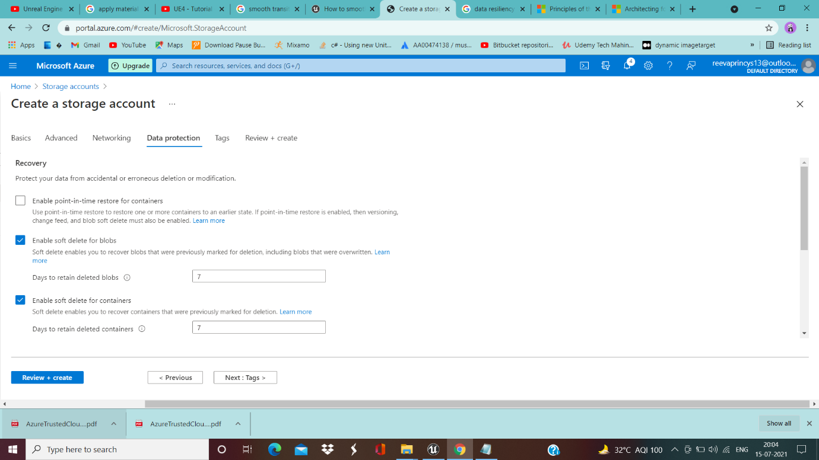

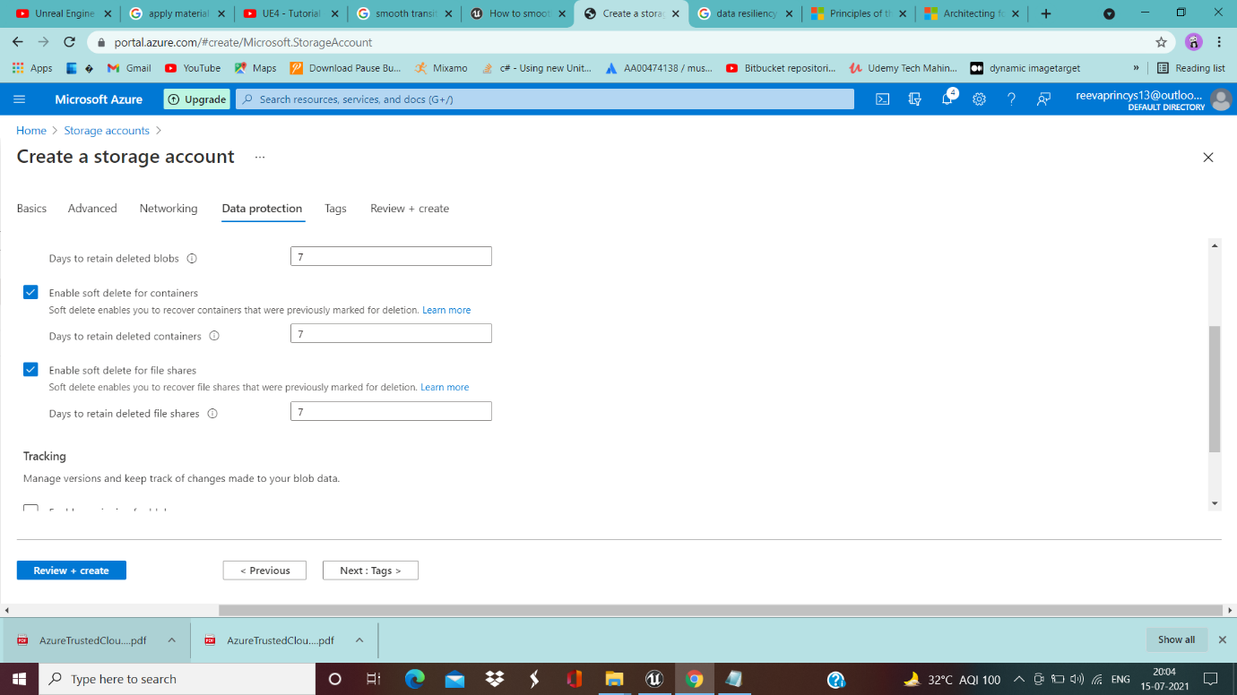

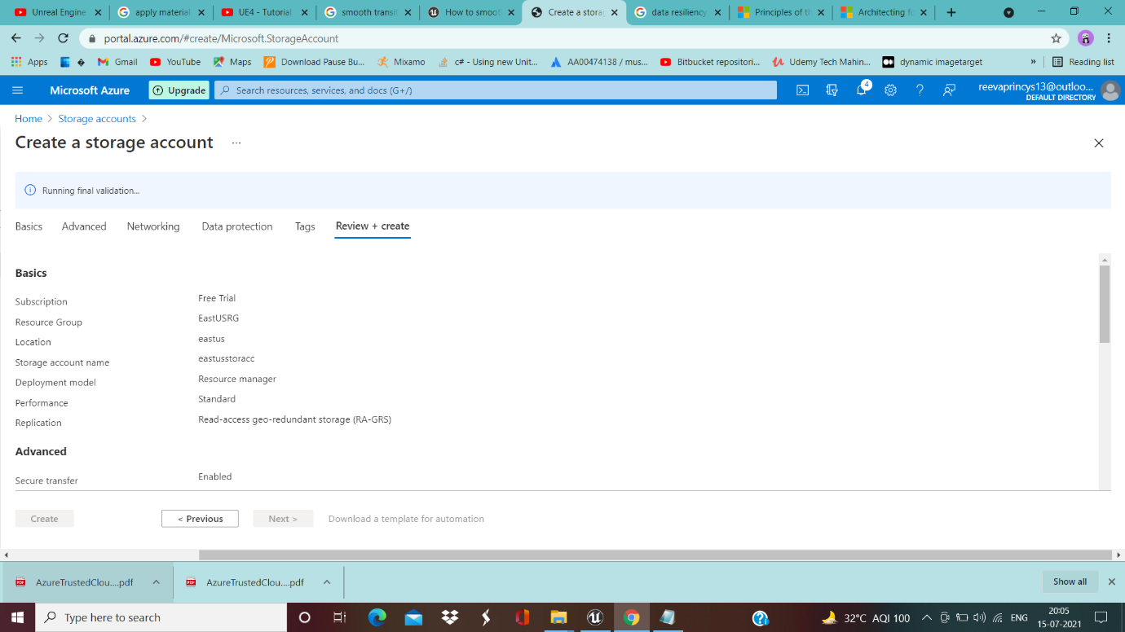

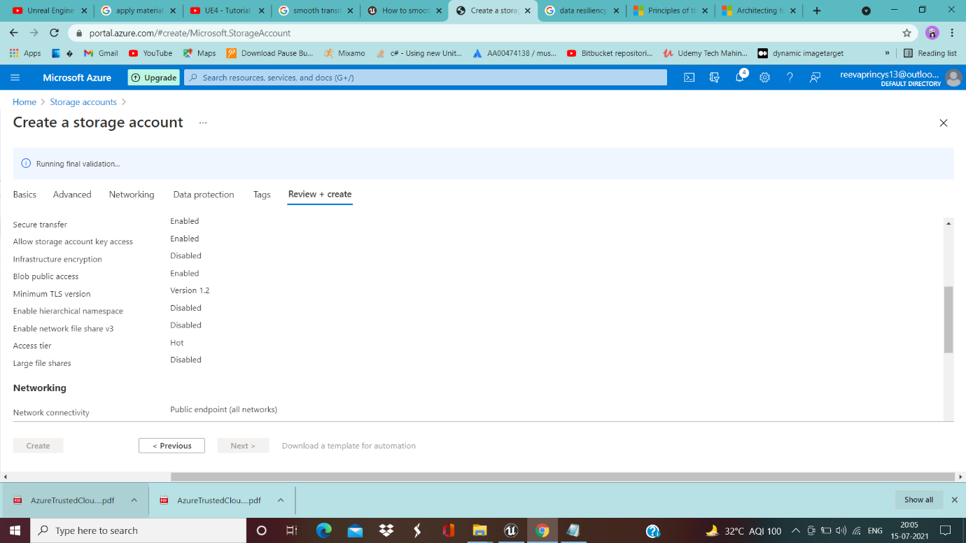

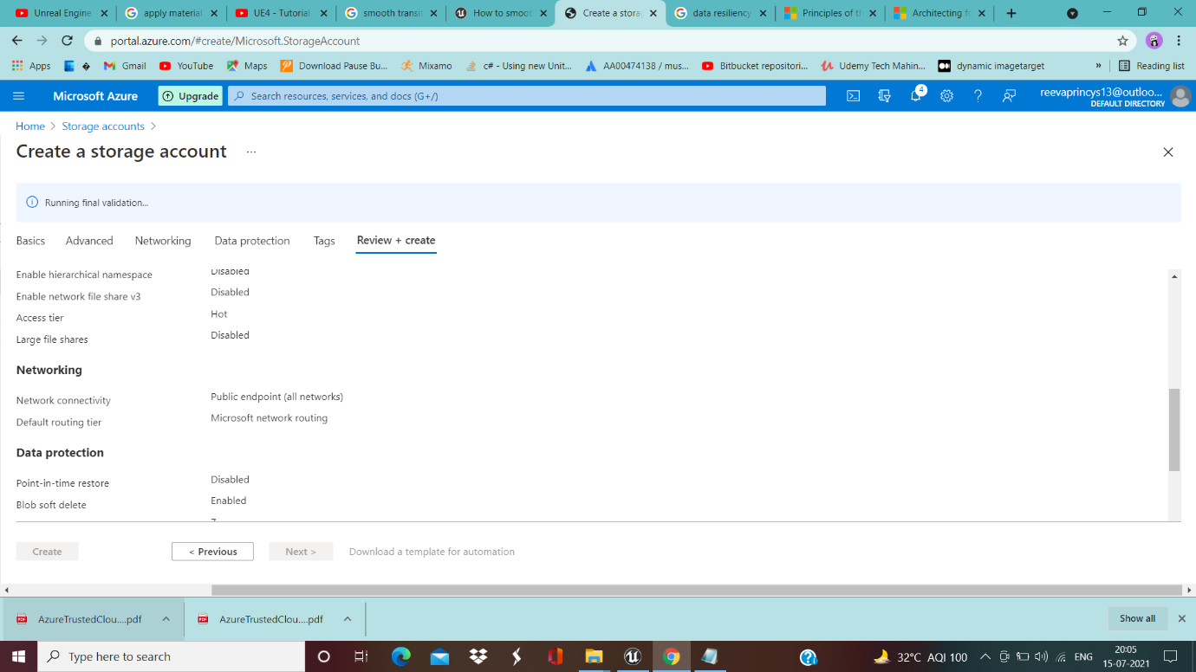

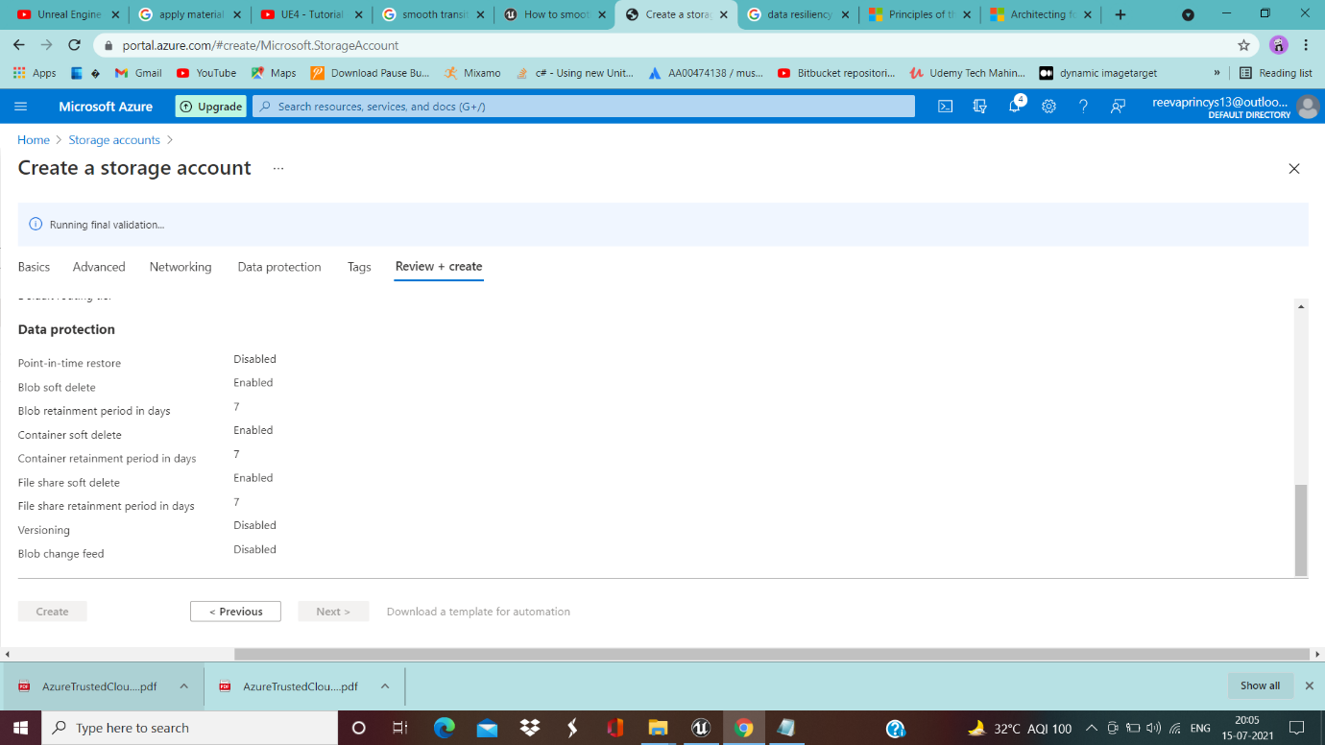

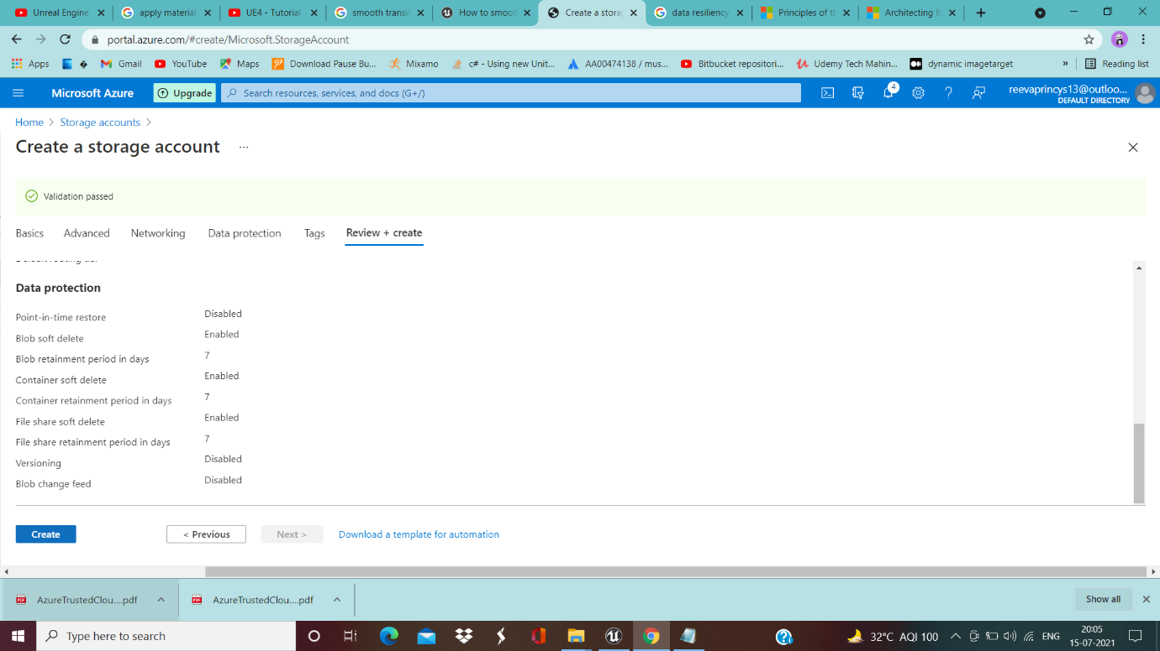

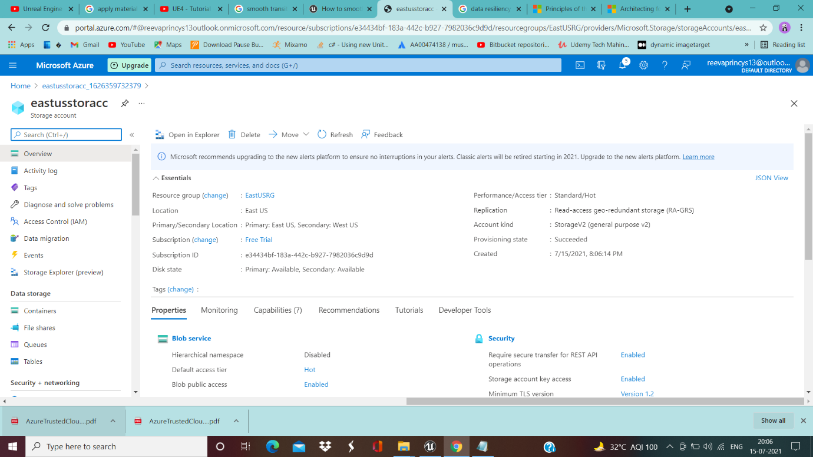

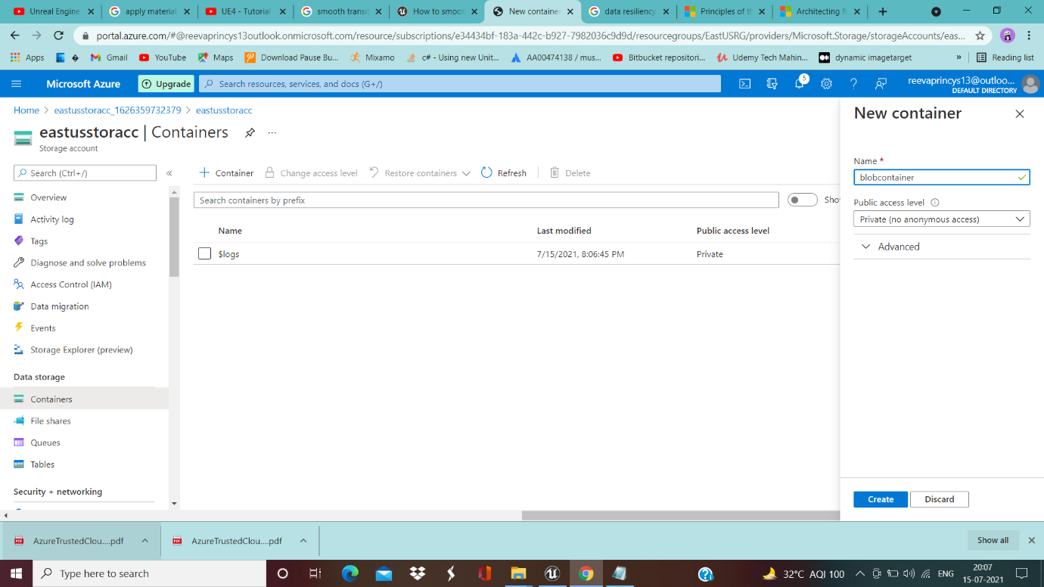

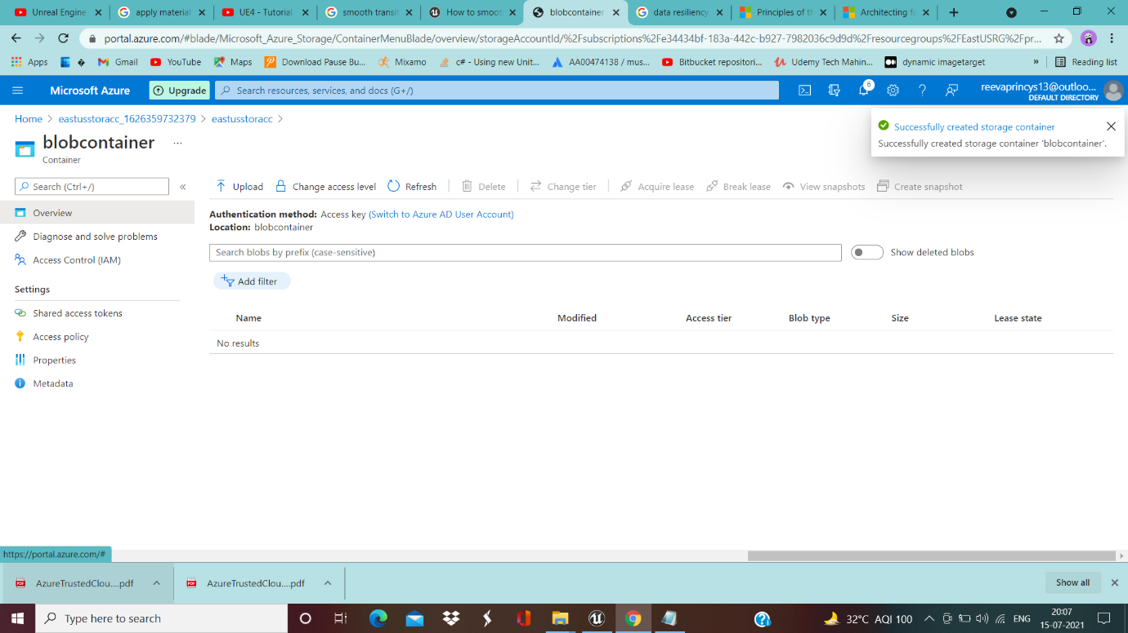

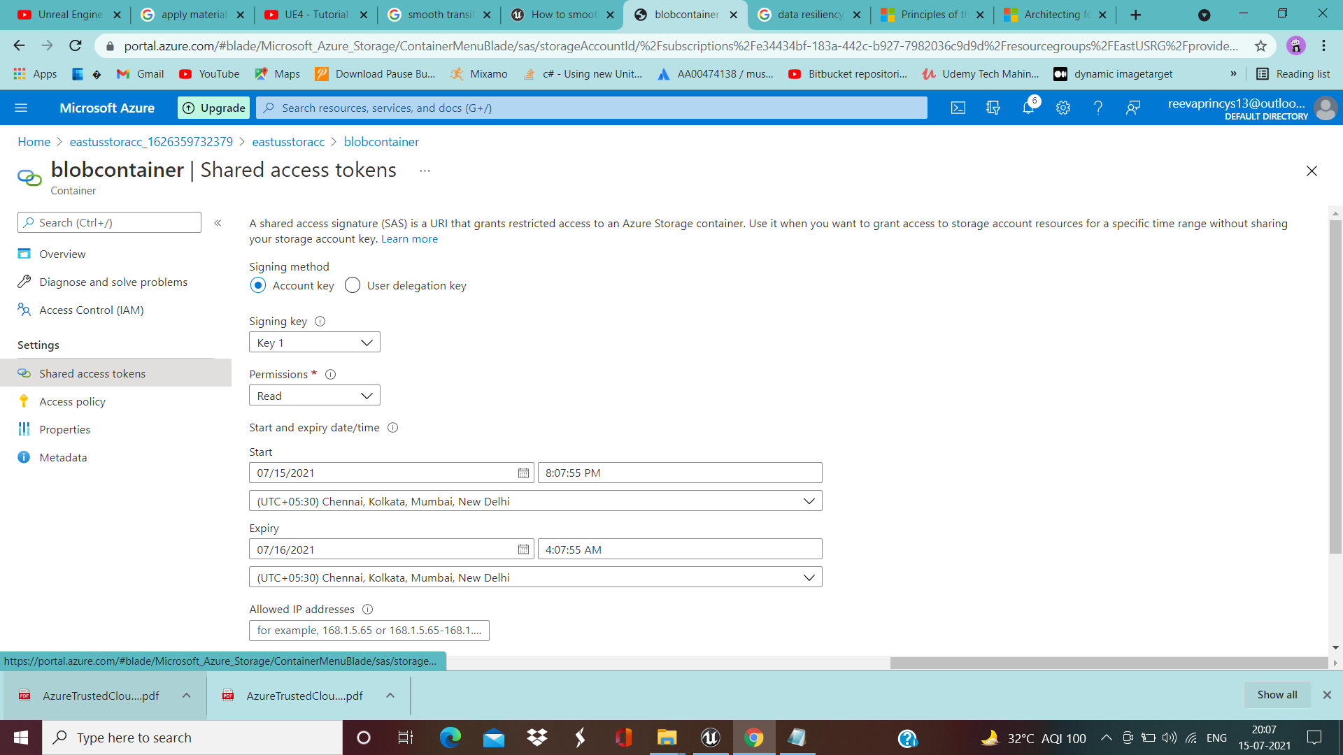

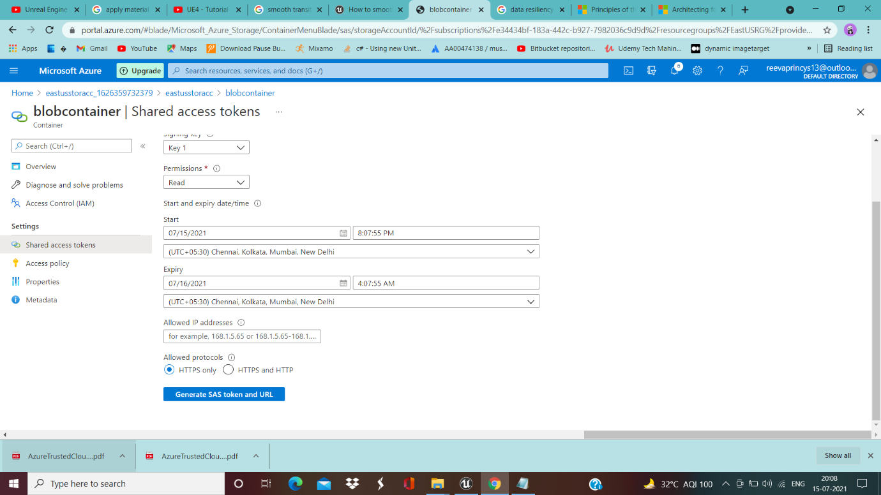

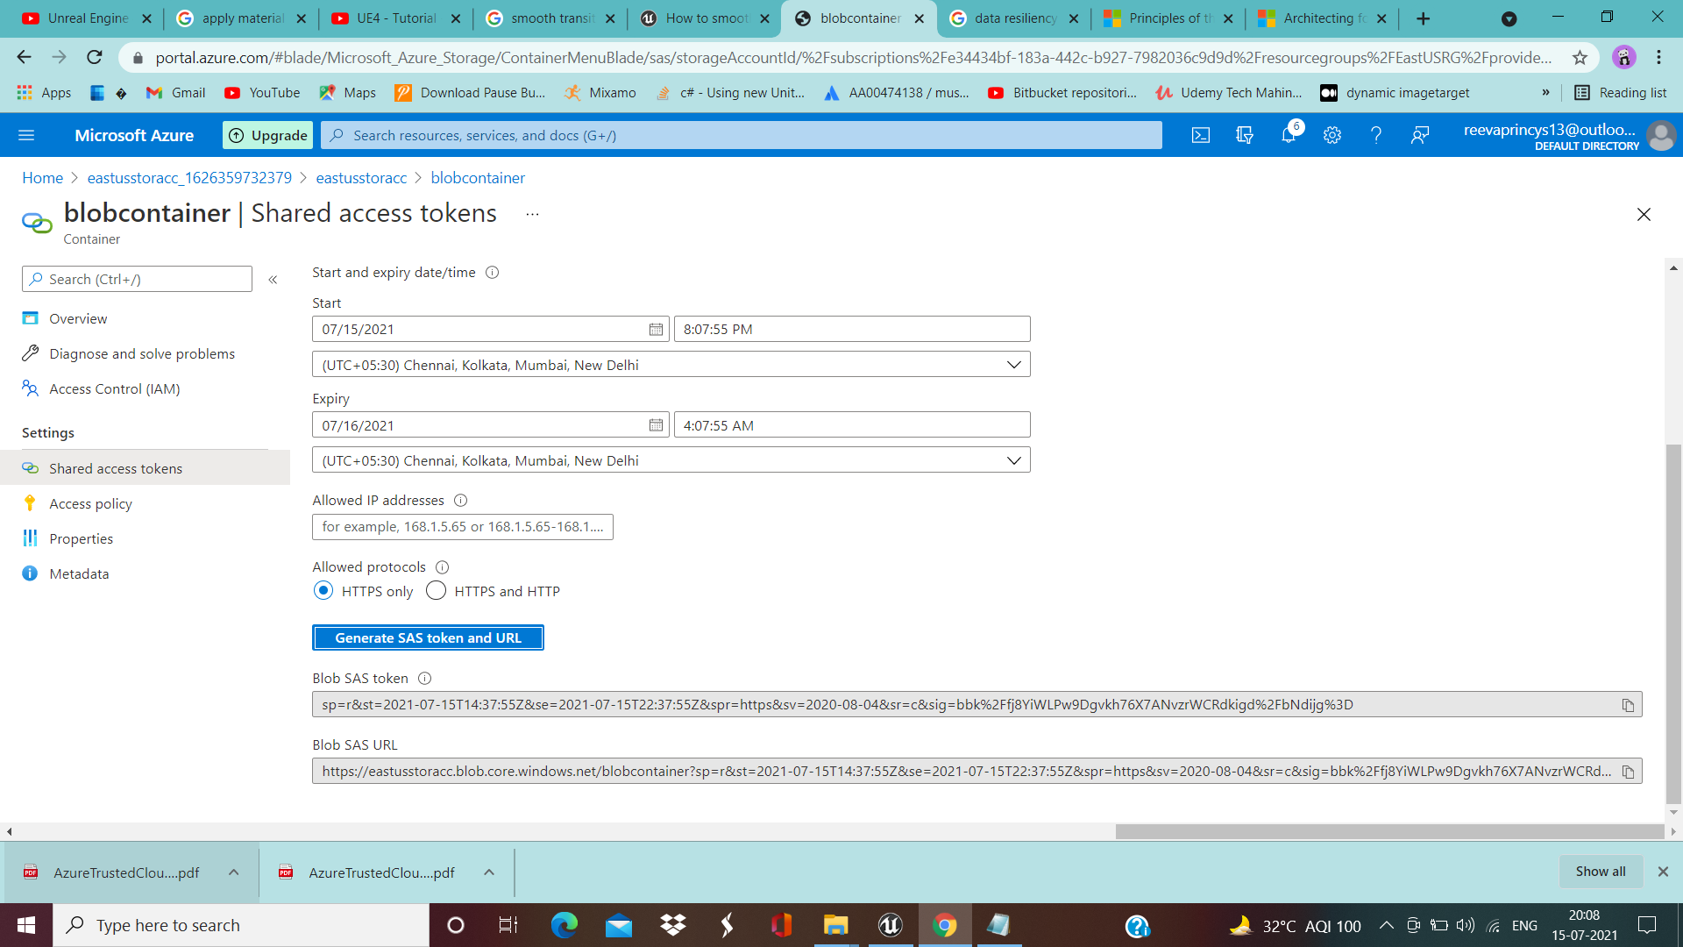

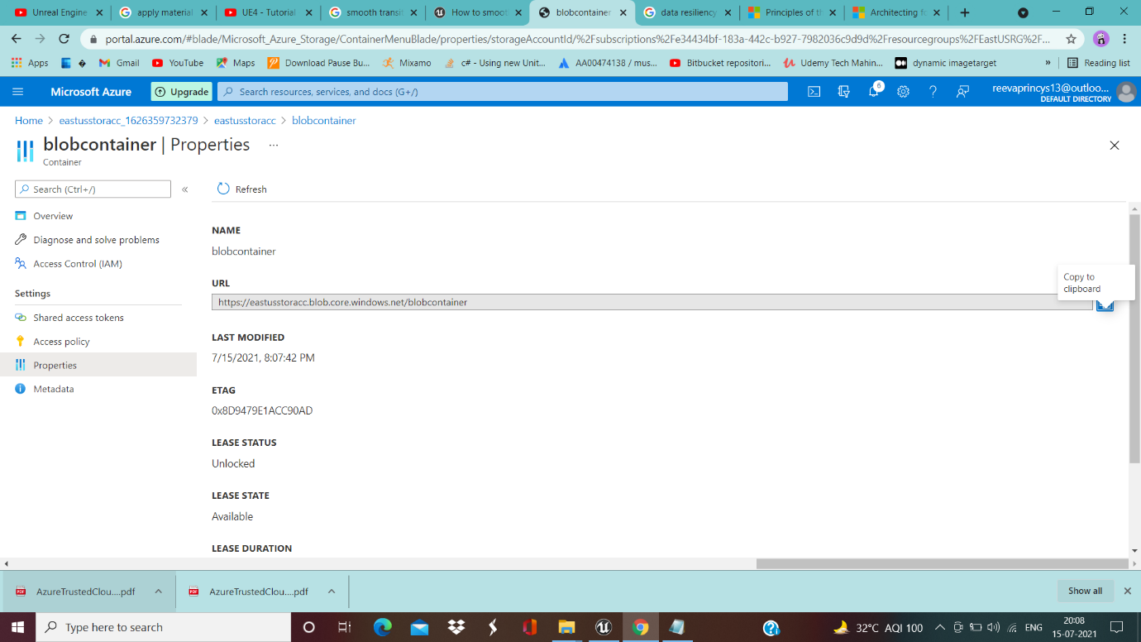

storagesearg(storage for Southeast Asia-Region)-------------------------------------------------

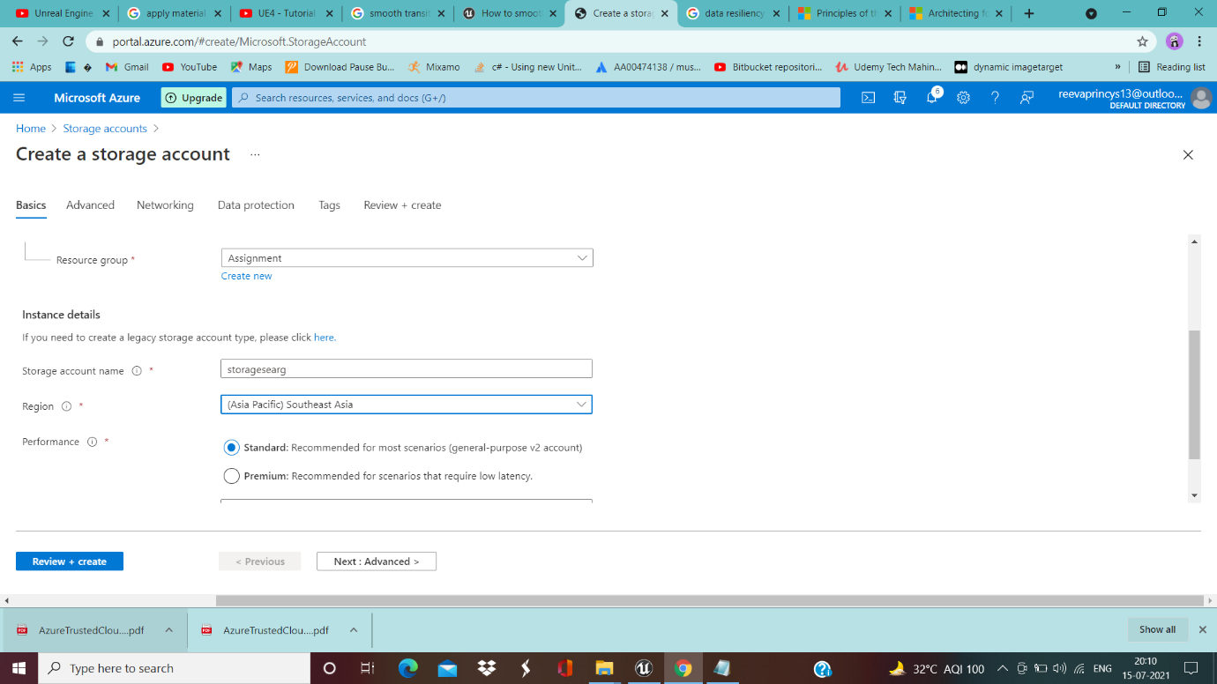

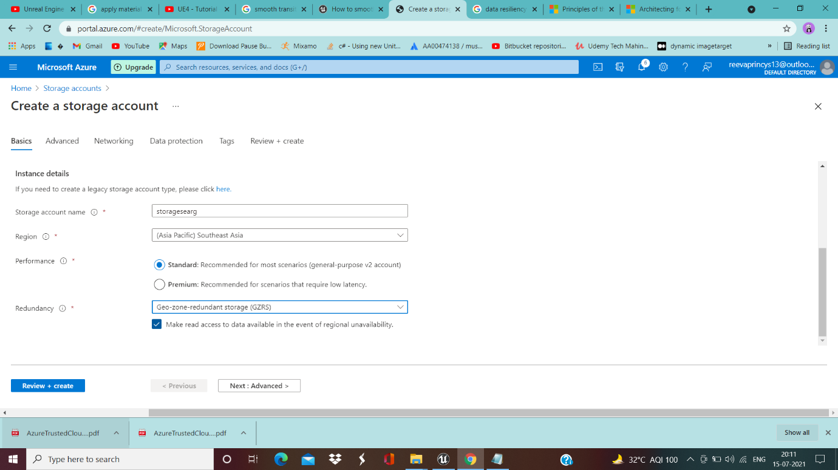

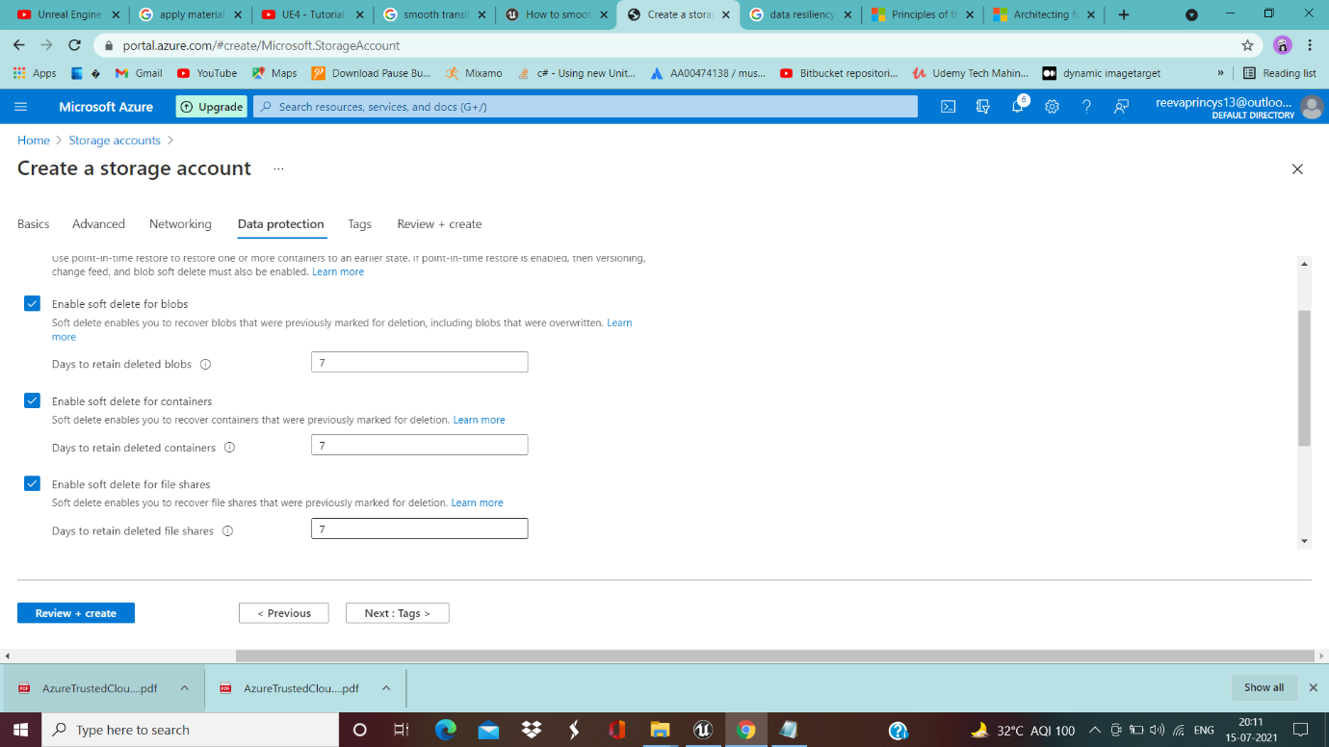

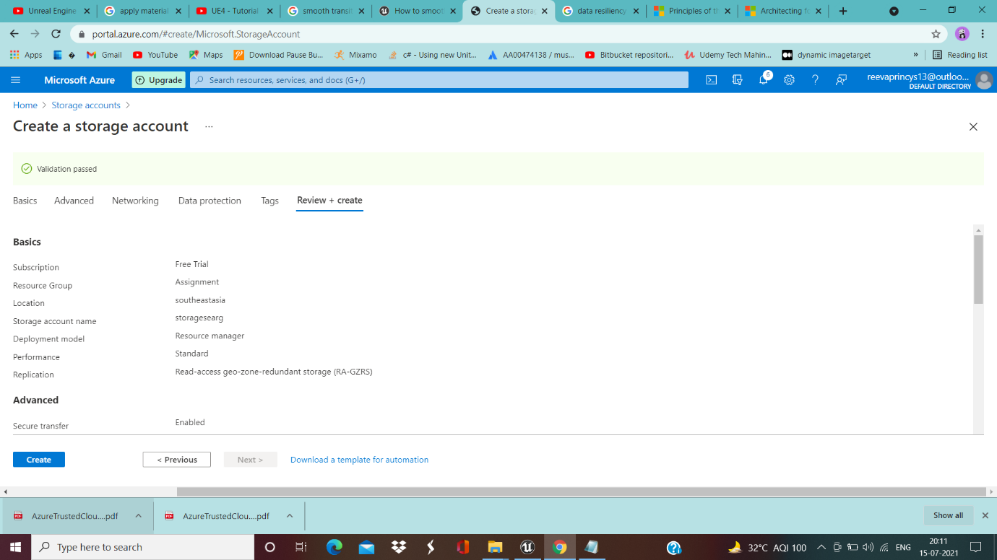

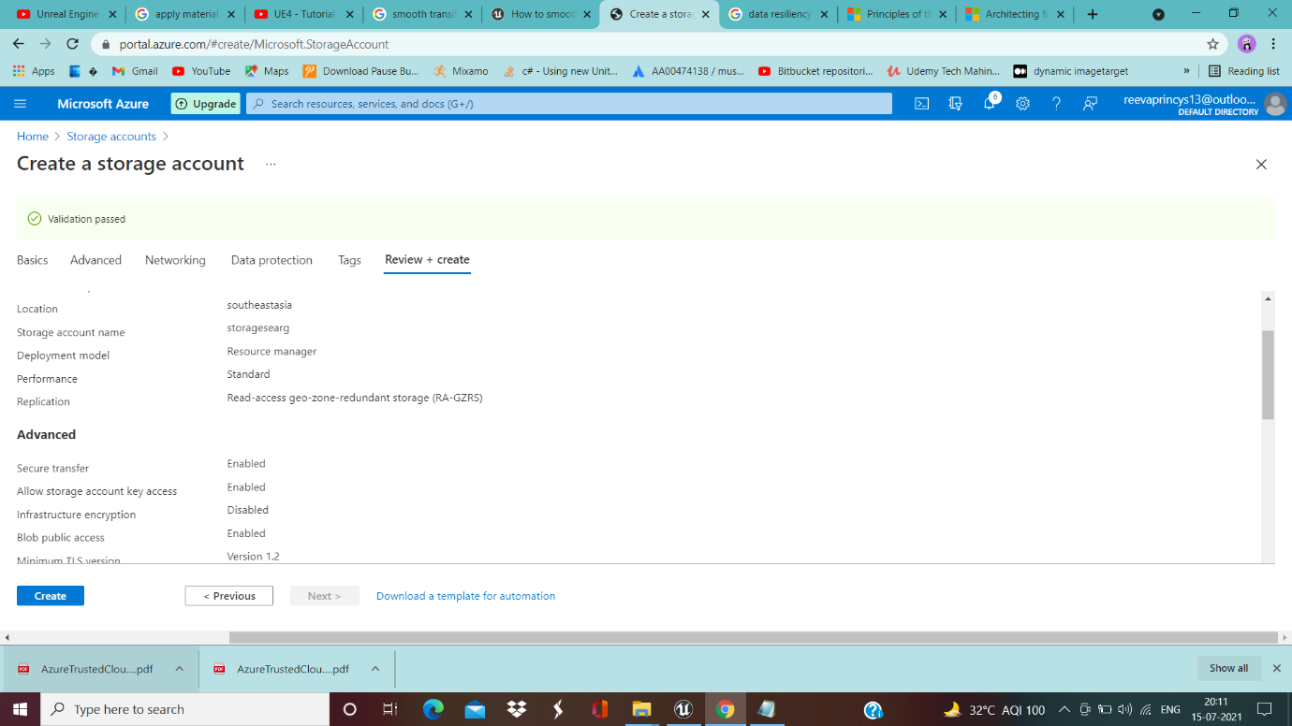

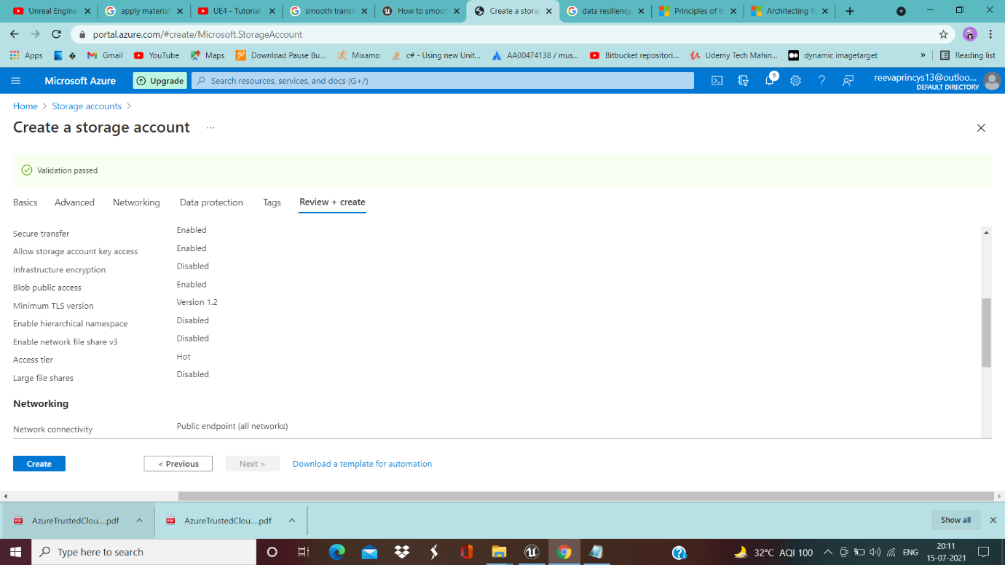

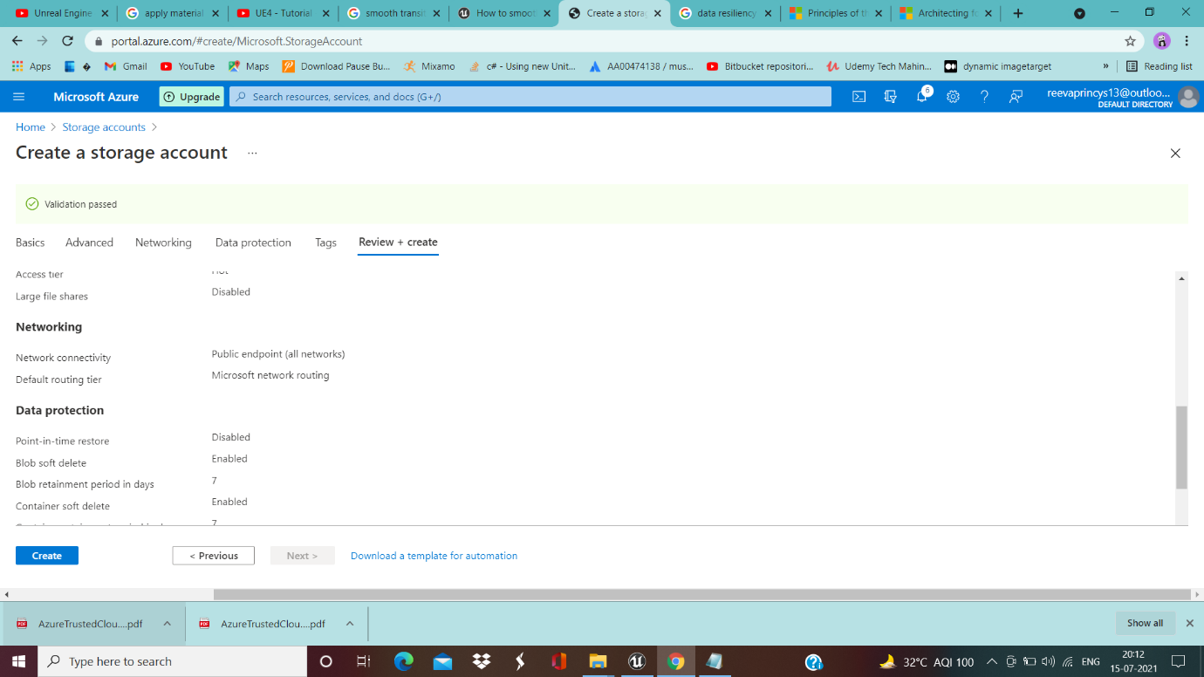

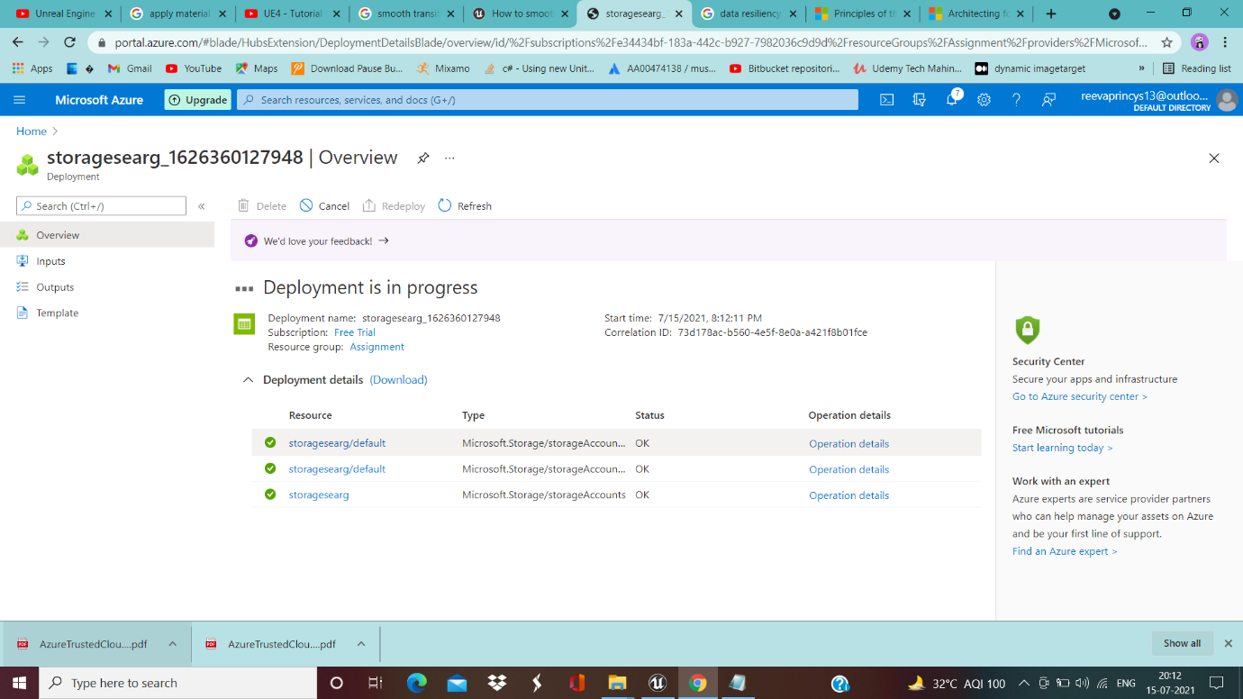

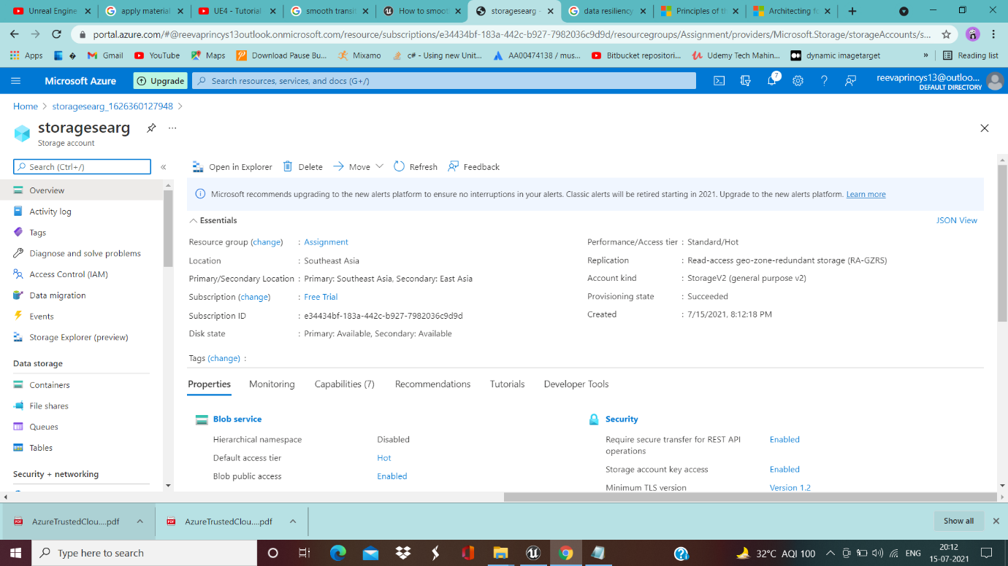

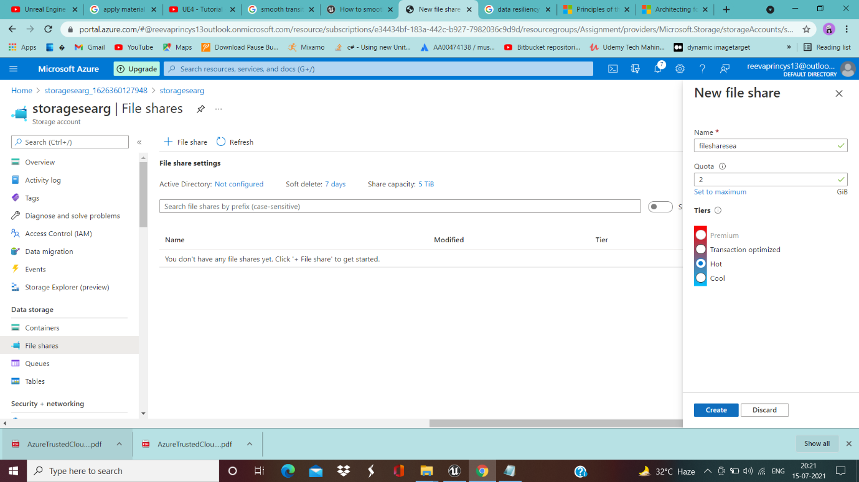

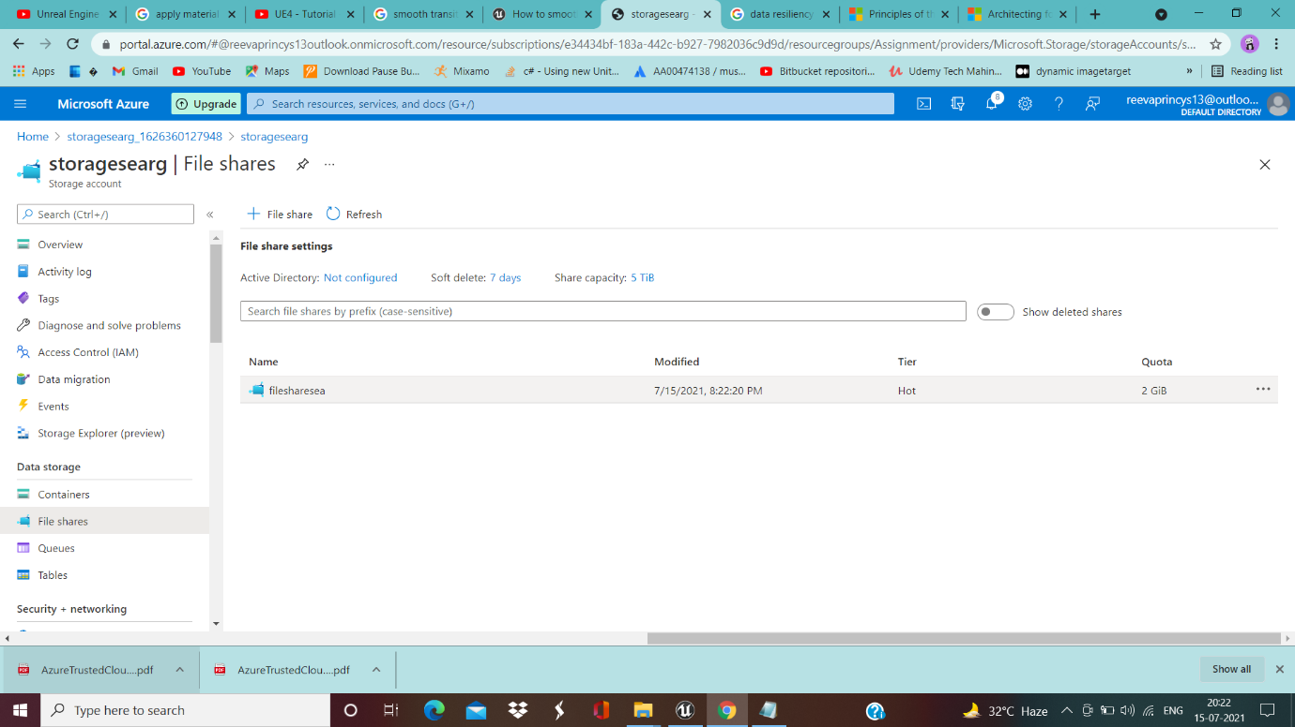

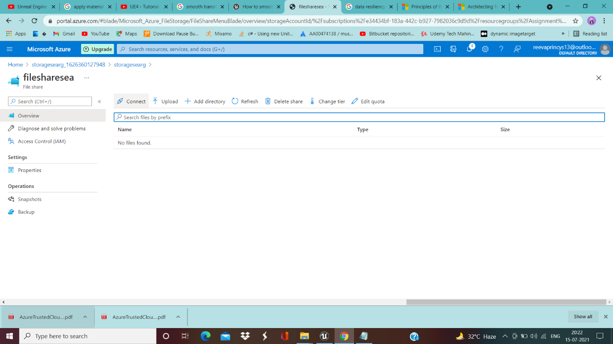

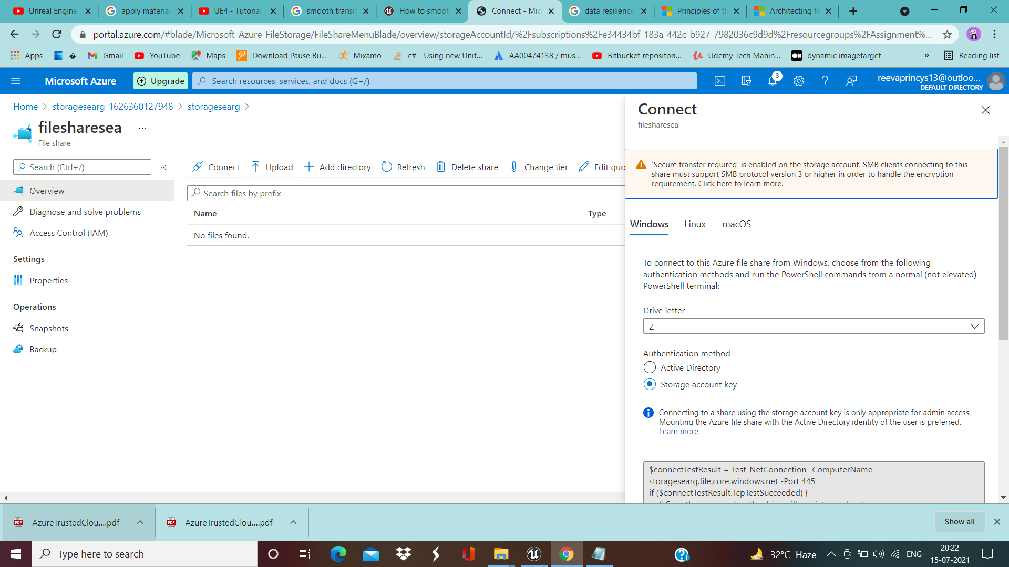

__________________________________________________________________________________

Sales Manager--------------------------------------

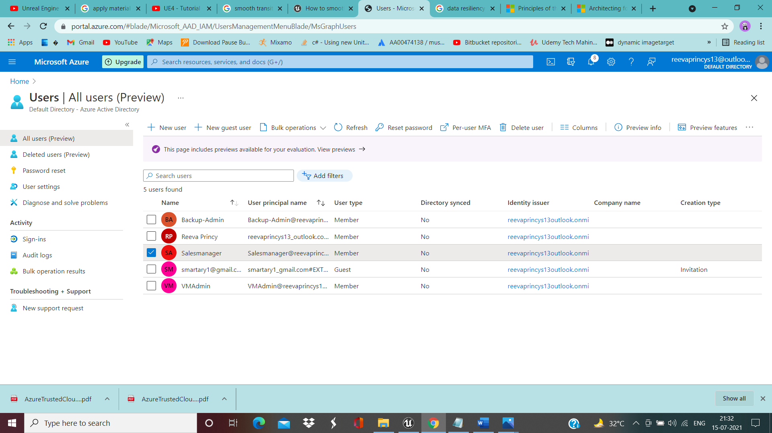

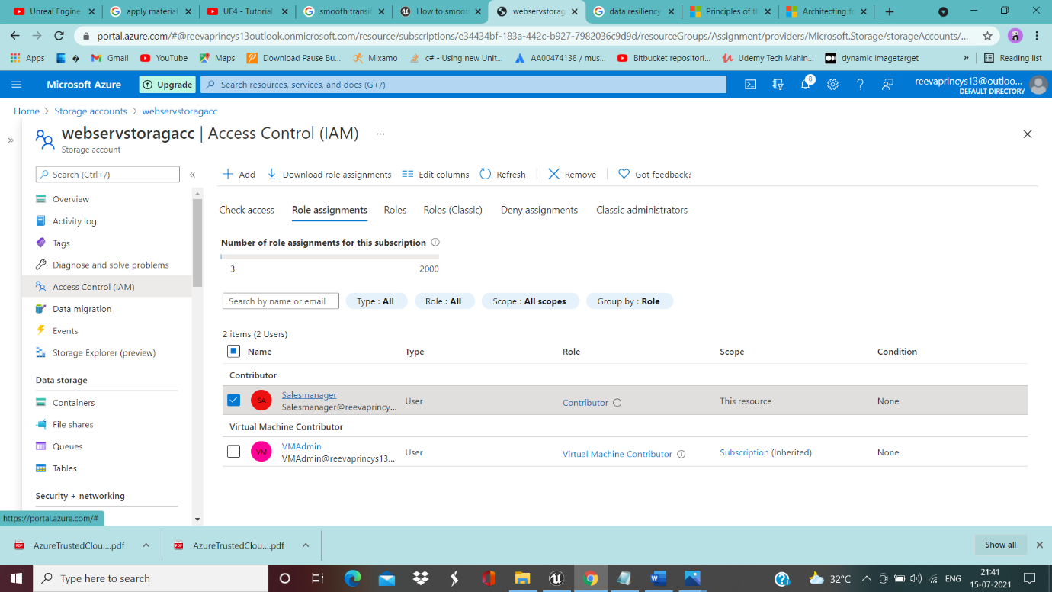

__________________________________________________________________________________

**Azure Resource Management**

VMadmin------------------------------------------

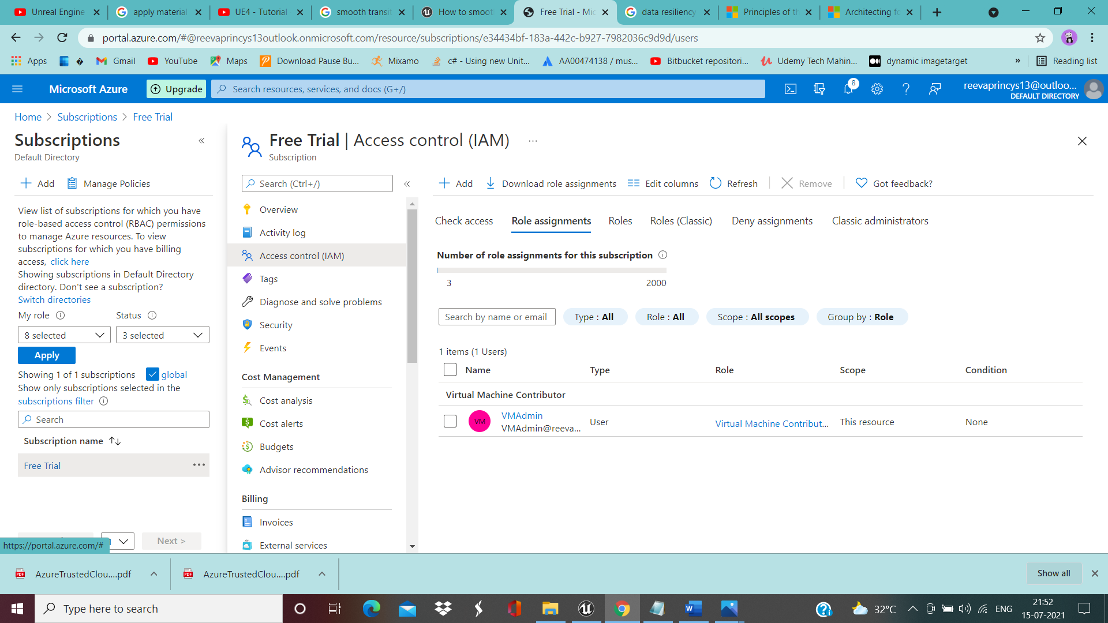

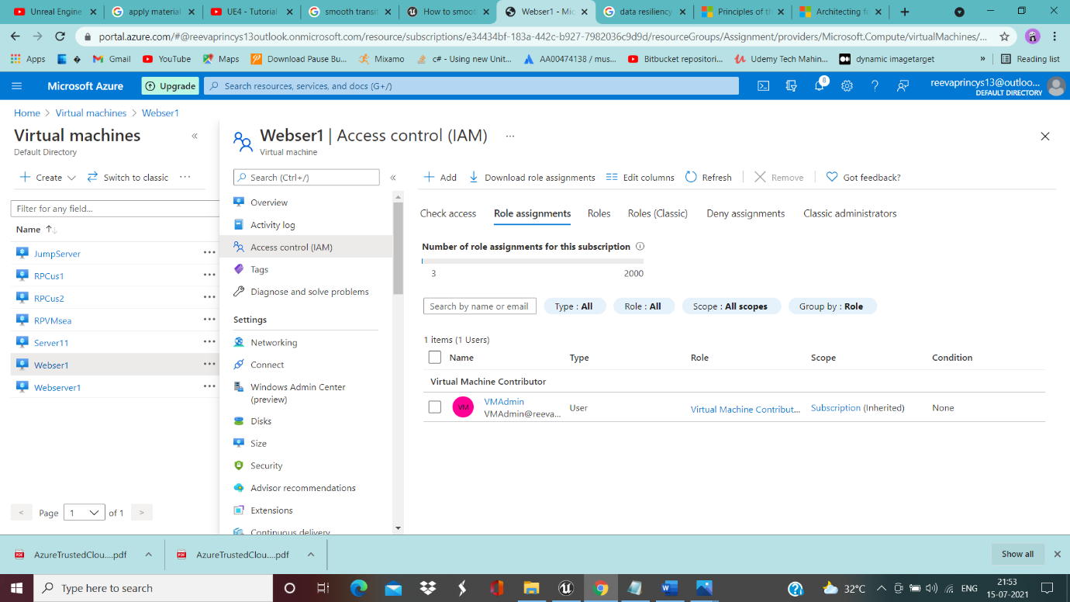

__________________________________________________________________________________

Backup-Admin-----------------------------------



